Sophia Antipolis, 11 May, 1999

To: SMG2, SMG3, TSG SA1, SA2, SA3, RAN2, CN1 and CN2

Invitation to the 3GPP
Workshop on Handover and Cell Selection

from Wednesday 9 to Thursday 10 of June, 1999
in Sophia Antipolis
(1st day at the Hotel Mediathel, 2nd day at the ETSI Headquarters)

Dear Sir, Dear Madam,

ETSI has the pleasure to inform you of the arrangements for the above-mentioned workshop:

PLEASE SEE HEREAFTER THE TIMETABLE:

WEDNESDAY 9 OF JUNE, 1999

Workshop on Handover
Start 9 of June at 9.00 am

HOTEL TULIP INN MEDIATHEL
Route des Crêtes, Sophia Antipolis

Tel: +33 (0)4 92 94 68 00 Fax:+33 (0)4 93 65 43 41

THURSDAY 10 OF JUNE, 1999
Workshop on Cell Selection
Start 10 of June at 9.00 am and will finish around 5.00 pm

ETSI, Amphitheatre

650, Route des Lucioles, SOPHIA ANTIPOLIS

Tel: +33 (0)4 92 94 42 00 Fax:+33 (0)4 93 65 47 16

The registration will start half an hour before the Workshop starts.

Please note that the agenda will be sent later on by Niels Andersen. You will also find attached the map to reach the first meeting venue.

Allocation of Tdoc numbers:
0 You should contact alain.sultan@etsi.fr

All documents that are available before the meeting will be placed on the ETSI server under the following directory: http://www.3gpp.org/

Hotel and transport information for Sophia Antipolis can be found on the ETSI server or on the 3GPP area at the following addresses:
http://www.3gpp.org/Meetings.htm

You will also find attached a document which gives all information needed for connecting your laptop to the ETSI meetings network.

Please complete and return the registration form by telefax (+33 4 93 65 2817) to the attention of Carole Rodriguez by 8 June, 1999

We look forward to seeing you in Sophia Antipolis.

I remain yours sincerely,

Emmanuelle Wurffel
( +33 4 92 94 42 66 + +33 4 93 65 28 17
/emmanuelle.wurffel@etsi.fr

REGISTRATION FORM
WORKSHOP ON HANDOVER AND CELL SELECTION
From Wednesday 9 to Thursday 10 of June, 1999
in Sophia Antipolis,
Please fill in this form and send it by 8 June, 1999 to: |  |  | Contact  Name Carole Rodriguez  E-Mail:  carole.rodriguez@etsi.fr  Tel: +33493652817
 | Title: | Miss Ms Mrs Mr Dr
 | Family Name:
 | Forename:
 | Mailing address:
 | Telephone:
 | Fax:
 | E-mail:
 | Date and time of arrival:
 | Date and time of departure:
 | I am unable to attend on this occasion:

Status of Represented Membership (tick one box in one column 1, 2 or 3):
1) Organizational Partner Representative (SDO)  (tick one box below) | 2) Individual Member Representative  (tick one box below) | 3) Market Representation Partner Representative  (tick one box below)
Representing Partner:  (tick one box below)  ARIB | Representing Partner:  (tick one box below)  ARIB | Representing Partner:  (tick one box below)  UMTS Forum
ETSI | ETSI | GSA
T1 | T1
TTA | TTA
TTC | TTC
Other: | Other: | Other:
Individual Member organization* name:
I am the voting representative for this Individual Member.
* For a list of Individual Member organizations, see HREF="http://www.3gpp.org/Individual_Member.htm

From: Jean-Luc Freisse

To: All meetings participants.

Copies to: ETSI Secretariat

Subject: Frequently Asked Questions about the new Meetings network

1 Scope
This document gives all information needed for connecting your laptop to the ETSI Meetings network.

2 Warning
- If meeting participants have forgotten their RJ45 – RJ45 cable they will be able to borrow one cable at the reception desk against a business card.
- However, ETSI cannot install software on meeting participants’ computers, or provide network cards to meetings participants.
- If you discover a malfunction on a network socket please inform the HelpDesk or the reception desk about it.

3 What do you need to connect to this new network?
- Your computer (Macintosh, PC,…) with any operating system.
- TCP/IP protocol implemented on this computer with DHCP client (BOOTP).
- Your network interface (Ethernet) with RJ45 connector.
- One network cable RJ45 – RJ45 category 5 or higher.
- One French power plug or adapter.

4 What can you do when connected to this network?
- As you are connected to the Internet, you have the opportunity to:
- Access the ETSI servers (www.etsi.org, docbox.etsi.org) with your Internet browser or FTP client and, then, read all documents available on Docbox and/or add documents provided (If you have an account and according to your access rights).
- Access to all Internet resources.
- Access to your mail server, if your company has a POP3 or IMAP server and if you have all the required client software already installed on you computer (ETSI will not provide software).
- You also have the possibility to mount the network printers and to print to them from any meeting rooms.

5 How to connect to self-service PCs located in meetings rooms and in the main building entrance?
When you have the log on banner type:
- Username: Anonymous
- Password: guest
- Domain: etsi_public

6 Where can I connect my laptop?
- Amphitheatre: Each table leg has two network sockets.
- Iris 1,2 and 3: In each room and inside almost every ground box, there is only one network socket. If more than one participant want to connect, contact the HelpDesk which will provide a hub.
- Hermes: Ground boxes are installed everywhere in the room with three networks sockets.
- Videoconference: One network socket is located under the main table. If more than one participant want to connect, contact the HelpDesk which will provide a hub.

7 How to connect to my computer when started?
- First of all, ensure that all necessary material (software & hardware) are operational. (See §3)
- Username: Anonymous
- Password: guest
- Domain: etsi_public

8 What are the address names of the network printers?
- \\gateway\hall Entrance hall in front of the reception desk
- \\gateway\amphi Translation room next to the Amphitheatre
- \\gateway\Iris Iris ground floor corridor
- \\gateway\hermes Hermes 1st floor corridor
- \\gateway\visioconf Hermes ground floor corridor

9 What else do I need to do?
You should get the following automatically

IP address: between 172.28.4.0 and 172.28.5.255  Subnet Mask: 255.255.0.0  DNS server: 212.234.161.10, 194.51.3.49  Default Gateway: 172.28.1.1  WINS server: 172.28.0.1  DHCP server: 172.28.0.1 | WorkGroup: etsi_public  Username: anonymous  Password: guest

10 Troubleshooting.

10.1 I do not get an IP address delivered by your Gateway server. What can I do to obtain it?
- Check whether your network card is correctly configured.
- Check whether your operating system is configured to use BOOTP or DHCP. If not, write down your TCP/IP configuration before enabling DHCP.
- Check whether the RJ45 – RJ45 cable is connected at both ends (network card and socket).

10.2 I have obtained an IP address from the Gateway server but when I’m using my web browser or FTP client I get a time out error message. What do I have to do?
- Check whether the proxy server option is selected. If yes, unselect it.
- Check whether your TCP/IP configuration uses hard coded DNS address(es). If it is the case, you can either:
- Write down your DNS configuration and then remove all hard coded DNS address(es); or
- Add 212.234.161.10 and 194.51.3.49 as your DNSs.
- Restart your computer if necessary.

10.3 How can I access the ETSI servers (www.etsi.org and docbox.etsi.org)?
- From your usual Internet tools (e.g. Internet Explorer, Netscape, FTP client, …).

10.4 What should I do if I want to see the Gateway server when I browse the network?
- If you want to see the Gateway server and its resources, you have to connect your laptop into the same workgroup as the server. The workgroup name is etsi_public.

10.5 I cannot mount the network printer and/or print. What is the problem?
- Ensure that you are connected as:
- Username: anonymous
- Password: guest
- Domain: etsi_public

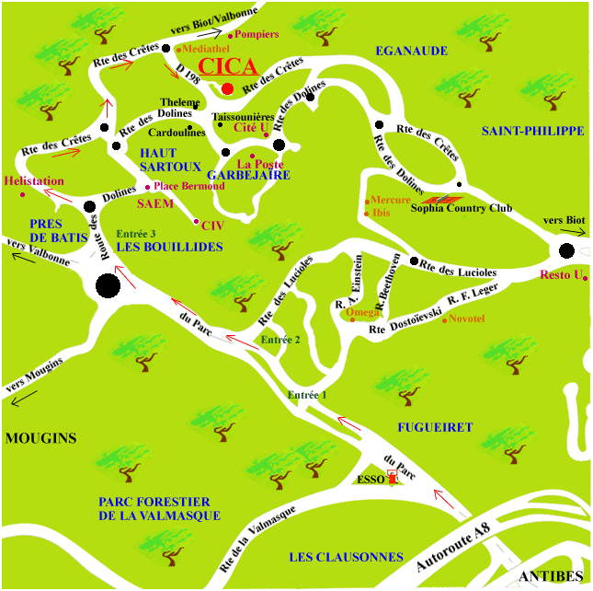

DHCP: Dynamic Host Control Protocol (rfc1531 and rfc1541)
If you not have an account please go to Error! Bookmark not defined. or ask for a registration form to the helpdesk.
POP3: Post Office Protocol
IMAP: Internet Mail Access Protocol
DNS: Domain Name Server

