3GPP TSG-T2 #7 / ETSI SMG4  Ystad, SWEDEN, 22-26 November 1999 | TSGT2#7(99)984

Agenda Item:

Source: Ericsson, Nokia

Title: Implementing MMS Stage 2 Using Wireless Application Protocol

Document for: Discussion

ABBREVIATIONS
MIME Multipurpose Internet Mail Extensions
MM Multimedia Message
MMI Multimedia Message Indication
MMS Multimedia Messaging Service
PDU Protocol Data Unit
SMIL Syncronized Multimedia Integration Language
WAP Wireless Application Protocol
WSP WAP Session Protocol

Introduction
This paper introduces how multimedia messaging service (MMS) described in MMS Stage 1 (22.140) and MMS Stage 2 (23.140) [1] can be implemented using Wireless Application Protocol [2] (WAP). The WAP reflects the current Internet era on the mobile market and due to similarities in the structure of the multimedia message the compatibility and interworking with existing Internet can be ensured.
The WAP protocols and data formats have been optimised to mobile environment and due to its efficiency in using the limited bandwith over the air interface it can be available both in high-end (e.g., MExE classmark 2 terminals) and low-end terminals (WAP terminals) and in 2G (e.g, GSM, TDMA, CDMA) and 3G networks with various of existing and future bearers.
This document describes only the solution for the communication of MMS Relay and the terminal. It does not describe protocols between MMS Relay and MMS Server. It also does not describe protocols between MMS servers and/or relays. The WAP Gateway is part of the MMS Relay.
There is almost direct mapping of the WAP session protocol and the needed MMS operations. Thus, most of the specification activities are related to the message formats and MMS presentation.

MMS Session
This paper presents the overview of the use of WAP WSP connection-oriented session whenever there is a need for connection-oriented communication. These cases include delivery of multimedia message, retrieval of multimedia message, MMS query, user profile settings etc.
The Figure 1 presents the operation of the WAP session. First, there is the connection establishment phase. In this phase, the capability negotiation is done. After the connection (as well as in parallel) a method is invoked in a server which allows, in the case of MMS, the delivery and retrieval of the user data. The POST method is used to deliver data and the GET method is used to retrieve data. The server responds the method invocation by either delivering the requested data or responding to a delivered data.
The method invocation may be done multiple times asynchronously, based on the application protocol model. The Figure 2 presents the disconnection of the session. This model is adopted directly from the HTTP/1.1 specifications in [4].
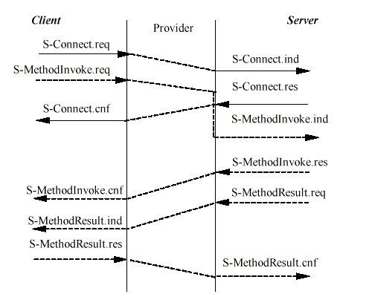
Figure 1. The establishment and use of WAP session [3].
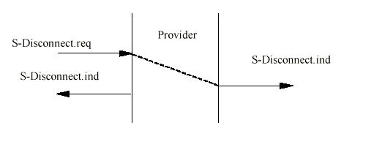
Figure 2. The disconnection of WAP session [3].

MMS CAPABILITY NEGOTIATION
The capability negotiation between the terminal and the server is done while the WAP session is being established, relying on the WAP UAProf mechanism [7]. Basically, the terminal indicates the supported MIME types and the maximum message size it supports.
The server does not deliver those media objects that are not supported by the terminal.

pROTOCOL OPERATIONS

MMS Origination
The multimedia messaging delivery is done by invoking the POST-method in the server over the connection-oriented WAP. The user data contains the multimedia message. The status in the reply PDU within the response indicates whether the delivery of the message is successful, or there was some failure, for instance, addressing problem.
The error cases in a WAP session are handled by the WSP itself. A session failure indicates an undelivered (and not charged) message.

MMS Push Delivery
The push delivery of the multimedia message is two-phased. First, a multimedia message indication (MMI) is delivered to the mobile. This is realised with the WAP Push technique which allows the server to push content to the client. The data in the push does not, however, contain the message itself, but some preliminary information of the message (size, media types of the multimedia objects etc).
In Figures 2 and 3 there are the arrow-diagrams of the non-confirmed and confirmed push mechanisms. By selecting SMS in a GSM network as a WAP push bearer, the problems in terminal reachability can be easily solved without accessing HLR.
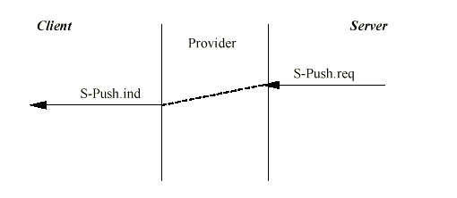
When the terminal receives the MMI, it automatically retrieves the multimedia message, based on its capabilities. In this retrieval, the GET method is invoked in the server over a connection-oriented WAP session.
Figure 2. The non-confirmed data push [3].
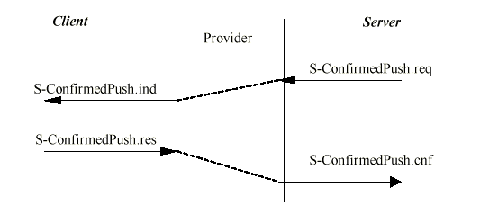
Figure 3. The confirmed data push [3].

MMS Query
The MMS query operation is used to retrieve information of the existing multimedia messages in the server. The query operation retrieves all the multimedia message indications (MMIs) from the server and then allows the user to retrieve the messages.
The MMS query operation uses GET method over connection-oriented WAP session. In the reply, there are one or more multimedia message indications.

MMS Pull Delivery
The MMS pull delivery combines the MMS query and the MMS push delivery so that there is no automatic delivery of multimedia message indications to the mobile. Instead, the user has always to do the MMS query first and then retrieve the messages.

MMS Delivery Report
The MMS delivery report is a report to the sender of the multimedia message indicating the status of the reception. Typical statuses could be: received, rejected, expired, etc.
Technically, the MMS delivery report is realised using connectionless Push and SMS as push bearer.

MMS User Profile Management
The user profile management is done using POST method over connection-oriented WAP session. A set of PDUs needs to be defined for the operations.

MMS Message Contents

MMS Message Encapsulation
The MIME multipart technique is standard Internet technique to combine the email body and the attachments together. The WAP has a binary equivalent to this, named application/wap.vnd.multipart which can be used to the combine multimedia objects in the multimedia messages together.
The use of the WAP binary multipart structure allows easy conversion between binary format and the Internet MIME multipart. In addition, the binary format allows efficient handling of the message especially in cases when some multimedia objects must be taken out of the structure.
In the multipart structure each multimedia object is a single part. In addition, the MMS presentation information is also found in one or more parts.
The MMS –related headers are either one part in the multipart or in WSP headers using application specific codepage technique.

Other messages
The other messages for which PDUs needs to be defined include multimedia message indications, delivery reports, MMS query and the profile management. The multimedia messaging indications could use the basic functionality from the WAP Service Indication model [6].

MMS Multimedia Formats
In order to guarantee a minimum support and compatibility between multimedia terminals, there should be some multimedia formats to be agreed.
Minimum set of supported formats could be for example text and:
- Baseline JPEG (Joint Photographic Expert Group)
Internet Media Type (mime): image/jpeg
- GIF 87, GIF 89a (Graphics Interchange Format)
Internet Media Type (mime): image/gif
In addition to these, some recommendations to the image sizes may be required to ensure bandwith efficiency.

MMS Presentation
The concept of MMS presentation means the layout, sequencing and timing of multimedia objects on the terminal screen and other devices such as speaker. The layout technique should be future-proof since the future terminals will have more advanced display and sound capabilities than today. In the future, there may be full multimedia slide-shows available for the terminal.
The Synchronised Multimedia Integration Language (SMIL) [5] is a well-known W3C effort for synchronised multimedia. It provides the necessary layout, sequencing and timing tools for the multimedia presentations. Figure 4 presents an example of SMIL having a single image and text parts.
For WAP transfer, a binary encoding for SMIL needs to be defined.
<smil>
<head>
<layout>
<root-layout width="160" height="160"/>
<region id="up" width="160" height="20" left="0" top="10"/>
<region id="center" width="160" height="120" left="0" top="40"/>
</layout>
</head>
<body>
<img src="image.jpg" region="center"/>
<text src="image.txt" region="up"/>
</body>
</smil>

Figure 4. Example of SMIL.

CONCLUSIONS
This paper summarises how the current MMS Stage 2 can be implemented using WAP. It shows that there is direct mapping between WAP session and the needed MMS operations. The server-originated operations are realised using WAP push.
The message encoding and the compatibility between Internet can be easily managed using WAP binary multipart encoding.
The W3C SMIL provides a flexible, future-proof presentation technique for the multimedia messages. Using SMIL, the multimedia messages can be extended to real multimedia presentations.
REFERENCES

[1] 3GPP 23.140: Multimedia Messaging Service Stage 2
[2] "Wireless Application Environment Specification", WAP Forum, April 30th, 1998. URL: http://www.wapforum.org/
[3] "Wireless Session Protocol", WAP Forum, April 30, 1998. URL: http://www.wapforum.org/
[4] "Hypertext Transfer Protocol - HTTP/1.1", R. Fielding, et al., January 1997. URL:ftp://ftp.isi.edu/in-notes/rfc2068.txt
[5] Synchronized Multimedia Integration Language (SMIL) 1.0 Specification - http://www.w3.org/TR/1998/REC-smil-19980615/
[6] "Service Indication", WAP Forum, November 8th, 1999. URL: http://www.wapforum.org
[7] User Agent Profile", WAP Forum, November 10th, 1999. URL: http://www.wapforum.org

