3GPP TSG-T1 E-Mail 2004 Tdoc T1s040035
01 Jan - 31 Dec 2004

CR-Form-v7
CHANGE REQUEST
 | TS 34.123-3 | CR | - |  rev | - |  Current version: | 3.4.0 | 
For HELP on using this form, see bottom of this page or look at the pop-up text over the  symbols.

Proposed change affects:  | UICC apps |  | ME |  | Radio Access Network |  | Core Network

Title:  | Addition of RAB test case 14.2.29 to RAB ATS V3.4.0
Source:  | Rohde & Schwarz
Work item code:  | N/A |  |  |  |  |  |  | Date:  |  | 16/02/2004
Category:  | B |  |  |  |  |  |  | Release:  |  | R99
 | Use one of the following categories:  F (correction)  A (corresponds to a correction in an earlier release)  B (addition of feature),  C (functional modification of feature)  D (editorial modification)  Detailed explanations of the above categories can  be found in 3GPP TR 21.900. |  |  |  |  |  |  |  | Use one of the following releases:  2 (GSM Phase 2)  R96 (Release 1996)  R97 (Release 1997)  R98 (Release 1998)  R99 (Release 1999)  Rel-4 (Release 4)  Rel-5 (Release 5)  Rel-6 (Release 6)
Reason for change:  |  | To add verified GCF package 2 RAB test case 14.2.29 to the approved RAB ATS V3.4.0
Summary of change:  |  | This document lists all changes applied to test case 14.2.29 required for approval.  See detailed change description for further information.
Consequences if   not approved: |  | Test case will not be added to ATS
Clauses affected:  |  | N/A
 |  | Y | N
Other specs  |  |  | X | Other core specifications 
affected: |  |  | X | Test specifications
 |  |  | X | O&M Specifications
Other comments: 

How to create CRs using this form:
Comprehensive information and tips about how to create CRs can be found at http://www.3gpp.org/specs/CR.htm. Below is a brief summary:
1) Fill out the above form. The symbols above marked  contain pop-up help information about the field that they are closest to.
2) Obtain the latest version for the release of the specification to which the change is proposed. Use the MS Word "revision marks" feature (also known as "track changes") when making the changes. All 3GPP specifications can be downloaded from the 3GPP server under ftp://ftp.3gpp.org/specs/ For the latest version, look for the directory name with the latest date e.g. 2001-03 contains the specifications resulting from the March 2001 TSG meetings.
3) With "track changes" disabled, paste the entire CR form (use CTRL-A to select it) into the specification just in front of the clause containing the first piece of changed text. Delete those parts of the specification which are not relevant to the change request.
3GPP TSG-T1 E-Mail 2004 T1s040035
01 Jan - 31 Dec 2004

Title: Changes to test case 14.2.29 required for approval
Source: Rohde & Schwarz
Agenda Item: TTCN Issues
Document for: Approval
Contact: Thomas Moosburger
thomas.moosburger@rsd.rohde-schwarz.com
Tel. +49 89 4129 11731

Overview
This document lists all the changes needed to correct problems in the TTCN implementation of test case 14.2.29 which is part of the RAB test suite. Only essential changes to the TTCN are applied and documented in section 4.
With these changes applied the test case can be demonstrated to run with one or more 3G UEs
(see section 6). Execution log files are provided as evidence.

Table of Contents
1 Overview 1
2 Table of Contents 1
3 Verification Test Summary 2
4 Corrections required for test case 14.2.29 2
4.1 Introduction 2
4.2 ts_SS_2DCH_ModifyInteractBackg_64k_144kPS (WA#RAB4054) 2
4.3 ts_SS_2DCH_ModifyInteractBackg_64k_144kPS (WA#RAB4055) 3
4.4 c_TrLogMappingDL_2_PS (WA#RAB4040) 4
4.5 c_TFCS_Cmpl0_To9_Rx (WA#RAB4104) 5
4.6 c_DL_AddReconfTransChInfoListAM_3_4k (WA#RAB4043) 7
4.7 ts_SendRB_SetUpDCH_64k_144kPS (WA#RAB4057) 8
4.8 ts_SendRB_SetUpDCH_64k_144kPS (WA#RAB4255 8
4.9 cb_RAB_InfoListAM1_No_Pdcp (WA#RAB4256) 9
4.10 c_RLC_InfoAM_Def_PS (WA#RAB4253) 10
4.11 cb_UL_AM_RLC_rst4_tp200 (WA#RAB4252) 10
4.12 ts_RB_SubTest_RB20_AM (WA#RAB4214) 11
4.13 c_DL_InformationPerRL (WA#RAB4090) 12
5 Branches executed in test case 14.2.29 14
6 Execution Log Files 14
6.1 Nokia 3G UE 7600 14
6.2 Ericsson 3G UE U100 14
7 References 14

Verification Test Summary
Test Case: TC_14_2_29
Test Group: RAB/CombinationOnDPCH/Interactive_Background/
ATS Version: iWD-TVB2003-03_D04wk04 + essential modifications
System Simulator used: Rohde & Schwarz 3G system simulator CRTU-W
UE used: Nokia 7600 & Ericsson U100
Verification Status: PASS

Corrections required for test case 14.2.29

Introduction
This section describes the changes required to make test case 14.2.29 run correctly with a 3G UE. All modifications are marked with label “WA#RAB<number>” for RAB related changes in the TTCN comments column of the enclosed ATS [1].
The ATS version used as basis was RAB_wk04.mp which is part of the iWD-TVB2003-03_D04wk04 release. This is the most recent ATS provided by MCC160 which contains GCF package 1, 2, 3 and 4 test cases.
The enclosed ATS [1] contains a number of additional changes (see list below) in common test steps which are required for other tests, but which are not applicable to test case 14.2.29:

WA#RAB4021, WA#RAB4030, WA#RAB4031, WA#RAB4058, WA#RAB4059, WA#RAB4060, WA#RAB4068, WA#RAB4091, WA#RAB4092, WA#RAB4093, WA#RAB4095, WA#RAB4098, WA#RAB4100, WA#RAB4101, WA#RAB4102, WA#RAB4103, WA#RAB4105, WA#RAB4178, WA#RAB4179, WA#RAB4190, WA#RAB4206, WA#RAB4208, WA#RAB4209, WA#RAB4210, WA#RAB4211, WA#RAB4212, WA#RAB4251, WA#RAB4254 WA#RAB4257 and WA#RAB4258.

ts_SS_2DCH_ModifyInteractBackg_64k_144kPS (WA#RAB4054)
Test step name | ts_SS_2DCH_ModifyInteractBackg_64k_144kPS
Reason for change | TTCN error, order REQ-CNF wrong.
Summary of change | Corrected order (request before that the correspondent request).
Source of change | New Change
Label | WA#RAB4054

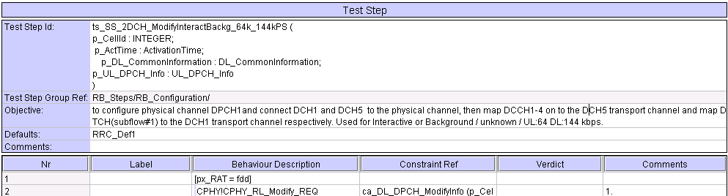
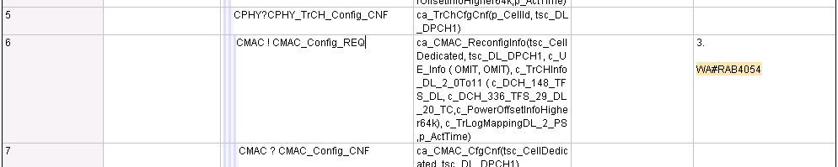
MCC160 >> Accepted

ts_SS_2DCH_ModifyInteractBackg_64k_144kPS (WA#RAB4055)
Test step name | ts_SS_2DCH_ModifyInteractBackg_64k_144kPS
Reason for change | TTCN error: wrong channel id used.
Summary of change | used tsc_DL_DPCH1  instead of tsc_UL_DPCH1.
Source of change | New Change
Label | WA#RAB4055

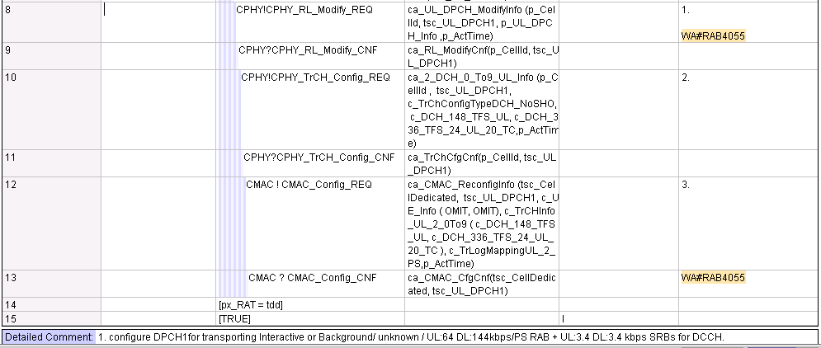
MCC160 >> Accepted in princlpe;In Row 8 TTCN already correct;In Row 15 used tsc_UL_DPCH1 instead of tsc_DL_DPCH1 (NOT tsc_DL_DPCH1 instead of tsc_UL_DPCH1)

c_TrLogMappingDL_2_PS (WA#RAB4040)
Test step name | ts_SendRB_SetUpDCH_64k_128kPS
Reason for change | Order for RBs in constraint leads to Radio Bearer Set Up procedure failure. The order is related with the defined TFCS. RB20 must be first.
Summary of change | Changed order: RB20 first.
Source of change | New Change
Label | WA#RAB4040

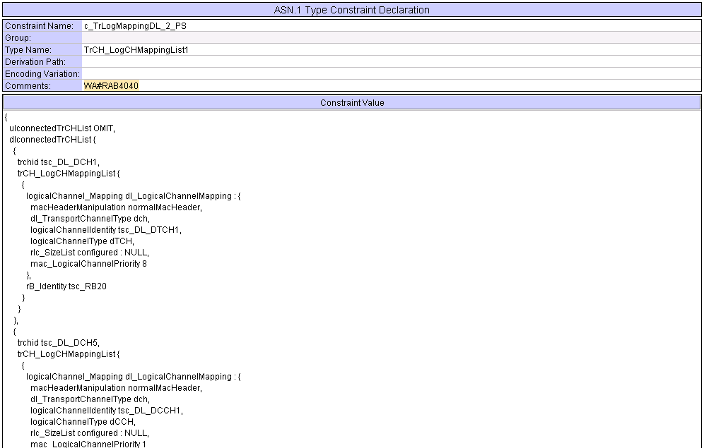
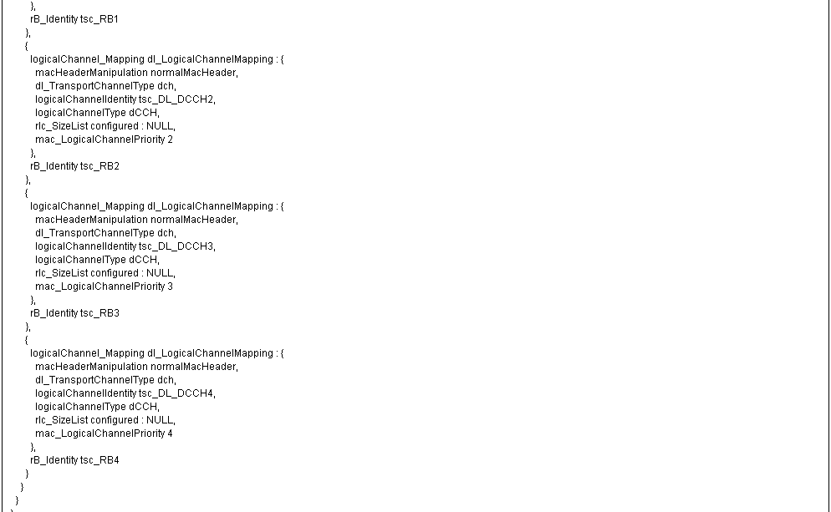
MCC160 >> Accepted

c_TFCS_Cmpl0_To9_Rx (WA#RAB4104)
Test step name | c_TFCS_Cmpl0_To9_Rx
Reason for change | Wrong CTFC ( cftc 6 bits) used in constraint leads to a failure in the Radio Bearer Set Up procedure.
Summary of change | Used CTFC set to 4 instead of 6.
Source of change | New Change
Label | WA#RAB4104

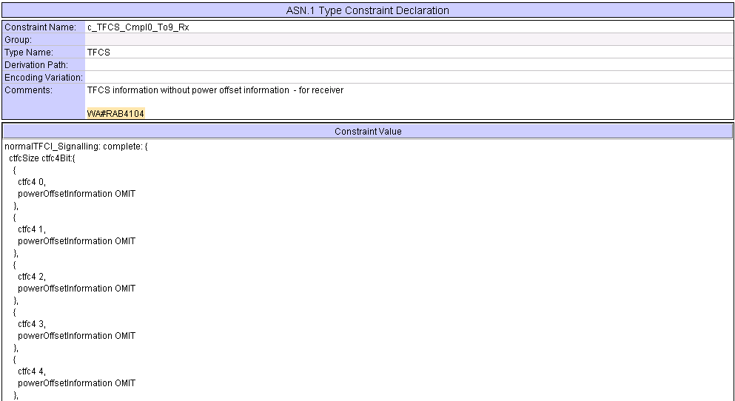
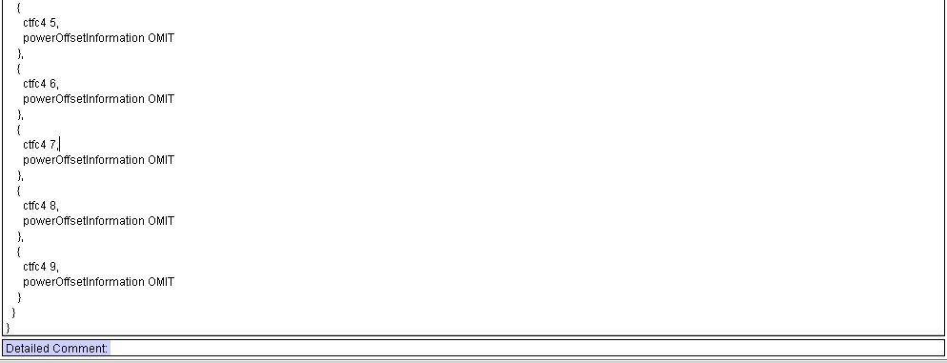
MCC160 >> Accepted

c_DL_AddReconfTransChInfoListAM_3_4k (WA#RAB4043)
Test step name | c_DL_AddReconfTransChInfoListAM_3_4k
Reason for change | Wrong parameter used when setting up RAB20: according to the default configuration for the “ Added or Reconfigured DL TrCH information” IE is “ Same as UL ” for tsc_DL_DCH5.
Summary of change | used c_DL_AddReconfTransChInfo ( tsc_DL_DCH5, tsc_UL_DCH5 ) intead of {  dl_TransportChannelType dch,  dl_transportChannelIdentity tsc_DL_DCH5,  tfs_SignallingMode explicit_config : dedicatedTransChTFS : c_DCH_148_TFS_UE_DL,  dch_QualityTarget { bler_QualityValue -20 },  dummy OMIT  }
Source of change | New Change
Label | WA#RAB4043

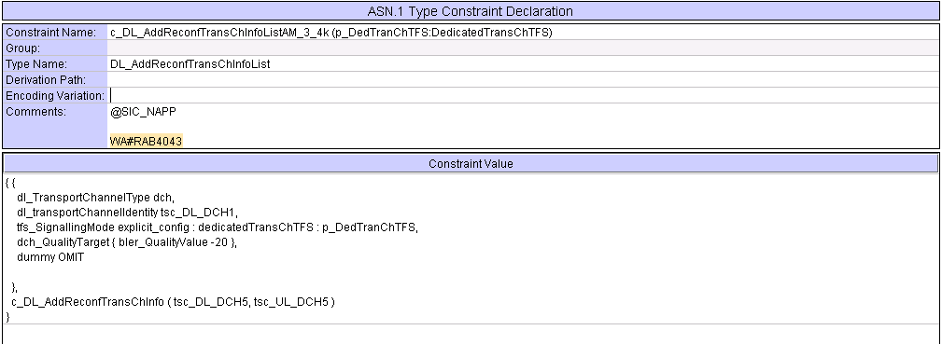
MCC160 >> Accepted

ts_SendRB_SetUpDCH_64k_144kPS (WA#RAB4057)
Test step name | ts_SendRB_SetUpDCH_64k_144kPS
Reason for change | Wrong parameters in RAB Set Up message leads to a misconfiguration. Values must be the default ones defined in TS 34.108.
Summary of change | Used c_UL_CommTrChInfoDCH_PS_64k instead of "c_UL_CommTrChInfo_AM0To9(c_PowerOffsetInfoHigher64k)" and  c_UL_AddReconfTransChInfoListDCH_PS_64k instead of c_UL_AddReconfTransChInfoListAM1 (c_DCH_336_TFS_24_UL_20_TC_UE)
Source of change | New Change
Label | WA#RAB4057

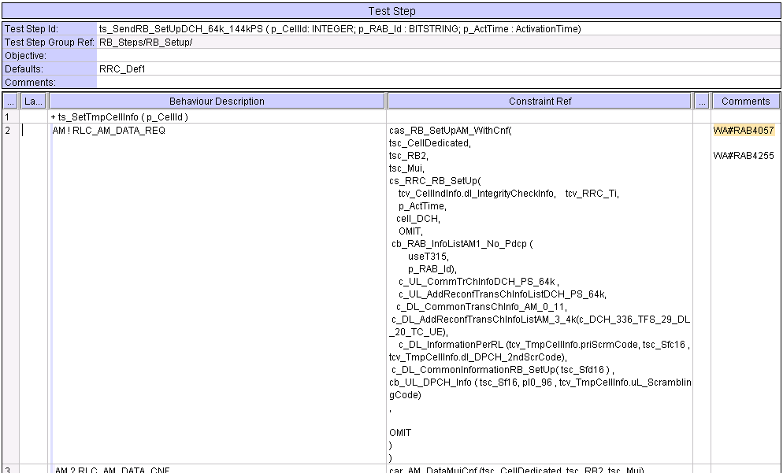
MCC160 >> Rejected, as not a necessary change. Even though they are different constraints both of them have same contents, hence the change is not needed. c_TFCS_Cmpl0_To9_Tx will be changed to use 4 bit CTFC based on T1s-040033.

ts_SendRB_SetUpDCH_64k_144kPS (WA#RAB4255
Test step name | ts_SendRB_SetUpDCH_64k_144kPS
Reason for change | Wrong value for “re-EstablishmentTimer” according to the default values (TS 34.108). Should be used T315 (PS), not T314.
Summary of change | Used “useT315” instead of “c_ReEstTimerT314”
Source of change | New Change
Label | WA#RAB4255

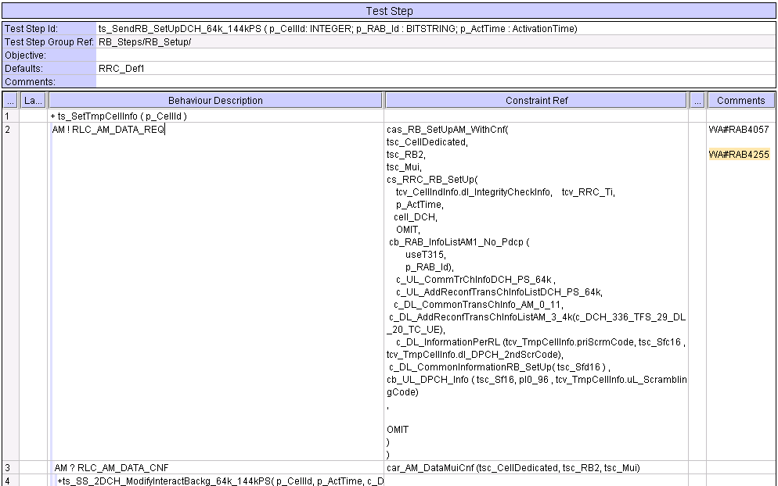
MCC160 >> Accepted

cb_RAB_InfoListAM1_No_Pdcp (WA#RAB4256)
Test step name | cb_RAB_InfoListAM1_No_Pdcp
Reason for change | Wrong value for “max-RST” and “timerPoll” according to the default values (TS 34.108). Should be used for max-RST rst4 (instead of e rst1) and for timerPoll tp200 (instead of tp400).
Summary of change | Used new constraint “c_RLC_InfoAM_Def_PS” containing the correct default values (WA#RAB4253) instead of “c_RLC_InfoAM_Def”
Source of change | New Change
Label | WA#RAB4256

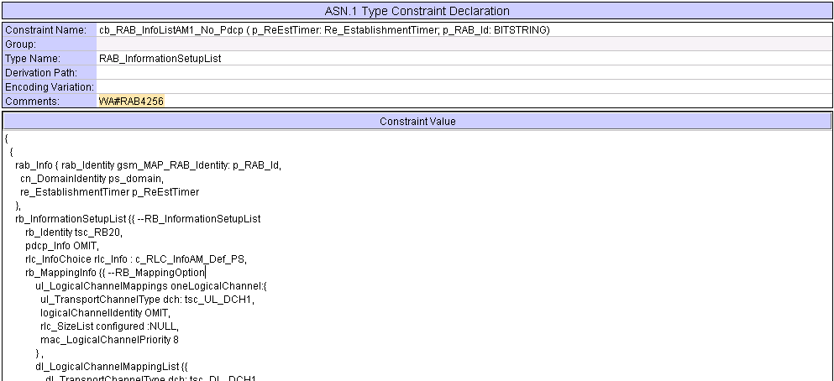
MCC160 >> Accepted

c_RLC_InfoAM_Def_PS (WA#RAB4253)
Test step name | c_RLC_InfoAM_Def_PS
Reason for change | In order to implementate a WA#RAB4254 a new constraint is needed.
Summary of change | Created a new constraint “c_RLC_InfoAM_Def_PS” (based in “c_RLC_InfoAM_Def”) containing the correct default values for “max-RST” and “timerPoll”.  This constraint introduces another new constraint with the commented values for AM mode: “cb_UL_AM_RLC_rst4_tp200” (see WA#RAB4252).
Source of change | New Change
Label | WA#RAB4253

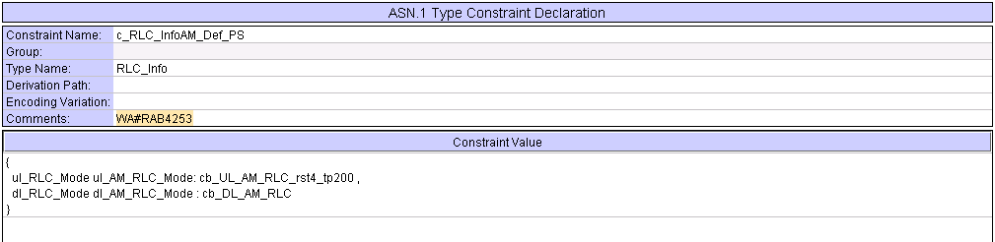
MCC160 >> Accepted

cb_UL_AM_RLC_rst4_tp200 (WA#RAB4252)
Test step name | cb_UL_AM_RLC_rst4_tp200
Reason for change | In order to implementate a WA#RAB4253 a new constraint is needed.
Summary of change | Created a new constraint “cb_UL_AM_RLC_rst4_tp200” (based in “cb_UL_AM_RLC_rst4_tp200” ) containing the correct default values for “max-RST” and “timerPoll” for this configuration.
Source of change | New Change
Label | WA#RAB4252

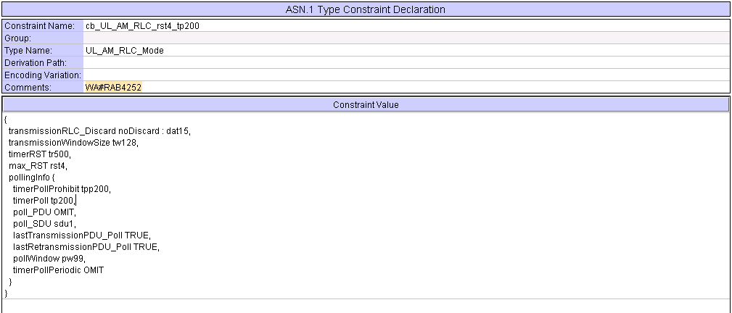
MCC160 >> Accepted

ts_RB_SubTest_RB20_AM (WA#RAB4214)
Test step name | ts_RB_SubTest_RB20_AM
Reason for change | All bit strings need to be initialised every time they are used. As this test step is used more than one time in one single execution (if both pc_Interactive and pc_Background are enable), variables tcv_RB_testdata2 and tcv_RB_testdata3 need to initialised in this test step.
Summary of change | Added in the initialiation list in line 1 of local test step It_Receive, the variables tcv_RB_testdata2 :=''B,  tcv_RB_testdata3 :=''B
Source of change | New Change
Label | WA#RAB4214

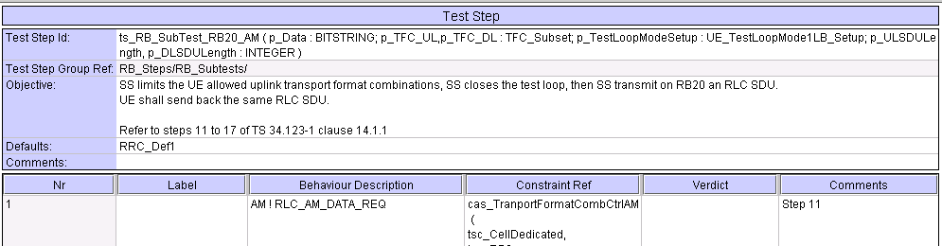
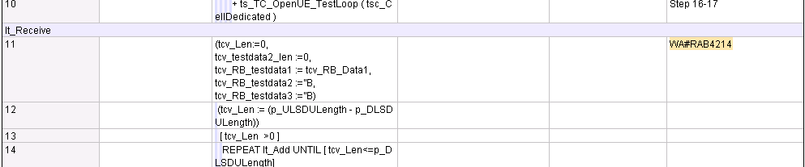
MCC160 >> Accepted

c_DL_InformationPerRL (WA#RAB4090)
Test step name | c_DL_InformationPerRL
Reason for change | According to the default contents in 34.108 “scramblingCodeChange” should be set as “noCodeChange”.
Summary of change | Used “noCodeChange” instead of OMIT for IE “scramblingCodeChange”.
Source of change | New Change
Label | WA#RAB4090

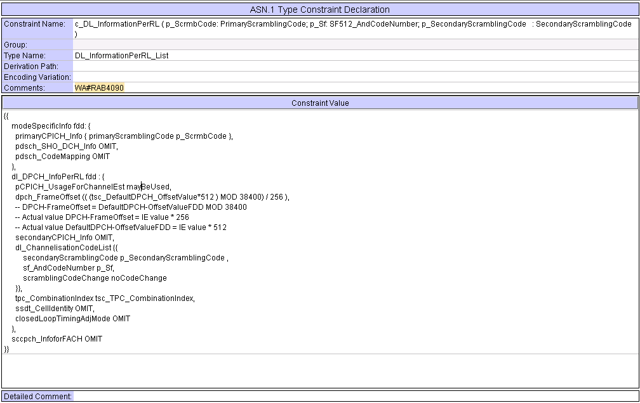
MCC160 >> The IE scramblingCodeChange makes sense only in Compressed mode with SF/2 method is used. This is not the case here, hence as per 25.331 clause 10.3.6.21, Omitting it as in TTCN makes more sense. Hence may be it is more suitable to change the 34.108, for this.

Branches executed in test case 14.2.29
The test case implementation executed the PS branch for NMO_I, UE_OpMode A with Integrity activated, Ciphering disabled, AutoAttach off.

Execution Log Files

Nokia 3G UE 7600
The Nokia 7600 passed this test case on Rohde & Schwarz 3G System Simulator CRTU-W. The documentation below is enclosed as evidence of the successful test case run [1]:
- Execution log files 14_2_29_PS-Nokia-Logs\Index.html
This execution log files in HTML format show the dynamic behaviour of the test in a tabular view and in message sequence chart (MSC) view. All message contents are fully decoded and listed in hexadecimal format. Preliminary verdicts and the final test case verdict are listed in the log file.
- PICS/PIXIT file 14_2_29-pics-pixit-Nokia.html
Text file containing all PICS/PIXIT parameters used for testing.

Ericsson 3G UE U100
The Ericsson U100 passed this test case on Rohde & Schwarz 3G System Simulator CRTU-W. The documentation below is enclosed as evidence of the successful test case run [1]:
- Execution log files 14_2_29_PS-Ericsson-Logs\Index.html
This execution log files in HTML format show the dynamic behaviour of the test in a tabular view and in message sequence chart (MSC) view. All message contents are fully decoded and listed in hexadecimal format. Preliminary verdicts and the final test case verdict are listed in the log file.
- PICS/PIXIT file 14_2_29-pics-pixit-Ericsson.html
Text file containing all PICS/PIXIT parameters used for testing.

References
[1] | T1s040036  This archive comprises HTML Execution log files, PICS/PIXIT files and the TTCN MP file

