3GPP TR 33.935 V0.3.0 (2020-05)
Technical Report
3rd Generation Partnership Project;
Technical Specification Group Services and System Aspects;
Security Aspects;
Technical report on detailed Long Term Key Update Solutions;
(Release 16)



The present document has been developed within the 3rd Generation Partnership Project (3GPP TM) and may be further elaborated for the purposes of 3GPP.
The present document has not been subject to any approval process by the 3GPP Organizational Partners and shall not be implemented.
This Report is provided for future development work within 3GPP only. The Organizational Partners accept no liability for any use of this Specification.
Specifications and Reports for implementation of the 3GPP TM system should be obtained via the 3GPP Organizational Partners' Publications Offices.

Keywords
<keyword[, keyword]>

3GPP
Postal address

3GPP support office address
650 Route des Lucioles - Sophia Antipolis
Valbonne - FRANCE
Tel.: +33 4 92 94 42 00 Fax: +33 4 93 65 47 16
Internet
http://www.3gpp.org
Copyright Notification
No part may be reproduced except as authorized by written permission.
The copyright and the foregoing restriction extend to reproduction in all media.

© 2019, 3GPP Organizational Partners (ARIB, ATIS, CCSA, ETSI, TSDSI, TTA, TTC).
All rights reserved.

UMTS™ is a Trade Mark of ETSI registered for the benefit of its members
3GPP™ is a Trade Mark of ETSI registered for the benefit of its Members and of the 3GPP Organizational Partners
LTE™ is a Trade Mark of ETSI registered for the benefit of its Members and of the 3GPP Organizational Partners
GSM® and the GSM logo are registered and owned by the GSM Association
Contents
Foreword 4
Introduction 4
1 Scope 5
2 References 5
3 Definitions, symbols and abbreviations 5
3.1 Definitions 5
3.2 Symbols 5
3.3 Abbreviations 5
4 LTKUP solutions 6
4.1 Overview 6
4.2 Solution 4b - Diffe-Hellman based Key agreement over SIM OTA 6
4.2.1 Solution Overview 6
4.2.2 Architecture overview 6
4.2.3 Implementation Recommendations 6
4.2.4 Example implementation 7
4.3 Solution 5 - Multiple sets of parameters on the USIM 7
4.3.1 Solution Overview 7
4.3.2 Solution Description 7
4.3.2.1 UICC in personalisation centre 7
4.3.2.2 UICC in the field 7
Annex <A>: Change history 10

Foreword
This Technical Report has been produced by the 3rd Generation Partnership Project (3GPP).
The contents of the present document are subject to continuing work within the TSG and may change following formal TSG approval. Should the TSG modify the contents of the present document, it will be re-released by the TSG with an identifying change of release date and an increase in version number as follows:
Version x.y.z
where:
x the first digit:
1 presented to TSG for information;
2 presented to TSG for approval;
3 or greater indicates TSG approved document under change control.
y the second digit is incremented for all changes of substance, i.e. technical enhancements, corrections, updates, etc.
z the third digit is incremented when editorial only changes have been incorporated in the document.

Introduction
Editor's note: Content to be added (or section removed)

1 Scope
The present document describes LTKUP solution 4b and LTKUP solution 5 from 3GPP TR 33.834 [2] in implementable detail.

2 References
The following documents contain provisions which, through reference in this text, constitute provisions of the present document.
- References are either specific (identified by date of publication, edition number, version number, etc.) or non-specific.
- For a specific reference, subsequent revisions do not apply.
- For a non-specific reference, the latest version applies. In the case of a reference to a 3GPP document (including a GSM document), a non-specific reference implicitly refers to the latest version of that document in the same Release as the present document.
[1] 3GPP TR 21.905: "Vocabulary for 3GPP Specifications".
[2] 3GPP TR 33.834: "Security Aspects; Study on Long Term Key Update Procedures (LTKUP)"
[3] 3GPP TS 31.115: "Secured packet structure for (Universal) Subscriber Identity Module (U)SIM Toolkit applications"
[4] 3GPP TS 31.116: "Remote APDU Structure for (U)SIM Toolkit applications"
[5] 3GPP TS 33.220: "Generic Authentication Architecture (GAA); Generic Bootstrapping Architecture (GBA)"

3 Definitions, symbols and abbreviations

3.1 Definitions
For the purposes of the present document, the terms and definitions given in 3GPP TR 21.905 [1] and the following apply. A term defined in the present document takes precedence over the definition of the same term, if any, in 3GPP TR 21.905 [1].
example: text used to clarify abstract rules by applying them literally.

3.2 Symbols
For the purposes of the present document, the following symbols apply:
<symbol> <Explanation>

3.3 Abbreviations
For the purposes of the present document, the abbreviations given in 3GPP TR 21.905 [1] and the following apply. An abbreviation defined in the present document takes precedence over the definition of the same abbreviation, if any, in 3GPP TR 21.905 [1].
LTKUP Long Term Key Update Procedure

4 LTKUP solutions

4.1 Overview
3GPP TR 33.834 [2] recommends the production of detailed implementation for:
- Solution 4b - Diffe-Hellman based key agreement over SIM OTA
- Solution 5 - multiple sets of parameters on the USIM.
Both solutions meet all of the key issues identified in TR 33.834 [2]:
- Key Issue 1: individual subscription - K exposed
- Key Issue 2: batch of subscriptions - K exposed
- Key Issue 3: LTK Derivation vs. LTK Transport
- Key Issue 4: Loss of synchronisation of long term keys
- Key Issue 5: undetected leakage of K
Both solutions can be implemented in GSM, UMTS, LTE and 5G and both require SIM/USIM changes and Home network HSS/AuC/UDM changes.

4.2 Solution 4b - Diffe-Hellman based Key agreement over SIM OTA

4.2.1 Solution Overview
This solution involves a key exchange protocol being run between the USIM/ISIM and the home network HSS, in order to create a newly agreed Ki value to replace the existing one. This key agreement protocol is transported over USIM OTA (TS 31.115 [3] and TS 31.116 [4]).

4.2.2 Architecture overview
The Architecture consists of a HSS / UDM, and OTA server and the USIM/UICC.

HSS
with
LTKUP service

OTA
Server

USIM/UICC

The HSS to OTA interface is proprietary.
The OTA server interface to the USIM/UICC is as specified in 3GPP TS 31.115[3] and 3GPP TS 31.116 [4]

4.2.3 Implementation Recommendations
Elliptic Curve Diffie Hellman is recommended as a suitable key exchange algorithm.
Exposing the HSS to update introduces risks, and so should be handled with great care. It is possible to run the key exchange protocol with a proxy for the HSS rather than with the HSS directly.
It is recommended that the update protocol take place over 3GPP-standardised signalling, rather than over the internet; and it is also recommended that the HSS, rather than the USIM/ISIM, be the entity to trigger the update protocol. With these two points in mind, it is recommended for simplicity that the update protocol be carried out by the HSS directly, rather than by a proxy.
In this solution, the key exchange protocol is authenticated using the pre-existing shared secret, so that an attacker who does not already know the secret cannot act as man-in-the-middle at all. An attacker who does already know the secret is able to act as man-in-the-middle during the key exchange protocol; however, a good protocol design can ensure that this attacker will have to remain as an active man-in-the-middle, essentially forever, in order to exploit that.
Using a key exchange protocol raises a risk that this protocol itself might be compromised over the lifetime of next generation systems (perhaps using quantum computers), and allow newly-exchanged keys to be recovered by an attacker. One counter-measure is that where parties to the protocol already have a shared secret (e.g. the USIM/ISIM and HSS already share Ki), then this existing shared secret is fed into the new key derivation function, together with the output from the key exchange protocol. That way, an attacker would have to know the existing shared secret and compromise the key exchange to learn the newly derived secret. A suitable key derivation algorithm can use HMAC-SHA256, as defined in 3GPP TS 33.220 [5], as follows:
new Ki = KDF (key exchange protocol output, initial Ki)
where "key exchange protocol output" refers to the shared secret resulting from the key exchange protocol, and "initial Ki" refers to the Ki value that was shared between the USIM/ISIM and the HSS before the protocol was run, and that was used to authenticate the key exchange.

4.2.4 Example implementation

4.2.4.1 OTA Transport
The LTKUP messages are securely transported to and from the USIM using APDUs within SIM OTA messages (see TS 31.115 [3]).
The APDUs are FFS.

4.2.4.2 LTKUP Message Flow
The LTKUP service is delivered using a Diffie-Hellman key agreement process as follows:
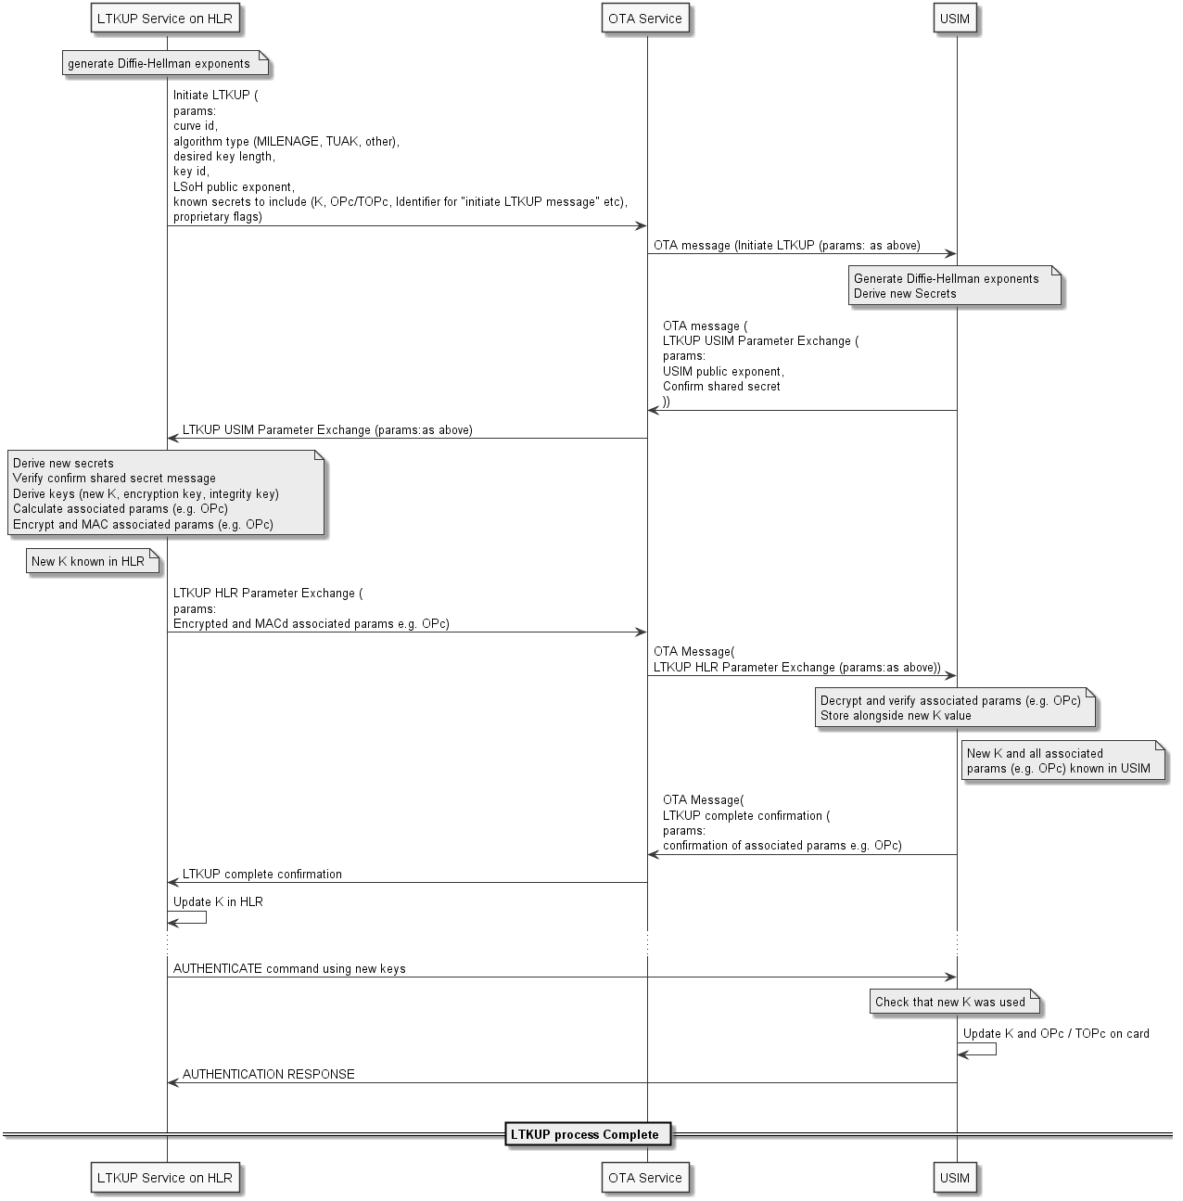Editor's note: This clause details an implementation of this solution.

Figure 4.2.4.2-1 - LTKUP key agreement process diagram

Initiate LTKUP
parameters:

curve/ECIES profile id:
Length:1
Values:0-5 + proprietary/reserved

algorithm type:
Length:1
Values: MILENAGE, TUAK, other

desired key length:
Length:1
Values:16, 32

key id:
Length:1
Values:0-127

LSoH public exponent:
Length:32, 48 (or 64)
Values: Random

known secrets to include:
Length:4
Values: Identifiers for K, OPc/TOPc, "initiate LTKUP message", others

proprietary flags:
Length:Any
Values: Any

LTKUP USIM Parameter Exchange
parameters:

USIM public exponent
Length:32, 48 (or 64)
Values:Random

Confirm shared secret
Length: 8
Values: Random

LTKUP HLR Parameter Exchange
parameters:

Encrypted Associated Params
Length:16 for OPc, 32 for TOPc, Any for Other
Values:Random

MAC-tag for Encrypted Associated Params
Length: 8
Values: Random

LTKUP Complete Confirmation
parameters:

Confirm Associated Params
Length: 8
Values:Random
The "confirm" messages from the USIM are best done by MACing all the parameters to be confirmed, using an integrity key derived from the shared secret. TBC: whether it is acceptable to use the same integrity key that was already derived for use in the "HLR Parameter Exchange" message (with some additional flags like a message id included as part of the data to be MACed), or whether it is better to derive an additional key just for the USIM confirmation

4.3 Solution 5 - Multiple sets of parameters on the USIM

4.3.1 Solution Overview
This solution aims to update the long term key K stored on a USIM application on UICC. The solution relies on the presence of several sets of parameters (K/OPc or K/TOPc) stored in the USIM. Only one set of parameters is active at a time in the USIM.
NOTE: the UICC application mentioned in this solution is the USIM. But the solution also applies to ISIM application.
The decision to launch the procedure to replace the long term key K in the USIM is taken by the home network operator.

4.3.2 Solution Description
The solution requires steps when the UICC is in the personalisation centre and then when the UICC is in the field.

4.3.2.1 UICC in personalisation centre
For each UICC, several sets of parameters (K/OPc or K/TOPc) are generated and provisioned in a USIM. But, only one set of parameters is active at a time in this USIM.
The personalisation centre sends to the network operator an output file, which contains only one single set of parameters (K and eventually OPc or TOPc). This set of parameters is provisioned in the network operator backend. The other sets of parameters generated may be retrieved on demand from the personalisation centre.
The OTA command sent to the USIM/UICC is secured thanks to secured packet mechanism specified in 3GPP TS 31.115 [3]. Optionally, a shared key called "replacement mechanism protection" key is provisioned in the UICC in order to protect in integrity the payload of the OTA command. This "replacement mechanism protection" key offers an additional level of security due to the sensitivity of the procedure. This "replacement mechanism protection" key, if present, is securely stored in the personalisation centre and never exits the personalisation center.

4.3.2.2 UICC in the field
Once the UICC is in a User Equipment in the field, the network operator can launch when he wants the replacement procedure as follows:
Input file (e.g. IMSI)
3. Output file (IMSI, new set of parameters, OTA payload)
5. OTA msg
UE
Home Network
10. Authentication Request
Personalisation Centre
4. OTA campaign to activate replacement mechanism

7. Optional OTA PoR
6. Activation of replacement mechanism
8. Provisioning of the set of parameters in the HLR/AuC

9. Issuance of new Authentication Vector

11. Authentication procedure

12. Authentication Response
2. Preparation of the output file
13. Check the status of the key replacement procedure
Figure 4.3.2.2-1. Key replacement procedure
The procedure to replace the long term key K works as follows:
- When the network operator decides to update the long term key K of a given USIM within a UICC, the network operator sends an input file requesting the personalisation centre to deliver an output file containing a new set of parameters for a given USIM/UICC. The input file contains at least an identifier enabling the personalisation centre to retrieve new set of parameters (e.g. IMSI or ICCID).
2. The personalisation centre generates a new output file. This new output file contains the IMSI, a new set of parameters for this USIM (K and eventually OPc or TOPC), and the OTA payload that the network operator will have to send to the USIM. The OTA payload contains the request to activate the replacement mechanism, and an index identifying the corresponding set of parameters provisioned in the USIM.
Optionally, in case that the "replacement mechanism protection" key was generated and stored in the personalisation centre, the personalisation centre protects the OTA payload in integrity.
3. The personalisation centre sends securely the output file to the network operator.
4. At reception of the output file, the network operator launches an OTA campaign targeting the corresponding USIM/UICC. The OTA campaign does not intend to immediately update the parameters in the USIM; the OTA campaign only activates the replacement mechanism for the targeted USIM.
5. The network operator sends to the USIM/UICC the OTA command activating the replacement mechanism in the USIM and providing the index of the new set of parameters.
6. The USIM/UICC in the UE receives the OTA command activating the replacement mechanism.
If the USIM is provisioned with the "replacement mechanism protection" key, then the USIM verifies the protection in integrity of the OTA payload. The replacement mechanism remains inactive if the if the OTA payload verification is unsuccesful.
If the OTA playload is not protected in integrity or if the OTA payload verification is successful, then the USIM activates the replacement mechanim and stores the index of the corresponding set of parameters.
Once the replacement mechanism is active, the USIM is ready to proceed the change of parameters set, but waits for an event to do so. The change of key is not yet done.
7. The USIM sends OTA Proof of Receipt to the network operator, if requested by the operator in step 4.
8. The network operator provisions the received set of parameters (K and eventually OPc or TOPC) in the backend using usual mechanism. Only one single set of parameters (K and eventually OPc or TOPc) is active at a time in the network operator for a given USIM
9. The network operator issues an authentication vector with the new set of parameters.
NOTE 1: Since the USIM has not yet replaced the set of parameters, the USIM will detect an authentication failure during the processing of AUTHENTICATE command with this authentication vector. The authentication failure aims to trigger the replacement mechanism in the USIM/UICC.
10. The network operator sends an authentication procedure request.
11. The USIM receives an AUTHENTICATE command and performs the authentication procedure. If the USIM detects an authentication failure due to wrong key K and if the replacement mechanism has been activated in the USIM, then the USIM tries to perform the MAC verification of the AUTHENTICATE command with the new set of parametres (K/OPc or K/TOPc) provisioned identified by the index received in step 6.
If the MAC verification with the new set of parameters is successful, then
- the new set of parameters becomes active and the previous set of parameters may be deleted,
- the USIM continues the authentication procedure with the new set of parameters,
- and the USIM deactivates the replacement mechanism.
Otherwise,
- the USIM increments a retry counter associated to the replacement mechanism,
- The USIM deactivates the replacement mechanism if the retry counter has reached its maximum value,
- And, the USIM abandons the authentication procedure with MAC failure error.
12. The UE sends the results of the authentication procedure.
13. The network operator knows the status of the key replacement procedure thanks to the results of the authentication procedure sent by the USIM. If the result of the authentication procedure sent by the USIM indicates a MAC failure, then the network operator knows that the replacement mechanism failed
If the replacement mechanism failed, the network operator can decide to perform a new replacement procedure starting from step 9, or to perform a full procedure starting from step 1, or to restore the existing set of parameters active in the USIM.

Annex <A>:
Change history

Change history
Date | Meeting | TDoc | CR | Rev | Cat | Subject/Comment | New version
2019-03 | SA3#94AH | S3-190956 | - | - | - | First Draft includes: S3-191024, S3-190953, S3-190954 and S3-190955. | 0.1.0
2019-11 | SA3#97 | S3-194634 | - | - | - | Updated with S3-193988 | 0.2.0
2020-05 | SA3#99e | S3-201451 | - | - | - | Added S3-201311 | 0.3.0

