3GPP TSG SA WG3 Meeting #99e S3-201219

e-meeting, 11-15 May 2020 revision S3-20abcd

Source: Huawei, Hisilicon

Title: NAS security based MIB/SIBs integrity protection

Document for: Approval
Agenda Item: 5.4

1 Decision/action requested
This contribution proposes a solution for the key issue 2 of TR 33.809.

2 References
[1] 3GPP TR 33.809, “Study on 5G Security Enhancement against False Base Stations.”

3 Rationale
In CIoT scenarios, the small data is transferred in NAS messages. To avoid UE camping false base station, the basic idea is to have UE receive the hash of the MIB/SIBs of access network in NAS SMC. The solution enables UE to receive genuine MIB/SIBs, which achieves integrity-protection.
The basic idea of proposed solution is similar with solution 19. The evualtion in solution 19 is also added in the evualtion part accordingly. This solution is NAS security based while solution 19 is AS security based.

4 Detailed proposal

*************** Start of Change ****************

6.x Solution #x: NAS security based MIB/SIBs integrity protection

6.x.1 Introduction
This solution addresses Key issue #2: Security protection of system information.
In CIoT scenarios, the small data may be transferred in NAS messages. The basic idea of this solution is that UE receives the hash of the MIB/SIBs of access network in NAS messages. The protected UL NAS security mode command is both ciphered and integrity protected, hence it is used to include the hash of the MIB/SIBs.
AMF determines whether UE has read the correct MIB/SIBs by comparing the genuine gNB provided hash values with the UE provided ones. If a hash mismatch is detected, the AMF sends the genuine MIB/SIBs to UE, who can then decide to select a different cell.

6.x.2 Solution details
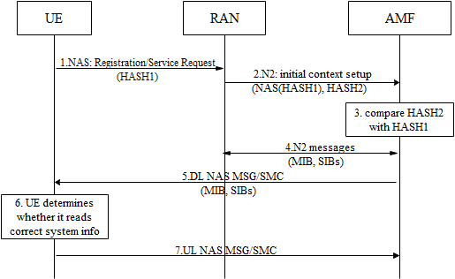
Figure 6.x.2-1: Procedure for system information protection
Step1: UE sends initial NAS messages to gNB. If the UE has a NAS security context, the message sent shall contain hash of the latest MIB/SIBs (called HASH1) ciphered in a NAS container. With a NAS security context, the sent message shall also be integrity protected. If UE has no NAS security context, the HASH1 is included in NAS Security Mode Complete message which is also integrity protected;
Step2: gNB sends registration/service request messages to AMF with hash of the gNB broadcasted MIB/SIBs (called HASH2).
Step3: AMF verifies the integrity of HASH1 and compares HASH1 with HASH2.
Step4: If the verification is successful and HASH1 doesn’t match with HASH2, AMF may determine to request and acquire the MIB/SIBs from gNB.
Step5: AMF sends protected DL NAS message to UE with MIB/SIBs from gNB if the received HASH1 and HASH2 don’t match.
Step6: UE may reselect the cell if a MitM false base station is suspected based on the received MIB/SIBs from gNB.
Step7: UE may send protected UL NAS message.
Editor’s Note: It is FFS what the point of this solution is for connected UEs because those UEs are already home safe.
Editor’s Note: It is FFS how this solution can work with SI that is modified while the UEs are in connected state.
Editor’s Note: In light of solutions for Ki#3 using the enrichment of measurement reports it is FFS why is this solution is needed.

6.x.3 Evaluation
TBD

*************** End of Change ****************

