3GPP TSG-SA WG3 Meeting #99e S3-201004

E-meeting, 11-15 May 2020

Source: Apple

Title: Initiation of AKMA

Document for: Approval
Agenda Item: 4.10

1 Decision/action requested
This pCR propose to add initiation procedure to TS 33.535

2 Rationale
There is an EN saying:
Editor’s Note: It is FFS whether the capability to negotiate the use of AKMA between the UE application and the AKMA AF also needs to be supported.
Per our discussion in last meeting and previous conf call, people agreed that the GBA-like method should be used in the Ua* interface. This contribution proposed the similar way with GBA to make the UE and AF agree on whether to use the AKMA.

3 CHANGES
********************** First Change ****************************

6.x Initiation of AKMA

Before communication between the UE and the AF can start, the UE and the AF first have to agree whether to use the AKMA. When a UE wants to interact with a AF, but it does not know if the AF requires the use of shared keys obtained by means of the AKMA, the UE may contact the AF for further instructions (see figure 6.x).

NOTE 1: The above text implies that a UE may contact either the AAnF or the AF without knowing whether the AF supports AKMA
NOTE 2: When the UE knows to use AKMA for a service, then it directly initiates the procedure in clause 6.2.

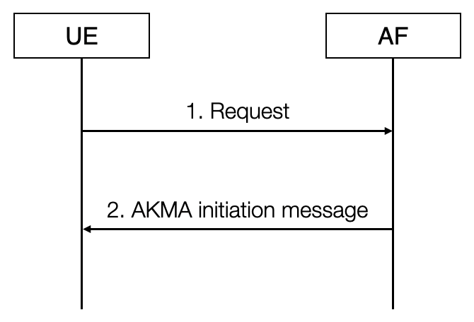
Figure 6.x: Initiation of AKMA
1. The UE may start communication over reference point Ua* with the AF with or without any AKMA-related parameters.
2. If the AF requires the use of shared keys obtained by means of the AKMA, but the request from UE does not include AKMA-related parameters, the AF replies with an AKMA initiation message. The form of this initiation message may depend on the particular reference point Ua*.

********************** Second Change ****************************

6.2 Deriving AKMA Application key for a specific AF

Figure 6.2-1 AF Key generation from K_{AKMA}
Before communication between the UE and the AKMA AF can start, the UE and the AKMA AF needs to know whether to use AKMA. This knowledge is implicit to the specific application on the UE and the AKMA AF.

1. When the UE initiates communication with the AKMA AF, it shall include the derived A-KID in the Application Session Establishment request message (cf. clause 6.1).
2. If the AF does not have an active context associated with the A-KID, then the AF sends a Naanf_key_create request to AAnF with the A-KID to request application function-specific AKMA keys for the UE. The AF also includes its identity (AF Id) in the request. The AAnF shall check whether the AAnF can provide the service to the AF by checking the AF Id. If succeeds, the following procedures are executed. Otherwise, the AAnF shall reject the procedure.
Editor’s Note: It is FFS how the AAnF knows whether it can provide the service to a specific AF
If the AAnF is in possession of the AF specific key (K_{AF}), it responds to the AF with the K_{AF} key. If not, the AAnF shall check if it has the UE specific K_{AKMA} key identified by the A-KID. The Step 3 to step 5 are skipped.
If K_{AKMA} is available in AAnF, it shall derive the AF specific AKMA key (K_{AF}) from K_{AKMA} and respond to the AF with K_{AF} and lifetime. The Step 3 and step 4 are skipped.
If K_{AKMA} is not available, the procedure continued.
3. The AAnF shall send a Nausf_AKMAkey_Create request to the AUSF to obtain the K_{AKMA} key specific to the UE. It includes the A-KID in the request.
4. The AUSF shall respond Nausf_AKMAkey_Create with the K_{AKMA} key identified by the A-KID.
5. The AAnF derives the AF specific key (K_{AF}) from K_{AKMA}.
6. The AAnF sends Naanf_key_Create response to the AF with K_{AF} and lifetime.
7. The AF response the Application Session Establishment request to the UE.
Editor’s Note: Derivation of the AF specific K_{AF} is FFS.

********************** End of pCR********************

