3GPP TSG-SA3 Meeting #99-e S3-201317r1

e-meeting, May 11 - 15 2020

Source: Philips International B.V

Title: Reduced overhead for UP IP for 5G RAN updates and conclusion

Document for: Approval
Agenda Item: 5.9

1 Decision/action requested
This pCR proposes to update the description of solution#4 in section 6.4 of TR 33.853.

2 References
[1] TR 33.853 v0.7.0 (2019-12), Technical report on key issues and potential solutions for Integrity protection of the User Plane
[2] R2-1905455, Response LS on full data rate support for UP IP.
[3] David Rupprecht etc., Breaking LTE on Layer Two. 2019 IEEE Symposium on Security & Privacy
[4] SP-200021/RP-200038, LS from GSMA: Mandatory User Plane Integrity for 5G GSMA (FSAG#79_002)

3 Rationale
As described in S3-200699, solution#4 provides much less overhead than applying PDCP based user plane integrity protection, and could therefore be very helpful as a way forward as a protective measure against the aLTEr attack, without the performance impact and potentially reduced data rates of applying PDCP based integrity protection at full rate.
During discussion of S3-200699 some comments were made that solution#4 does not allow the operator to switch integrity protection on/off per PDU session, which may be desired by some operators, since it would basically operate on all data in all transport blocks. In this proposal we address these concerns, and also propose some other clarifications and improvements to address some of the other comments that were made.
Note that normative work on this solution would be targeted for release 17.

4 Detailed proposal
SA3 is kindly requested to approve the pCR to update sections 6.4 with the changes as indicated below.
**** START OF CHANGE 1 ****

6.4 Solution #4: Zero-overhead user plane integrity protection on the link layer

6.4.1 Introduction
Existing attacks on UP-IP require a man-in-the-middle (MitM) relay that is located between UE and eNB. The MitM relay receives packets from the UE/eNB, modifies them, and forwards them towards eNB/UE. Thus, techniques that defeat MitM relay attacks defeat also attacks on UP-IP. The “Zero-overhead user plane integrity protection on the link layer” solution does this -- it defeats MitM relay attacks -- by replacing the CRC associated to each transport block in L2 by a cryptographic CRC denoted CRC’ and linked to the transport block identity itself. By doing this, an attacker cannot receive a packet, process and modify it, and forward it in a later transport block since this changes the transport block identity used, and thus, the verification of the cryptographic CRC fails.
This solution addresses the key issue #3: "UE support of UP IP at the full uplink data rate" and key issue #5: "Optionality of integrity protection in UP DRB".
Key issue #3 is addressed since it provides protection against attacks on UP IP even at full uplink data rate. Key issue #5 is addressed since this protection is applied to all UP DRBs.
The proposal is to use a cryptographic CRC instead of the regular CRC in Transport Blocks on the user plane.
This solution reduces the overhead of integrity protection to ZERO.
The effective user data throughput remains the same as without the integrity protection.
The error behaviour of the Link layer remains exactly the same as without the proposed integrity protection.
This solution requires the addition of the computation of a MAC over or the encryption of 128 bits per CRC in a Transport Block so per 6144 bits, which is a reduction of about a factor 50 in the amount of computations required for the UP IP of a PDCP packet. It can therefore be used at full uplink data rates and is a solution to key issue 3.
With this solution, all Transport Blocks independent of the data rate can be integrity protected, so automatically, all PDCP packets become integrity protected and the integrity protection does not have to be a serving network operator-dependent policy anymore, which solves the UP IP optionality KI#5

Some background
- A Transport Block is defined as the basic data unit exchanged between L1 and MAC. An equivalent term for Transport Block is "MAC PDU".
- Each Transport Block has a CRC over the total TB. Most TBs, including User Data TBs, have a 24-bit CRC.
- Transport Blocks are subdivided in Code Blocks if larger than 6144 bit. Each CB has its own 24-bit CRC.
- A Resource Block pair is the unit for the scheduling of resources by the base station.
- One Resource Block consists of 12 successive OFDM sub-carriers in frequency and one slot of 0.5 millisecond in time
➔72 or 84 OFDM symbols per RB of 1 to 10-bit each.
- A Resource Block pair consists of the two successive RBs in the two successive slots of a subframe of 1 millisecond.
- If a Transport Block is larger than a Resource Block pair, more RB pairs are added in the frequency direction.
➔ Each TB is limited to a subframe of 1 millisecond.
- TBs with an incorrect CRC are discarded by the receiver and a retransmission is requested (Hybrid Automatic Repeat-Request (HARQ)).
- An LTE frame consists of 10 subframes.
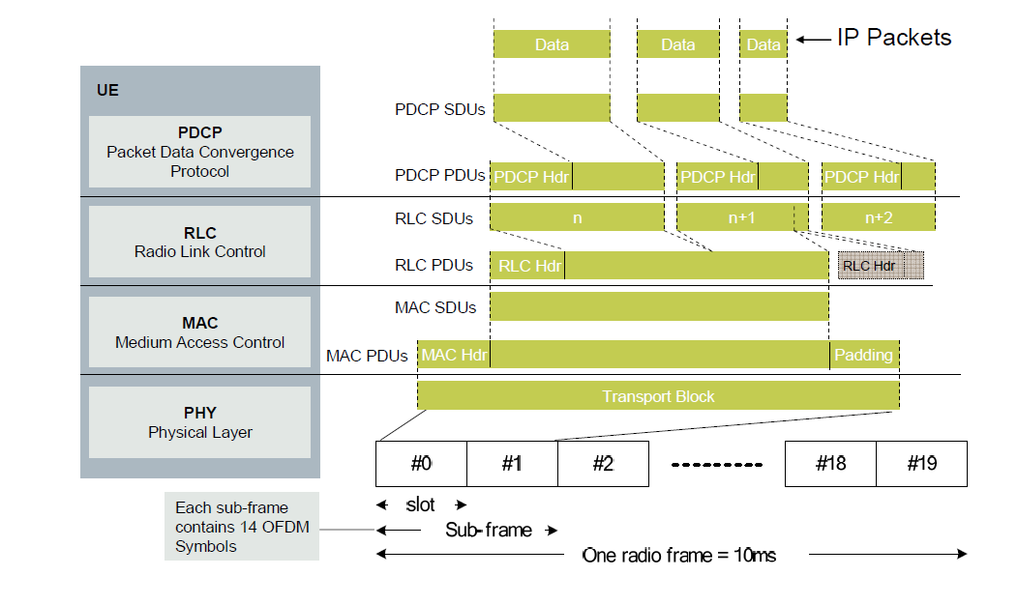
Figure 6.4.2-2 LTE packet structure relating PDCP packets to Transport Blocks

6.4.2 Network options affected
This solution is applicable to the following network options:
- Option 2 - NR standalone with 5G Core
- Option 3 - EPC based Dual Connectivity of eUTRA and NR RAT
- Option 4 - 5G core based Dual Connectivity (NR master - eUTRA secondary)
- Option 7 - 5G core based Dual Connectivity (eUTRA master - NR secondary)

6.4.3 Solution Description
It is proposed to use a cryptographic version of the CRC in every user Transport Block.
This can be achieved by replacing the 24-bit CRCs in a Transport block by 24-bit CRC's as computed by
CRC' = truncate { 24, HMAC( K, CRC | TransportBlockID) } (1)
or
CRC' = truncate { 24, Encrypt( K, CRC | TransportBlockID) } (2)

In addition, the CRCs of the Code Blocks inside a TB may also be replaced by their cryptographic versions.
Encryption requires probably less effort than HMAC. The encryption is done in ECB mode. A truncated encryption is OK, the truncated encryption serves as a CRC. Both sender and transmitter compute the CRC' using truncated encryption of equation (2). The transmitter puts the computed CRC' at the CRC field of the TB. The receiver computes it too according to equation (2) and compares this with the CRC' value in the CRC field of the received TB. If they are the same, the integrity protection check passes, else it fails. Therefore, because there is no decryption required, only checking whether truncated encryptions are the same or not.

Mobility problem (different key per gNB)
The key K to use is derived from a master key such that the derivation is dependent on the gNB or the DU inside the gNB. The master key is different for each UE (or UICC/USIM), but is used only for the UPIP functionality in this solution. gNBs or DUs get provisioned with the key K derived for them. The UE (or UICC/USIM) is provisioned with the master key and does the derivation of the key K itself.

Rekeying of the master key
The master key needs to be rekeyed before the time dependent part of TransportBlockID rolls over. An HSFN + 11 extra bits leads to a roll-over every 1.4 year.

Bundling of PDCP-PDUs
The master key and the key K are not dependent on the content of a TB, i.e. the PDCP-PDUs that are carried inside that TB.

Dual connectivity (split bearer) situation
In case of dual connectivity (split bearer), TBs that are sent over a bearer that does support this solution are integrity protected, while TBs that are sent over a bearer that does not support this solution are not protected.

The TransportBlockID is used to prevent an attacker to collect entries for a CRC -> CRC' dictionary.
Requirements for the TransportBlockID are the following two.
1. TransportBlockID should be different for different slots or subframes.
2. TransportBlockID should be different for TBs of the same user in the same slot or subframe.

Candidates for requirement 1 that are simple to retrieve by both UE and eNodeB may be
- the subframe number ( 0 – 9) that the TB starts in,
- the System Frame Number (SFN) (0 – 1023) that the TB starts in (repeats every 10.24 seconds) ,
- the hyper-SFN (HSFN) (0 – 1023) that the TB starts in (repeats about every 3hours; the HSF is also used as part of the COUNT in the PDCP integrity protection),
- a new sequence number similar to the hyper-SFN (HSFN) and made available in a system message to all devices in a cell similar to the way the HSFN or the SFN is made known (HSFN + 11 extra bits leads to a roll-over every 1.4 year),
- a new sequence number made available through an AS secured RRC message.
- a Radio Network Temporary Identifier (RNTI), either existing or new one, only known to the UE and the gNB, that gets updated frequently
- the length of the TB,
- the slot number (0 or 1) of the slot the TB starts in (?),
- etc.

Candidates for requirement 2 that are simple to retrieve by both UE and eNodeB may be
- indication of uplink or downlink bit,
- indication whether the CRC/CRC' is for the entire TB or for a Code Block (sub part of TB with its own CRC),
- CB number in case the CRC/CRC' is for a CB,
- indication whether the TB is the first (0) or second (1) TB to/from a device in this subframe,
- lowest (or highest) frequency of all sub carriers used for the entire TB,
- number of subcarriers and/or Resource Blocks used for the entire TB,
- number of the spatial stream or the antenna port number in case of spatial multiplexing,
- carrier indicator indicating the carrier this TB is transferred on in case of carrier aggregation,
- PLMN ID, or Cell Identity,
- Evolved Cell Global Identifier = PLMN ID concatenated with the Cell Identity,
- physical layer cell identity (0 – 503),
- base station name (eNodeB name) as transmitted in the System Information Block 9 (SIB9),
- etc.
Control of the Transport Block level integrity protection provided by this solution
When the system wants to use the UP-IP at the Transport Block level of this solution between a certain UE and gNB, it starts a PDCP entity just for this purpose, while using one integrity algorithm identifier of a set of new integrity algorithm identifiers in the integrityProtAlgorithm attribute in the SecurityAlgorithmConfig information element (clause 6.3.3 of TS 36.331 [9]), see "Negotiation of UP-IP" below. Any of the existing ciphering algorithm identifiers can be used for the cipheringAlgorithm attribute.
This PDCP entity, as any other PDCP entity, may be used for the transfer of IP packets. All of these packets are integrity protected at the Transport Block level.
When the system wants to use different bearers, with different policies and QoS, etc., it can do so as it was used to. But when the system starts a PDCP entity with one of the new nia4, nia5, nia6, nia7 integrity algorithm identifiers, all Transport Blocks to and from the UE are going to use the cryptographic CRC. This does not influence the data rates/QoS of the other PDCP entities. In case another PDCP entity did not use PDCP UP-IP protection, it has now UP-IP based on the cryptographic CRC. In case it already had PDCP UP-IP, it now also has UP-IP based on the cryptographic CRC at the TB level.
If performing cryptographic CRC is not desired for all user plane data (even though this is identified as possibly problematic in KI#5), then the security policy per PDU session may be extended to include a flag which indicates whether to apply cryptographic CRC or not. A UE that supports multiple MAC entities (as described in TS 38.321), which the UE may already have in order to support e.g. multi-RAT connections or dual connectivity, can use one MAC entity to serve all PDU sessions with integrity protection switched on, and another MAC entity to serve all PDU sessions with integrity protection switched off. If a UE that does not support multiple MAC entities wants to establish an additional PDU session, and the additional PDU session has a different value for cryptographic CRC in the security policy as the already established PDU session(s), then the UE may choose to wait or cancel the additional PDU session until the existing PDU session is torn down and the MAC entity becomes available, and may inform the user that the additional PDU session cannot be established due to device limitations. Alternatively, the AMF can be made aware of such device limitation and update the security policy such that the UE will change to using PDCP based integrity protection instead of using cryptographic CRC, possibly at a lower data rate, due to overhead that this may bring.

Negotiation of UP-IP
The application of this solution can be negotiated and controlled with the same procedures as those for the PDCP integrity protection with the following extensions for NR. Similar extensions may be made for E-UTRA.
- The F1-C interface is extended with one or more new messages to supply the DU with the required information for the integrity protection of this solution.
- The list of integrity algorithm identifiers in clause 5.11.1.2 of [4] is extended with one or more of the following values:
- "0100₂" 128-NIA4 128-bit SNOW 3G based algorithm using equation (2) above in ECB mode;
- "0101₂" 128-NIA5 128-bit AES based algorithm using equation (2) above in ECB mode;
- "0110₂" 128-NIA6 128-bit ZUC based algorithm using equation (2) above in ECB mode; and/or
- "0111₂" 256-NIA7 HMAC-SHA256 based algorithm using equation (1) above.
- The list of integrity algorithm identifiers in the integrityProtAlgorithm attribute in the SecurityAlgorithmConfig information element (clause 6.3.3 of TS 36.331 [9]) is extended with the same new value(s) as the ones in the previous bullet.
- The integrityProtAlgorithm enumeration in the IE SecurityAlgorithmConfig in clause 6.3.2 of [8] is extended with nia4, nia5, nia6, and/or nia7, consistent with the extension of the list of integrity algorithm identifiers as described the bullet above.

Consequence of UP-IP termination in the DU
Since the negotiation of the application of this solution is done in the PDCP layer, but the application itself in the DU, the F1-C interface is extended with one or more new messages to supply the DU with the required information for the integrity protection of this solution.
This solution provides integrity protection between the UE and the DU. The integrity protection can be extended to the CU, by applying IPsec on the F1-U interface, as specified in clause 9.8.2 of [4].
Since the key K is part of the information to be sent on the F1-C interface to the DU, the security mechanisms as specified in clause 9.8.2 of [4] for the F1-C interface need to be applied as well.
The contents of a TB with an incorrect cryptographic CRC is blocked by the DU from further transmission to the CU.

Key hierarchy and key management
The key K in equation (1) or (2) above can be taken as the key K_{UPint} as specified in [4].
However, this would mean that PDCP UP-IP and the integrity protection of this solution cannot be used at the same time. Therefore, a new key K_{TBint} may be defined in [4] that is managed and derived in the same way as K_{UPint} except that a value of 0x07 is used for the algorithm type distinguisher in clause A.8 of [4] instead of 0x06.

6.4.4 Solution Evaluation
The impact on the protocol stack (PHY + MAC + RRC)
The PHY in the UE and in the DU needs to be extended with means to generate the CRC' in outgoing Transport Blocks and means to check the CRC' of incoming Transport Blocks according to equations (1) and/or (2) above. This means that for every CRC computed, an additional HMAC must be computed if equation (1) is used or one encrypted value needs to be computed if equation (2) is used.
Since the cryptographic CRC computation is based on the (linear) CRC itself, XOR-ing a TB that is protected with the cryptographic CRC with a TB with a zero-valued CRC will lead to a TB that passes the integrity check.
The PHY in the UE needs to be extended with means to receive the information required to apply and cease to apply the integrity protection of this solution from the RRC layer in the UE.
The PHY in the DU and the RRC in the CU need to be extended with means to exchange the information required to apply and cease to apply the integrity protection of this solution using one or more new messages over the F1-C interface. Since the key K is part of this information, the security mechanisms as specified in clause 9.8.2 of [4] for the F1-C interface need to be applied.
The RRC in the UE and CU need to be extended with the new integrity algorithm identifier(s) specified for this solution.
There is no change required in the MAC, but it may be desirable for a UE to support multiple MAC entities.
The integrity protection strength of this solution is less than that of the PDCP MAC, namely 24 bit instead of 32 bit.
The security properties of using the cryptographic CRC as an integrity protection have not been evaluated.
This solution addresses the key issue #3: "UE support of UP IP at the full uplink data rate" and key issue #5: "Optionality of integrity protection in UP DRB".
The proposal is to use a cryptographic CRC instead of the regular CRC in Transport Blocks on the user plane.
This solution reduces the overhead of integrity protection to ZERO.
The effective user data throughput remains the same as without the integrity protection.
The error behaviour of the Link layer remains exactly the same as without the proposed integrity protection.
This solution requires the addition of the computation of a MAC over or the encryption of 128 bits per CRC in a Transport Block so per 6144 bits, which is a reduction of about a factor 50 in the amount of computations required for the UP IP of a PDCP packet. It can therefore be used at full uplink data rates and is a solution to key issue 3.
With this solution, all Transport Blocks independent of the data rate can be integrity protected, so automatically, all PDCP packets become integrity protected and the integrity protection does not have to be a serving network operator-dependent policy anymore, which solves the UP IP optionality KI#5

**** END OF CHANGE 1 ****

