3GPP TSG-SA3 (Security) S3-100187

SA3#58, 1-5 February 2010, Xian, China revision of S3-092232
CR-Form-v9.6
CHANGE REQUEST
 | 33.310 | CR | 00XX |  rev | - |  Current version: | 9.1.0 | 
For HELP on using this form look at the pop-up text over the  symbols. Comprehensive instructions on how to use this form can be found at http://www.3gpp.org/specs/CR.htm.

Proposed change affects:  | UICC apps |  | ME |  | Radio Access Network | X | Core Network | X

Title:  | NDS enhancement - SCEP option for Certificate Enrolment to support only general network elements (NE’s) leaving base stations to support CPMv2 only (Release 10)
Source to WG:  | BT
Source to TSG:  | SA3
Work item code:  | Backhaul security |  |  |  |  |  |  | Date:  |  | 25/01/2010
Category:  | B |  |  |  |  |  |  | Release:  |  | Rel-10
 | Use one of the following categories:  F (correction)  A (corresponds to a correction in an earlier release)  B (addition of feature),  C (functional modification of feature)  D (editorial modification)  Detailed explanations of the above categories can  be found in 3GPP TR 21.900. |  |  |  |  |  |  |  | Use one of the following releases:  R99 (Release 1999)  Rel-4 (Release 4)  Rel-5 (Release 5)  Rel-6 (Release 6)  Rel-7 (Release 7)  Rel-8 (Release 8)  Rel-9 (Release 9)  Rel-10 (Release 10)
Reason for change:  |  | To add SCEP option for Certificate Enrolment for network elements in general ( Release 10)
Summary of change:  |  | CMPv2 option retained in clause 9.1 new clause 7.2.1 adding SCEP as an option
Consequences if   not approved: |  | Specification does not reflect the protocol commonly supported by CA’s and network elements in the scope of TS33.310
Clauses affected:  |  | 2 3.1 5.2.11 5.2.13 7.2
 |  | Y | N
Other specs  |  |  | X | Other core specifications 
affected: |  |  | X | Test specifications
 |  |  | X | O&M Specifications
Other comments: 

************************** start of changes ************************

2 References
[X1] Cisco Systems’ Simple Certificate Enrolment Protocol Draft-nourse-scep-20
[X2] HTTP over TLS
[X3] Open reference implementation of a SCEP v2 client
[X4] Internet X.509 Public Key Infrastructure Certificate and Certificate Revocation List (CRL) Profile

************************** start of next change *********************

3.1 Defintions

CA: Certificate Authority.
Client: Client is a software agent or serverlet or process (browser) employed to generate appropriate key material and forward this to the SCP Client / Proxy device.
CRL DP: Certificate Revocation List Distribution Point
CSR Generator: Certificate Signing Request Generator
End Entity: The user of PKI certificates and/or end user system that is the subject of a certificate.
RA: Registration Authority.
SCEP Server: Simple Certificate enrolment Protocol is the successor of CEP the Certificate Enrollment Protocol. Both protocols were developed from Cisco. The idea is to have simple but secure protocol to enroll certificates.
SCEP Client / Proxy:The SCEP Client / Proxy is a SCEP Client with a small web server that allows trusted clients to forward prepared key material to be forwarded to a SCEP server.

************************** start of next change *********************

5.2.11 End entity certificate creation
Using device-specific management methods, the certificate creation shall be initiated. As specified in section 7.2, either the CMPv2 or the SCEP [X1] protocol for automatic certificate enrolment or manual certificate installation using PKCS#10 formats can be used. This is an operator decision depending for example on the number of NEs or SEGs and TLS entities.

************************** start of next change *********************

5.2.13 End entity certificate renewal
A new NE, SEG or TLS entity certificate needs to be in place before the old certificate expires. The procedure is similar to the certificate creation and can be either fully automated by using either CMPv2, or SCEP[X1] as specified in section 7.2 or done manually using PKCS#10 formats. This is an operator decision depending for example on the number of NEs, SEGs and TLS entities.

************************** start of next change *********************

Life cycle management

7.2.1 CMPv2
Certificate Management Protocol v2 (CMPv2) [4] shall be the supported protocol to provide certificate lifecycle management capabilities for SEGs. All SEGs and SEG CAs shall support initial enrolment by the SEG to the SEG CA via CMPv2, i.e. receiving a certificate from the SEG CA, and updating the key of the certificate via CMPv2 before the certificate expires.
Certificate Management Protocol v2 (CMPv2) [4] should be the supported protocol to provide certificate lifecycle management capabilities for TLS entities. All TLS entities and TLS CAs should support initial enrolment by the TLS entity to the TLS CA via CMPv2, i.e. receiving a certificate from the TLS CA, and updating the key of the certificate via CMPv2 before the certificate expires.
Certificate Management Protocol v2 (CMPv2) [4] shall be the supported protocol to provide certificate lifecycle management capabilities for NEs. All NEs and NE CAs shall support initial enrolment by the NE to the NE CA via CMPv2, i.e. receiving a certificate from the NE CA, and updating the key of the certificate via CMPv2 before the certificate expires.
Enrolling a certificate to a SEG, NE or TLS entity is an operation that may be done more often than inter-operator cross-certifications, thus more automation could be required by the operator than is possible with a PKCS#10 approach. However, also manual SEG and NE certificate installation using PKCS#10 formats shall be supported. It should be also noted that the lifetime of a SEG CA cross-certificate is considerably longer than the lifetime of a SEG certificate.
NOTE: CMPv2 is preferred to CMPv1 (specified in obsoleted RFC 2510), because of the interoperability issues with CMPv1.

7.2.2 SCEP

7.2.2.1 Architecture
Simple Certificate Enrolment Protoco (SCEP) [X1] shall be the supported protocol to provide certificate lifecycle management capabilities for SEGs
SCEP shall be the supported protocol to provide certificate lifecycle management capabilities for NEs
SCEP should be the supported protocol to provide certificate lifecycle management capabilities for TLS entities.
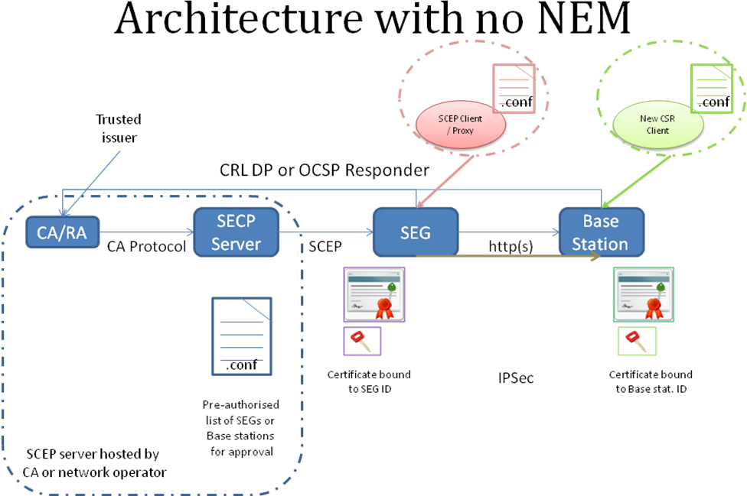
Figure XX, Shows the general deployment architecture for certificate enrolment for a network element subordinate to a SEG of a centrally managed PKI.

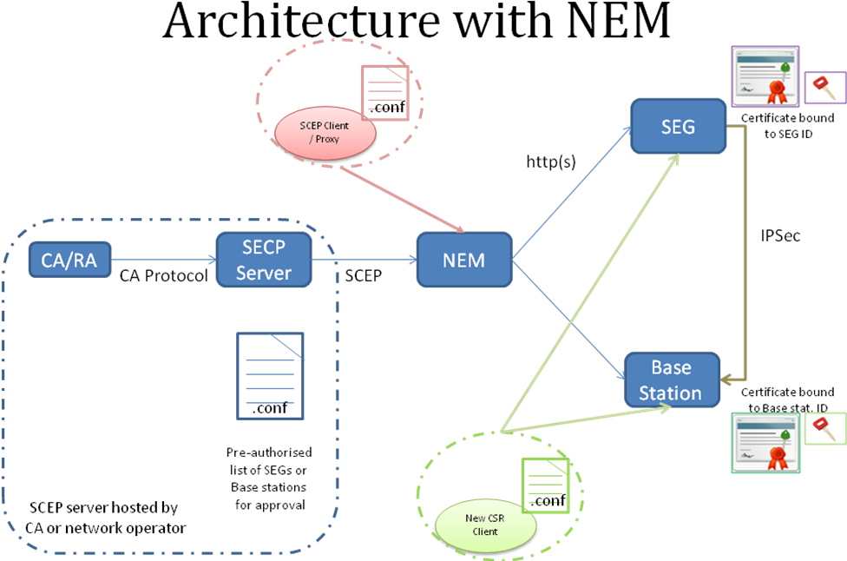
Figure XX, Shows the general deployment architecture for certificate enrolment for a network element and SEG that are subordinate to a NEM of a centrally managed PKI.

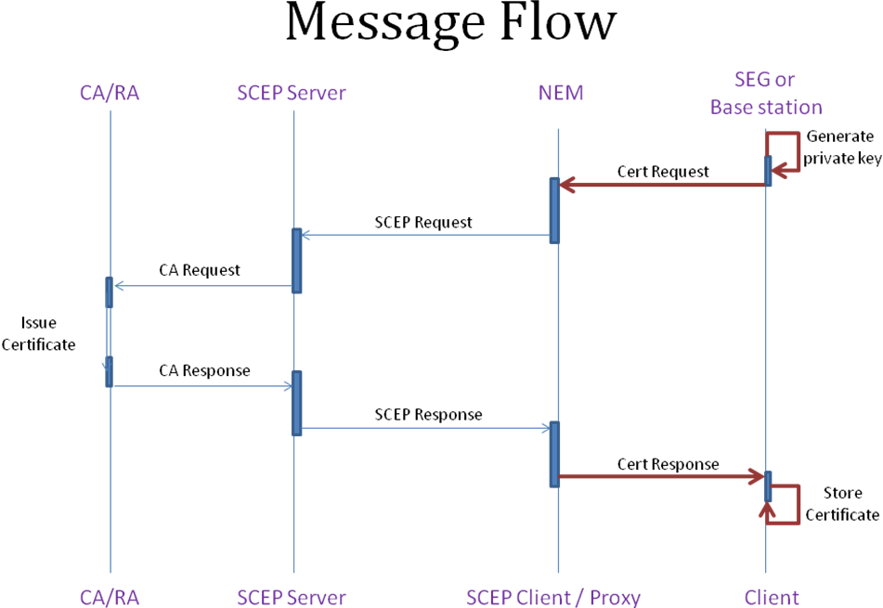
Figure XX, Shows the Message flow of the standard SCEP protocol with the addition of an http proxy server to support remote devices SCEP requests.
Architecturally this solution is underpinned by the proven draft IETF SCEP protocol. This solution relies upon the SCEP 2002 extension of SCEP “Open reference SCEPv2” [X3]. As indicated in the above diagrams the end entity client is either preconfigured or configured via a trusted mechanism from a “network element manager”. Typical trusted network element management protocols include x509v3 mutually authenticated HTTPS. Once configured the SCEP client acts HTTP client to the SCEP Client / Proxy’s web server.
In its simplest form the “Client” within the above architectures maybe either a web browser or an automated agent driven by a configuration file that was pre-configured or configured via the NEM.
The “Client” communicates with the “SCEP Client / Proxy” via http or https. Communication from the “SCEP Client / Proxy” employs PKCS#7 message level security as indicated within the IETF SCEP-20 internet draft. Between the SCEP Server and the CA/RA service the CA’s preferred protocols are used.
To support automated certificate enrolment the CA, “SCEP Server” or “SCEP Client / Proxy” should be configurable to support automated or manual client certificate request authorisation. Authorisation options may include:
- Challenge passphrase,
- Proof of possession of the RA certificate, or
- Pre-authorised common name.
Bootstrapping of the “Client” results from populating the associated configuration file name value pairs. The initial request (test) requests the issuing CA certificate and associated certificate chain to the self-signed Root CA.
Once bootstrapping is complete and NTP (network time protocol) is established the “Client” agent is able to support 3 life-cycle processes:
- Update or renew the issuing CA certificate and associated chain, based on NVPs of the associated configuration file.
- Request a certificate based on the NVPs of the associated configuration file. The certificate profile should be standards compliant.
- Should the response to a certificate request be a “pending” message, the “SCEP Client / Proxy” will indicate this to the “Client”, and the “Client” will use the “SCEP Client / Proxy” response to trigger the entery of a polling mode to collect the new certificate as it is issued.
Should there be a certificate request failure or the configurable “Client” polling window be exceeded without the “Client t” receiving a certificate response the “SCEP Client / Proxy” device will be notified. The “Client” device will not be able to establish an IPSec tunnel without a valid digital certificate.
Assuming a valid certificate is provisioned the “Client” device will be capable of establishing an IPSec tunnel. Again this tunnel attributes are established by a configuration file.
If at later stage of network element deployment the operator wants to renew the network element certificate, the same procedure will be executed with the old operator-signed certificate of the network element taking the place of the vendor-signed certificate in the initial enrolment.

7.2.2.2 Reference Security Model
The SCEP protocol is dependent on a message level rather than transport level security to mitigate man-in-the-middle attacks.

7.2.2.3 Security Requirement for Certificate Enrolment
The security goals of SCEP are that no adversary can:

- Subvert the public key/identity binding from that intended,
- Discover the identity information in the enrolment requests and issued certificates,
- Cause the revocation of certificates with any non-negligible probability.

7.2.2.4 Security Mechanisms
The first and second goals are met through the use of PKCS#7 [RFC2315] and PKCS#10 [RFC2986] encryption and digital signatures using authenticated public keys. The CA's public key is authenticated via the checking of the CA fingerprint, and the SCEP client's public key is authenticated through the manual authentication or pre-shared secret authentication. The third goal is met through the use of a challenge password for revocation, which is chosen by the SCEP client and communicated to the CA protected by the PKCS#7 [RFC2315] encrypted Data.

7.2.2.5 Certificate Profiles
The supported certificate profile will be based on the standards based IETF x509v3 certificate profiles, in the above example an IPSec certificate profile. Certificate request configuration attributes will be drawn form name value pairs from the device’s configuration file.

7.2.2.6 SCEP Profiling

7.2.2.2.6.1 General SCEP Profiling
Simple Certificate Enrolment Protocol (SCEP) was developed to automate certificate provisioning for devices. SCEP is a draft IETF document and is designed to provide a simplified way of handling certificate distribution for large-scale device deployments. This enables http enrolment of identity certificates to devices that can be used for authentication and encryption based on services requirements.

7.2.2.2.6.2 SCEP Profile Overview for End-to-End Network element Certificate Enrolment
The following requirements shall apply to SCEP usage end-to-end between network element and RA/CA:
- Key generation will be performed on the end entity devices the issued certificate will be used on.
- This SCEP profile shall only include get CA certificate (GetCACert), key material generation, initial certificate request and certificate renewal.
- Revocation processing and CRL fetches are supported, but these actions are part of the usual CA services.
- For PKI Message Protection the SCEP profile shall use PKCS#7 message wrapping. For example the PKCS#10 certificate request would be encrypted and then signed.

7.2.2.2.6.3 SCEP Transport
Transport of SCEP messages between end entities (network elements) and RA/CA shall be done using HTTP-based protocol as specified in Draft-nourse-scep-20 [X1].
Support is mandatory for communication initiated by the end entities where every SCEP request triggers a SCEP response message from the CA or RA. Support for RA/CA initiated HTTP requests (i.e. announcements) is not mandatory.
Support for HTTP is mandatory. Usage of HTTPS is optional.
HTTP GET is mandatory while HTTP POST is optional.

*****************End of changes*************************

