3GPP TSG-SA3 Meeting #115e S3-241245-r1

e-meeting, 15 - 19 April 2024 revision of S3-2xxxx

Source: CMCC

Title: New solution for key issue 2

Document for: Approval
Agenda Item: 5.3

1 Decision/action requested
It is proposed to approve the proposed changes for inclusion in TR 33.757 [1].

2 References
[1] 3GPP TR 33.757: Study of security for PLMN hosting a NPN

3 Rationale
This contribution proposes the solution for SBA interface security of key issue 2. This solution proposes a Security Gateway to securely isolate the secure domain and non-secure domain by providing the security protections such as topology hiding, inspection and control of signaling message etc,. for the traffic through SBA interface over trust boundary.

4 Detailed proposal
It is proposed to approve the following changes for inclusion in TR 33.757 [1].

*************** Start of the changes ***************

2 References
The following documents contain provisions which, through reference in this text, constitute provisions of the present document.
- References are either specific (identified by date of publication, edition number, version number, etc.) or non-specific.
- For a specific reference, subsequent revisions do not apply.
- For a non-specific reference, the latest version applies. In the case of a reference to a 3GPP document (including a GSM document), a non-specific reference implicitly refers to the latest version of that document in the same Release as the present document.
- 3GPP TR 21.905: "Vocabulary for 3GPP Specifications".
[2] 3GPP TS 33.501: "Security architecture and procedures for 5G system"
[3] 3GPP TS 23.502: "Procedures for the 5G System (5GS)"
[4] 3GPP TS 29.500: "Technical Realization of Service Based Architecture"
[x] <doctype> <#>[ ([up to and including]{yyyy[-mm]|V<a[.b[.c]]>}[onwards])]: "<Title>".

6.X Solution #X: Secure SBA interface with Security Gateway

6.X.1 Introduction
This solution addresses key issue #2.
Considering the nature that the dedicated NF locates outside of operator’s controlled network and interact with PLMN through SBA interface, which leads to the exposure threats to the operator’s core network, this solution proposes to introduce an Security Gateway at the border of operator’s core network to prevent operator’s core network against the attacks through SBA interface. The Security Gateway should be the first contact node when the dedicated NFs interacting with PLMN. All SBA related input/output traffic over the trust boundary should be delegated and protected by the Security Gateway.
Editor’s Note: whether the Security Gateway can be an SCP with additional security gateway functionality is FFS.

X.2 Solution details
The assumed architecture with the Security Gateway deployed over the trust boundary for SBA interface is shown in Figure 1.

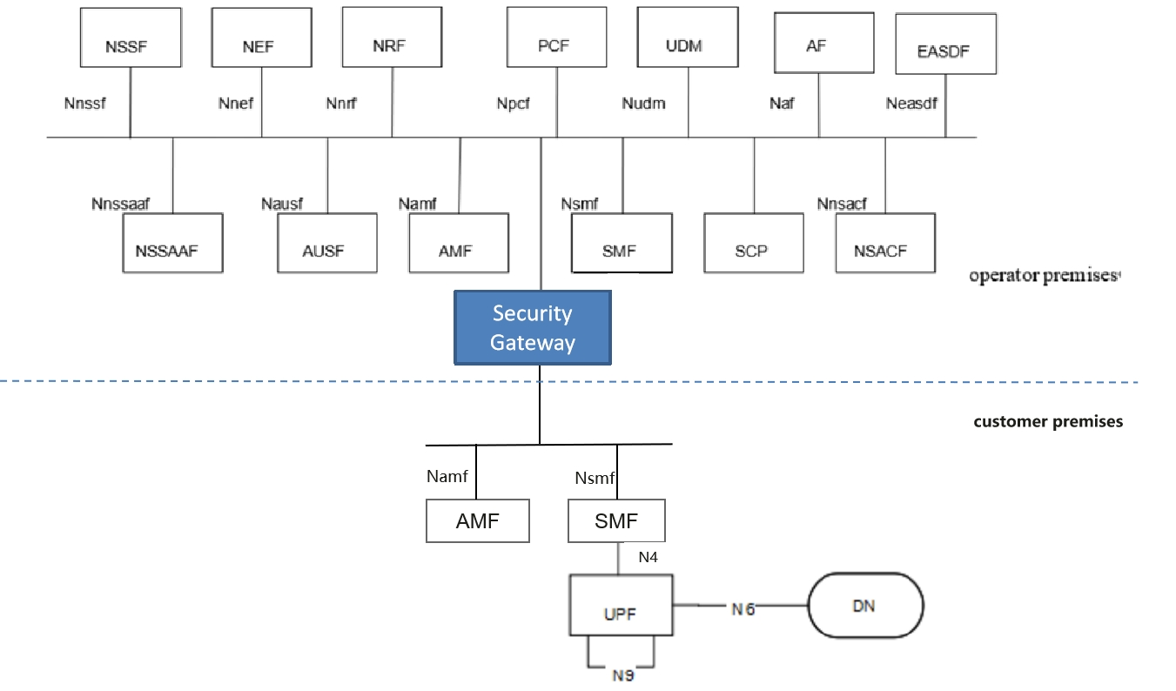
Figure 1: System architecture for Security Gateway

Security protections provided by Security Gateway for the traffic through SBA interface over the trust boundary can be categorized in the following way:
- Topology information hiding of the PLMN and the customer premises network,
- Signaling inspection and message filtration
- Security between the NF in customer premise and the Security Gateway
- Security between the Security Gateway and the NF in PLMN
- Access control etc.

6.x.2.1 Topology information hiding
The Security Gateway delegates every Control Plane message in inter-domain signaling, acting as a service relay between the actual Service Producer and the actual Service Consumer. For both Service Producer and Consumer, the result of the service relaying is equivalent to a direct service interaction. The Security Gateway handles topology hiding by limiting the PLMN network topology information visible to the dedicated network in customer premises and vise versa.
For SBA interface, the following address information in the message may need to hide:
- IP address or FQDN of the NF in the incoming/outgoing message including in the fields such as CallbackUri, link, Location etc.
Based on the local policy provided by the operator, the appropriate topology hiding mechanisms can be performed based on the security requirements.

6.x.2.2 Signaling inspection and message filtration
The Security Gateway supports to protect application layer Control Plane messages, it receives all messages through SBA interface over the trust boundary and forwards them to the appropriate NF after verifying security, where present.
The Security Gateway supports to discard malformed signaling messages sent from NFs in the customer premises or operator premises through SBA interface over the trust boundary according to 3GPP specifications. If an SBI message violates the specified input or output (i.e., SBI message violation), that message can be considered as malformed message.
NOTE : 3GPP specifications specifies N4 message inputs and outputs described in TS 23.502 [x] and TS 29.500 [Y] can be considered as normal messages.
The Security Gateway supports the means to block messages with wrong NF types sent from NFs in the customer premises or operator premises over the trust boundary according to 3GPP specifications.
The Security Gateway supports anti-spoofing mechanisms that enable cross-layer validation of source and destination address.
NOTE : An example for such an anti-spoofing mechanism is the following: If there is a mismatch between different layers of the message or the destination address does not belong to the Security Gateway’s PLMN, the message is discarded.
The Security Gateway supports the rate-limiting functionalities to defend itself and subsequent NFs against excessive CP signaling.
In addition, as the Security Gateway provides a single point of entry for the signaling messages trough SBA interface, this gives it the global view on all the NFs connecting with it, which makes it be capable to inspect and filter more advanced behavioral and logical attacks against signaling by analyzing the signaling messages received from multiple NFs.

6.x.2.3 Security between the NF in customer premise and the Security Gateway
The Security Gateway is a network function at the border of a security domain of the operator. After successful mutual authentication between the NF in the customer premise and the Security Gateway, the Security Gateway connects the NF to the operator’s security domain.

6.x.2.3.1 Authentication
Authentication between the NF in customer premise and the Security Gateway can use one of the following methods:
- If the dedicated network uses protection at the transport layer, authentication provided by the transport layer protection solution for the SBA interface specified in TS 33.501 [x] can be used for authentication between the NF in customer premise and the Security Gateway.
- If the dedicated network does not use protection at the transport layer, authentication between the NF in customer premise and the Security Gateway may be implicit by NDS/IP or physical security.

6.x.2.3.2 Authorization
Authorization between the NF in customer premise and the Security Gateway is based on local authorization policy.

6.x.2.3.3 Transport protection between the Security Gateway and the NF in PLMN
TLS is used for transport protection between the NF in customer premise and the Security Gateway unless network security is provided by other means.

6.x.2.4 Security between the Security Gateway and the NF in PLMN
As a network function locating at the border of the security domain of the operator, the authentication, authorization of the Security Gateway, and the transport protection between the Security Gateway and the NF in PLMN can reused the existing mechanisms on SBA interface.

6.x.2.5 Access control
The Security Gateway supports access control:
- The Security Gateway allows the NF in customer premise access to the core network only after successful completion of all required authentications.
- Any unauthenticated traffic from the NF in customer premise is filtered out at the Security Gateway.
- The ACL (Access Control List) based access control mechanism for the NF in customer premise accessing the service of the NF in PLMN and vise versa(e.g. the accessible service based on NF’s address, the accessible service based on the SBA interface type, the accessible data scope based on SUPI ).

6.X.3 Evaluation
Editor's note: evaluation is ffs
**** End of Changes****

