3GPP TSG-SA3 Meeting #115AdHoc-e draft_S3-241228-r2
Electronic meeting, online, 15 - 19 April 2024

Source: China Mobile

Title: New solution of onboard UDM

Document for: Approval
Agenda Item: 5.7

1 Decision/action requested
It is proposed to approve this new solution in TR 33.700-29.

2 References
[1] 3GPP TR 23.700-29: "Study on integration of satellite components in the 5G architecture; Phase 3".

3 Rationale
To ensure authentication procedure completion, the UDM could be onboard to enable S&F operation.

4 Detailed proposal

*** Start of 1st Change****

6.Y Solution #Y: Onboard UDM

6.Y.1 Introduction
This solution addresses key issue #1.
During the feeder link’s intermittent unavailability, in order for the completion of authentication and NAS security procedures, UDM/AUSF could be onboard
6.Y.2 Solution details
The following assumptions and principles apply:
- The gNB, AMF and UDM/AUSF are placed on board the same satellite.
- The UE has a subscription and credentials in the onboard UDM. The long term key onboard is the same as the one on the ground.
- The onboard UDM is synchronized with the UDM on the ground when feeder link is available.



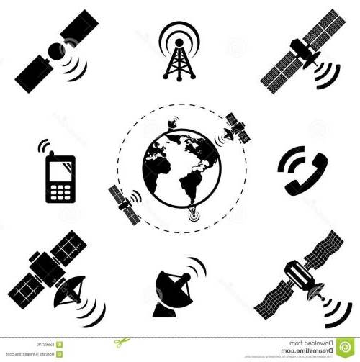

UE
SMF
UPF
AMF
RAN
UPF

DN
UDM/AUSF

When the gNB, AMF and UDM/AUSF are all on board, the authentication and NAS security procedures follow what defined in TS 33.501[4]. The differences are:
- After the on-board registration completion, the on-board UDM may send the authentication result to the ground UDM for backup.
Editor’s Note: It is FFS whether the solution can support roaming scenarios.
Editor’s Note: If UE is served by single satellite hosted 3GPP systems or multiple is FFS.
Editor’s Note: How does onboard UDM sync with ground UDM is FFS.

6.Y.3 Evaluation
TBD
**** End of 1st Change****

