3GPP TSG-SA3 Meeting #115AdHoc-e S3-241148
Electronic meeting, online, 15 - 19 April 2024

Source: Charter, CableLabs
Title: UE authentication while connecting to a new WLAN AP through the same NSWOF

Document for: Approval
Agenda Item:

1 Decision/action requested
This contribution proposes a solution for optimization of the authentication process during UE connecting to a new WLAN AP connected via the same NSWOF

2 References
[1] 3GPP TS 33.501 Security architecture and procedures for 5G system
[2] 3GPP TS 23.501 System Architecture for the 5G System
[3] IETF RFC 6696 EAP Extensions for EAP Re-Authentication Protocol (ERP)
[4] IETF RFC 5295 Specification for the Derivation of Root Keys from an Extended Master Session Key (EMSK)
[5] 3GPP TR 33.702. Study on Security for mobility over non-3GPP access to avoid full primary authentication.

3 Rationale
This pCR proposes a solution for key issue #4 in TR 33.702. The solution is based on ERP

4 Detailed proposal
It is proposed that SA3 approved the below changes for inclusion in the TR

**** START OF CHANGES ****

6.x Solution #X: ERP based re-authentication for NSWO

6.X.1 Introduction
This solution addresses key issue #4: Security aspect of UE connecting to a new WLAN AP connected via the same NSWOF

6.X.2 Solution details

6.X.2.1 Solution overview
In TS 33.501, annex S.3.2 5G NSWO procedures describe the UE authentication for connectivity through a NSWOF. Here it is adapted with minor revisions to store the context information during initial full authentication, and subsequnely use this information to optimize the UE authentication when the UE connects to a different WLAN AP.EAP Re-authentication Protocol (ERP) [4] is an EAP method-independent protocol for efficient re-authentication between the peer and an EAP re-authentication server. ERP allows a peer and server to mutually verify proof of possession of key material from an earlier EAP method run and to establish a security association between the peer and the authenticator. The APs in WLAN AN shall act as ER authenticators and NSWOF shall act as ERP server. AUSF remains to be an EAP authentication server.
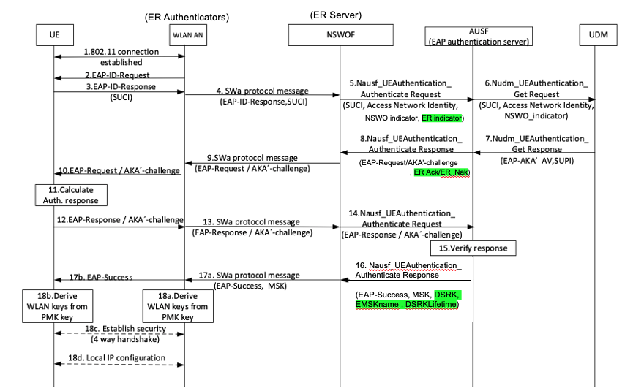
Fig. 6.X.2.1-1 Revised UE authentication procedure with NSWOF

- Steps 1 through 4 are fully compliant with annex S.3.2 in TS 33.501
- In step #5 the NSWOF indicates its EAP re-authentication capability by including the ER-Indicator
- AUSF in step #8 acting as EAP authentication server by responds with ER-Ack/ER-Nak.
- No changes are needed for steps #9 through 15.
- In step 16 the AUSF shall send to NSWOF the DSRK and EMSKname, DSRKLifetime (RFC 6696 [3], pg.11, sec 3.2, Fig 4) in addition to the MSK and EAP Success.
- In step17 the NSWOF retains the DSRK and EMSKname and sends the MSK and EAP success indicator to the Authenticator
- No changes in steps 18(a), 18(b), 18(c) and 18(d)

6.x.2.2 UE Re-Authentication Procedure for NSWO
The following is a new and optimized procedure for UE re-authentication, that avoids full authentication during UE mobility from a AP to another in the WLAN AN connected to the same NSWOF. It uses the context information saved in NSWOF during the initial UE full authentication. During re-authentication there are no messages exchanged with AUSF and UDM.
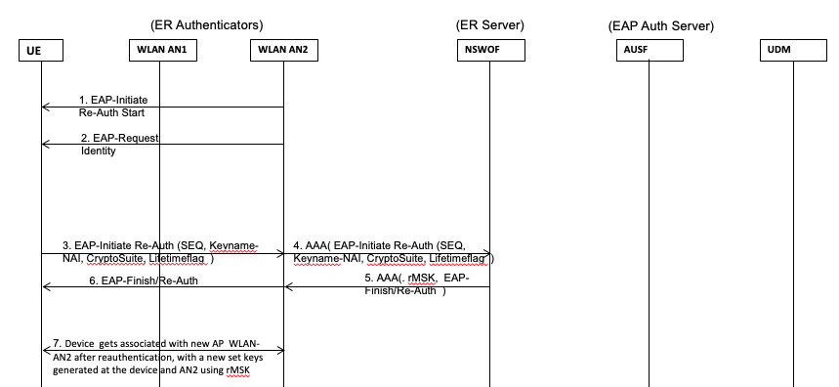

Fig. 6.X.2-2 UE Re-authentication procedure with NSWOF ( Change diagram )

- In steps #1 and #2 the UE get associated with the new AP, the AP indicates its EAP Re-auth capability by sending
    - (1) EAP-Initiate/ Re-auth-Start
    - (2) EAP-Request/Identity
This indicates to the UE that the AP being associated with is EAP re-auth capable.
- In steps #3 through #6 the UE then initiates the EAP re-auth process by exchanging the following messages in the format as specified in RFC 6696 [3] sections 5.3.2 and 5.3.3.
    - EAP-Initiate Re-Auth
    - EAP-Finish Re-Auth
  - In step #7 the UE gets associated new AP in the WLAN AN after successful authentication
In this manner during its mobility in WLAN access network the device may get associated with different parts of access network and get re-authenticated. Each time the device re-authenticates with the network, the key derivation process shall follow procedures in (RFC 6696[3] Sec 4 and RFC 5295[4])

6.X.3 Evaluation
This solution addresses key issue #4 and meets the security requirements to re-authenticate UE without performing full primary authentication. The network function changes needed to support this solution are listed below
NSWOF
- During initial authentication, the NSWOF shall include the ERindicator as an additional attribute to the AUSF in the Nausf_UEAuthentication_Authenticate_Request message ( in step 5 TS 33.501, annex S.3.2 )
- During intial authentication the Nausf_UEAuthentication_Authenticate_Response message ( in step 8 TS 33.501, annex S.3.2 ) the NSWOF shall receive an additional attributes ER-Ack or ER-Nak from AUSF
- During intial authentication the Nausf_UEAuthentication_Authenticate_Response message ( in step 16 TS 33.501, annex S.3.2 ) the NSWOF shall receive additional attributes DSRK, EMSKname, DRSKLifetime from AUSF. NSWOF shall retain these additional attributes with itself.

AUSF
- During initial authentication, the NSWOF shall include the ERindicator as an additional attribute to the AUSF in the Nausf_UEAuthentication_Authenticate_Request message ( in step 5 TS 33.501, annex S.3.2 ). AUSF shall process these additional attributes
- During intial authentication the Nausf_UEAuthentication_Authenticate_Response message ( in step 8 TS 33.501, annex S.3.2 ) the AUSF shall send an additional attributes ER-Ack or ER-Nak fto the NSWOF. If reauth is supported by AUSF, it shall include ER-Ack other shall send ER-Nak
- During intial authentication the Nausf_UEAuthentication_Authenticate_Response message ( in step 16 TS 33.501, annex S.3.2 ) the AUSF shall send additional attributes DSRK, EMSKname, DRSKLifetime to NSWOF.
WLAN
- TBD
UE
- UE needs to support ERP
Editor’s Note: It is FFS how the solution fulfills the requirement that mobility shall be for WLAN APs connected to the same NSWOF. Further evaluation is FFS.

**** END OF CHANGES ****

