**3GPP TSG-SA3 Meeting #109AdHoc-e *S3-230175***

**Electronic meeting, 16 - 20 January 2023** Revision of S3-23xxxx

**Source: Huawei, HiSilicon**

**Title: Evaluation Update on Solution 1**

**Document for: Approval**

**Agenda Item: 5.11**

# 1 Decision/action requested

***The contribution*** ***proposes to*** ***update evaluation in solution 1 in TR 33.884.***

# 2 References

# 3 Rationale

The contribution proposes to update current evaluation in solution 1.

# 4 Detailed proposal

*************** Start of 1st Change ****************

## 6.1 Solution #1: Resource Owner Authorization in API Invocation using OAuth Token

### 6.1.1 Introduction

This solution addresses the requirement in KI#2.

This solution proposes to reuse OAuth 2.0 with authorization code grant model to obtain resource owner’s authorization in case that an API invocation of network exposure is to process the resource owner’s data.

NOTE1: how the API invoker is authenticated to the authorization server is out of scope of this solution.

NOTE2: how the Resource owner is authenticated to the authorization server is out of scope of this solution.

### 6.1.2 Solution details

### 6.1.2.1 Architecture



Figure 6.1.2.1-1 architecture for CAPIF with SNA enhancement

The architecture is derived from solution 2 in TR 23.700-95 [3]. Definition of the authorization function, CAPIF-8, CAPIF-10, and CAPIF-10e is the same. Triggerer has the same definition of resource owner client(s).

It is proposed that the authorization function is collocated with the CCF.

However, the difference is that CAPIF-9 is not needed in this solution because there is no communication with AEF. CAPIF-8 is application layer, which is out of 3GPP

### 6.1.2.2 Procedure



Figure 6.1.2.2-1 Procedure of Obtaining Resource owner Authorization

As shown in the Figure 6.1.2.2-1, the details of obtaining resource owner authorization in API invocation is summarized as following:

1. API invoker obtains authorization method (e.g. method 1: TLS-PSK, or method 2: PKI, or method 3: TLS with OAuth token) as specified in clause 6.1 in TS 33.122 [5].

NOTE 3: CCF needs to pre-configure with TLS with OAuth token method.

Editor's Note: details for API invoker onboarding is FFS.

2. API invoker discovers service API as specified in clause 6.3.1.3 in TS 33.122 [5].

3. Resource owner triggers the API invocation. If resource owner authorization is needed for the invoked API and the method 3: TLS with OAuth token is selected, then the API invoker obtains tokenCAPIF via OAuth 2.0 with authorization code grant model as depicted in clasue 6.1.2.3.

4. The API invoker invokes nouthbound API to the AEF as depicted in clause 6.5.2.1 or 6.5.2.2 in TS 33.122 [5]. The API Invocation message includes tokenCAPIF.

The API invoker is pre-configured with a certificate and use TLS to authentice with AEF.

5. The AEF verifies the tokenCAPIF in the message, and the profile of this token is depicted in clause 6.1.2.4. The AEF verifies the integrity of tokenCAPIF and shall check whether IDs in the scope are align with the IDs in the API invocation message. If the verification is successful, it means the CCF has authorized the API Invoker to access the API and the resource owner has authorized the API invoker to access its resource.

Editor’s Note: Details of content and verification of token is ffs.

### 6.1.2.3 OAuth 2.0 role mapping

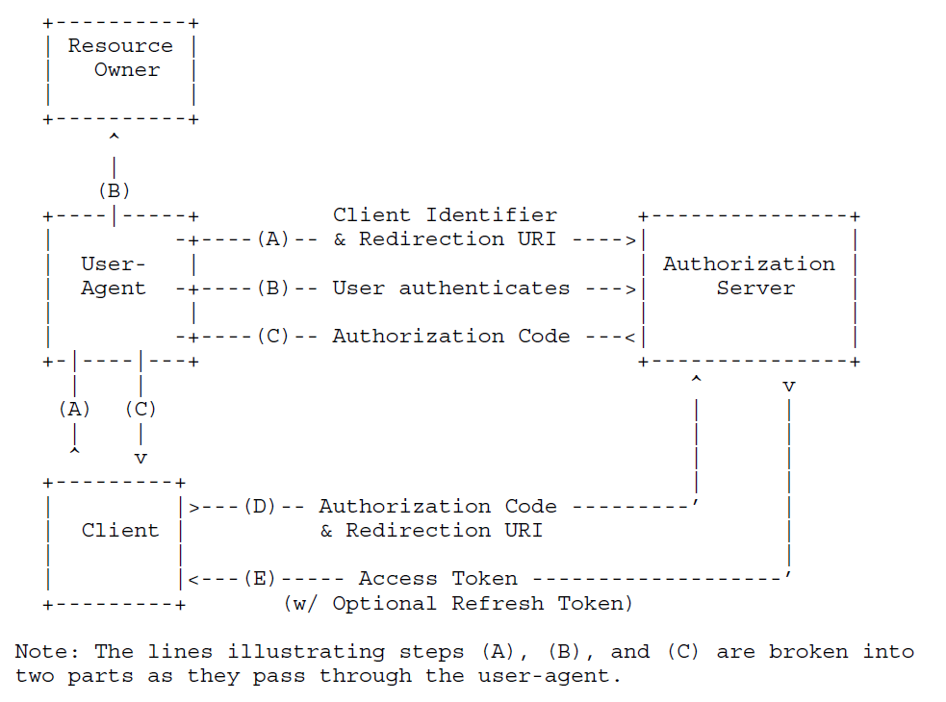

Figure 6.1.2.3-1 Procedure of Obtaining Resource owner Authorization (from RFC 6749 [4])

OAuth 2.0 with authorization code grant model is depicted in clasue 4.1 in RFC 6749 [4]. In this solution, the API invoker endorses the role of client, the triggerer endorses the role of user-agent. The Authorization Function authenticates the resource owner in step B, which depends on existing mechanism and is out of this solution. The API invoker (i.e. client) retrieves tokenCAPIF from the Authorization function in CCF. The scope of the tokenCAPIF includes API invoker ID, service API ID and resource owner ID (i.e. GPSI).

Authorization can be revoked according to mechanism defined in IETF RFC 7009 [7].

The resource owner ID is equal to the UE ID in the API invocation message, e.g. GPSI.

6.1.2.4 TokenCAPIF Profile

The tokenCAPIF is protected by the JSON signature profile as specified in IETF RFC 7515 [8].

The claim in the tokenCAPIF includes the parameters defined in C.2.2 in TS 33.122 [5]. In addition, “resource owner ID” related to the list services is also added in scope. The resource owner ID is equal to the UE ID in the API invocation message, e.g. GPSI.

Editor’s Note: It is FFS how authorization decision is executed in the UE by which entity.

### 6.1.3 Evaluation

The solution works when the TLS with OAuth token is selected. This solution addresses the requirements Authz-1, Authz-2, Authz-3 and Authz-4, but does not address the following requirements in KI#2:

This solution doesn’t touch authentication of the resource owner by the authorization server, it may be addressed by other solution.

This solution doesn’t touch authentication between API invoker and CCF and authentication between API invoker and AEF, it may be addressed by other solution.

This solution doesn’t touch revocation of authorization, it may be addressed by other solution.

This solution doesn’t touch privacy of the UE's external identity against the third-party, it may be addressed by other solution. This solution doesn’t address a static token claim issue after token revocation.

*************** End of 1st Change ****************