**3GPP TSG-SA3 Meeting #109Adhoc-e *S3-230157***

**Online, 16 - 20 January 2023**

**Source:**  **Huawei, HiSilicon**

**Title:** **Addressing the editor's note in solution 1**

**Document for: Approval**

**Agenda Item: 5.10**

# 1 Decision/action requested

***It is proposed to approve the change described in this document.***

# 2 References

N/A

# 3 Rationale

It’s proposed to address the editor’s note with additional clarification.

# 4 Detailed proposal

*** 1st CHANGE ***

## 6.2 Solution #1: PINE authentication and authorization

### 6.2.1 Introduction

This solution addresses the requirement in KI#1 on authentication and authorization for PINE.

This solution provides a method to ensure that the PINE can be authenticated and authorized by an AF before the connectivity for PINE is enabled. The authentication may be triggered by the SMF during the PDU session modification procedure. The authorization is performed based on authentication results.

### 6.2.2 Solution details

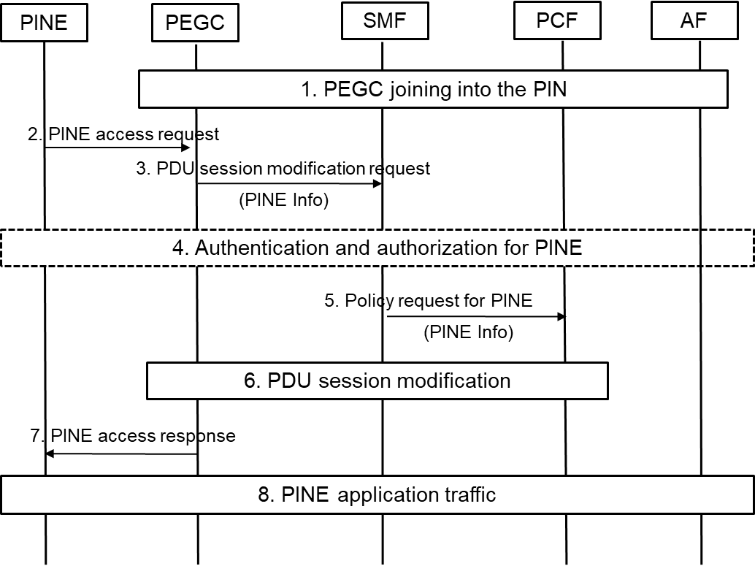

Figure 6.2.2-1 call flow of authentication and authorization for PINE

As show in the Figure 6.2.2-1, the details of authentication and authorization for PINE is summarized as following:

1. PEGC registers to the 5GS and joins into the PIN.

2. A PINE requests to access the PEGC for traffic relay to 5GS.

3. The PEGC initiates PDU Session modification procedure with the PINE information sent to the SMF via NAS signalling. PINE information includes at least PINE ID. The criteria for triggering PDU Session modification request can be based on existing mechanism or implementation.

4. The SMF determines whether authentication is required for the PINE with PINE information. Authentication for PINE shall only be triggered if the PEGC has provided PINE ID. The SMF triggers the authentication procedure and send a message to AF via NEF. The authentication messages are included in a transparent container and conveyed between the PINE and the AF via 5GC. AF provides authentication result to SMF. In this case, authorization is performed based on authentication results.

NOTE: Multiple round-trip messages may be needed as required by the authentication method used by the AF. The EAP method used to authenticate the UE and the content of Authentication Messages to support that method are out of scope of 3GPP.

5. The SMF updates the PCF with the PINE information in SM Policy Association Modification if PINE is authorized.

6. The QoS flow for the PINE communication with 5GS is established via PDU session modification procedure.

7. The PEGC sends a response to the PINE.

8. The application traffic of the PINE is relayed to the AF via the PEGC and 5GS.

### 6.2.3 Evaluation

This solution addresses the requirement in KI#1 on authentication and authorization for PINE.

In 5GC, SMF determines to trigger the authentication procedure during the PDU session modification procedure. The authorization is performed based on authentication results. Therefore, the solution has impact on 5GC.

The authentication messages are included in a transparent container and conveyed between the PINE and the AF via 5GC. No additional impact is required for transferring these messages.

Editor’s note: Alignment with SA2 conclusion is FFS.

Editor’s Note: Impact of 5GS managing credentials should be evaluated

*** END OF 1st CHANGE***