3GPP TSG-SA3 Meeting #105-e S3-213897-r1

e-meeting, 8 - 19 November 2021

Source: Johns Hopkins University APL, US National Security Agency, CableLabs, InterDigital, AT&T, CISA ECD, NIST

Title: New Solution Using Boot Time Attestation for NF Registration

Document for: Approval
Agenda Item: 5.3

1 Decision/action requested
It is requested to approve this contribution for a new solution in TR 33.848

2 References
[1] 3GPP TR 33.848: “Study on Security Impacts of Virtualisation”

3 Rationale
Key Issue 13 states that without a full attestation chain from the 3GPP function level to the hardware level, a 3GPP Network at the application layer is not able to verify the trustworthiness of VNFs or the NFVI. This solution proposes using attestation starting at the hardware level and propagating it up through NFVI layers to the VNF software to create a full attestation chain for establishing a level of trustworthiness for VNFs and the NFVI.

4 Detailed proposal
****Start of 1st Change ****

2 References
The following documents contain provisions which, through reference in this text, constitute provisions of the present document.
- References are either specific (identified by date of publication, edition number, version number, etc.) or non-specific.
- For a specific reference, subsequent revisions do not apply.
- For a non-specific reference, the latest version applies. In the case of a reference to a 3GPP document (including a GSM document), a non-specific reference implicitly refers to the latest version of that document in the same Release as the present document.
[1] 3GPP TR 21.905: "Vocabulary for 3GPP Specifications".
[2] ETSI GS NFV 002: "Network Functions Virtualisation (NFV); Architectural Framework".
[3] ETSI GS NFV-SEC 009: "Network Functions Virtualisation (NFV); NFV Security; Report on use cases and technical approaches for multi-layer host administration".
[4] 3GPP TS 33.210: "3G security; Network Domain Security (NDS); IP network layer security"
[5] ETSI GS NFV-SEC 001: "Network Functions Virtualisation (NFV); NFV Security; Problem Statement"
[6] 3GPP TS 33.501: "Security architecture and procedures for 5G System".
[7] "Virtualization Technology: Cross-VM Cache Side Channel Attacks make it Vulnerable"; Shahzad and Litchfield 2015; https://arxiv.org/ftp/arxiv/papers/1606/1606.01356.pdf
[8] "OpenStack"; https://www.openstack.org/
[9] ETSI GR NFV-SEC 016: "Network Functions Virtualisation (NFV); Security; Report on location, timestamping of VNFs".
[10] ETSI GS NFV-SEC 012: "Network Functions Virtualisation (NFV) Release 3; Security; System architecture specification for execution of sensitive NFV components".
[11] ETSI GR NFV-SEC 011: " Network Functions Virtualisation (NFV); Security; Report on NFV LI Architecture".
[12] ETSI GS NFV-SEC 013: "Network Functions Virtualisation (NFV) Release 3; Security; Security Management and Monitoring specification".
[X] 3GPP TS 23.502: “System architecture for the 5G System (5GS)"
[Y] ETSI GR NFV-SEC 007: "Network Functions Virtualisation (NFV); Trust; Report on Attestation Technologies and Practices for Secure Deployments".
[Z] ETSI GR NFV-SEC 018: “Network Functions Virtualisation (NFV); Security; Report on NFV Remote Attestation Architecture”.
****End of 1st Change****

Note to rapporteur: all text in change #2 below is new.
****Start of 2nd Change ****

6.Y Solution Y: Solution Using Boot Time Attestation for NF Registration
This solution addresses Key Issue 13: Attestation at 3GPP Function Level. ETSI NFV reports, such as ETSI GR NFV-SEC 007 [Y] and ETSI GR NFV-SEC 018 [Z], provide guidance on attestation technologies, practices, and architectures. However, no standardized attestation framework is specified for virtualized 3GPP NFs. To attest a virtualized 3GPP NF through a full chain of trust from the VNF layer down to the hardware layer, attestation infrastructure and procedures are needed both within the 3GPP functional domain and outside its domain. This solution seeks to 1) identify dependencies on underlying elements outside the 3GPP functional domain and 2) introduce new functionality to coordinate access to attestation services at the 3GPP functional level.

6.Y.1 Introduction

6.Y.1.1 Reference Architecture for Attestation
Attestation is a process to determine the trustworthiness of a platform. Attestation provides cryptographic evidence of the integrity of hardware, firmware, software, and other critical security functions to show that a system has not been breached and is in a valid state.
Implementation of an attestation architecture and protocols are not in scope of this solution. A conceptual attestation architecture is depicted in Figure 6.Y.1.1-1 to make clear the attestation terminology used in this solution.
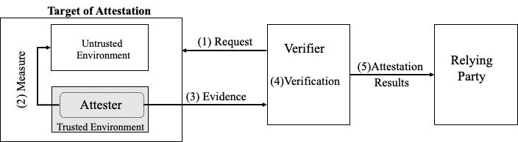
Figure 6.Y.1.1-1: Reference Architecture for Attestation
An attestation architecture typically involves three roles:
- Attester: performs integrity measurements on the target system which is to be attested and generates a set of claims called Evidence.
- Verifier: verifies the Evidence on the basis of reference values or other complex logic and generates an Attestation Result that declares the target system as trustworthy or not.
- Relying Party: depends on the Attestation Results to apply specific actions.
A typical attestation cycle consists of the following steps illustrated in Figure 6.Y.1.1-1:
- Verifier sends an attestation request to the target system.
- Upon receiving the attestation request, the Attester measures the target’s untrusted environment and collects the integrity measurements into evidence.
- Attester sends the evidence to the Verifier.
- Upon receiving the evidence, the Verifier validates the received measurements against reference values or applies implementation-specific logic. The validation results assert whether the system under evaluation is in trustworthy state or not.
- Verifier sends validation results to a Relying Party. The Relying Party uses the attestation results to decide the extent to which it will interact with the attested system.
Local attestation occurs when the Attester and Verifier run on the same physical machine. When the Verifier is remote, this is referred to as remote attestation.
Attestation procedures should adhere to the following in order to trust the process:
- An Attester should run in a trusted environment with complete access to the system so that it can take accurate and comprehensive measurements even when measuring a corrupted component.
- An Attester should run on component boot up.
- Measurements should be sent from the Attester to the Verifier in a manner that ensures freshness, confidentiality, integrity, and authenticity.
- Measurements on a component should be stored in a secure manner to prevent unauthorized modification prior to being sent to the Verifier.
- A Verifier should run in a trusted environment.
- Attestation results should be sent from the Verifier to the Relying Party in a manner that ensures freshness, confidentiality, integrity, and authenticity.

6.Y.1.2 Attestation in NFV Environments
In a NFV environment, a virtualised 3GPP NF executes inside a virtual instance (e.g., virtual machine or OS container) created by virtualisation software (e.g., hypervisor or container engine). The virtualisation software mediates access to virtual resources that it abstracts from the physical resources in the hardware platform. The hardware platform includes other building blocks (e.g., BIOS, operating systems, etc.) for operation. Therefore, the scope of attestation of a VNF comprises all the aforementioned systems and components involved.
Attestation in an NFV environment is established with a chain of trust (CoT). That is, the trustworthiness of the VNF is guaranteed by the trustworthiness of the virtual instance, the trustworthiness of the virtual instance is guaranteed by the trustworthiness of the virtualisation software, and so on back to the trustworthiness of the hardware. A component participating in a CoT cannot influence its own measurement procedure, as its execution begins only after it has been measured and verified [Y]. The CoT starts with an implicitly trusted attester, called a Root of Trust (RoT), and extends up to the last software component.
In the NFV architecture, components participating in the CoT are under the control of different domains. The VNF and virtual instance it runs within are in the 3GPP functional domain. Whereas the virtualisation software and the hardware platform are in the NFVI domain.
To illustrate the interdependency of attestation across domains, Figure 6.Y.1.2-1 shows a conceptual flow of measurements needed to form a CoT from the hardware layer to the VNF. The steps include:
- RoT measures hardware (including supporting components: firmware/BIOS, OS, etc.)
- Hardware measures virtualisation layer (e.g., hypervisor or container engine)
- Virtualisation layer (e.g., hypervisor or container engine) measures the virtual instance (e.g., VM or container)
- Virtualized RoT (vRoT) measures the VNF. The vRoT is a virtual instance associated to the hardware protected RoT. The virtualisation layer software provides this virtual resource to the virtual instance.

Figure 6.Y.1.2-1: Conceptual flow of measurements that form a CoT from the hardware layer to the VNF
A VNF’s trusted state relies on the state of trust of the underlying elements. More precisely, measurement of the VNF relies on a mechanism in the NFVI domain (in this example the vRoT). The cross-over in domain affects the scope of attestation for VNFs. The target of attestation, i.e., the VNF, is in the 3GPP functional domain and the mechanism for generating evidence on the target, e.g., the vRoT, is in the NFVI domain. Furthermore, trust in any measurements logged by the virtual resource (e.g., vRoT) is predicated on trust in the virtualisation layer software (e.g., hypervisor or container engine) that instantiates the resources to be used by the virtual instance (e.g., VM or OS container).
Additionally, relying parties in the 3GPP functional domain that make decisions based on attestation results may need to influence what is measured during the attestation process according to the level of assurance required by the relying party. Different 3GPP VNFs (i.e., relying parties) may have different criteria for trustworthiness. These aspects on configuration are within scope of 3GPP.

6.Y.2 Solution Details
This solution focuses on boot-time attestation, where a chain of trust is established during the boot process of the NFVI. The chain is extended to include attestation of the VNF when it is first instantiated on top of the NFVI.
Editor’s Note: Run-time attestation is FFS
Defining attestation for NFV environments is out of scope of 3GPP. However, attestation of NFVI and attestation of VNFs are discussed in this solution to layout the foundational building blocks and propose a set of requirements from the perspective of 3GPP functional domain. It is also necessary to examine NFVI and VNF attestation to understand how attestation results can be used within 3GPP functional domain and how the 3GPP functional domain can influence configuration of attestation in the NFV domain.
A new function called the Profile and Attestation Check Function (PACF) is proposed to enable access to the attestation results from the 3GPP functional level and distribute attestation policy to control how attestation is applied. The PACF may be standalone or co-located with OSS/BSS, NRF, or other network security functions.
This solution proposes using proof of attestation results to decide whether to register a VNF. A modified NF Registration procedure is proposed that uses the PACF to obtain access to the attestation results.
This solution is complementary to attestation services performed by the management layer.

6.Y.2.1 Attestation of the NFVI
Figure 4.2-1 shows the ETSI NFV high-level architecture. The NFVI is a collection of NFVI-Nodes. Each NFVI-Node is a physical device deployed and managed as a single entity, providing the NFVI functions required to support the execution environment for VNFs. Each node goes through the attestation process to produce a chain of trust starting from the server/hardware layer. Only after successful attestation of each layer, the NFVI-node joins the NFV infrastructure.
Each NFVI-node includes at minimum the following components:
- Server / Hardware Resource – bare metal equipment that the entire NFV stack runs upon. It provides physical storage, compute, and network I/O to the OS and virtualization software. Virtual resources are instantiated on these physical resources for VNFs.
- Operating System (OS) – full featured or customized OS that runs the software necessary for a NFV.
- Virtualization Layer– software (e.g., hypervisor or container engine) that creates a virtual instance (e.g., Virtual Machine or OS container) to run VNFs
Any attestation solutions for NFVI should provide the following chain of attestation:
- Attestation of the Server / Hardware Resource: a RoT measures and verifies the server platform consisting of firmware and hardware. After successful attestation of the server, it will act as the attester for the layer above. The attestation results and corresponding measurements are maintained by a verifier for subsequent access.
- Attestation of the OS: the server measures and verifies the OS. After successful attestation of the OS, it will act as attester for the layer above. The attestation results and corresponding measurements are maintained by a verifier for subsequent access.
- Attestation of the Virtualisation Layer software: the OS measures and verifies the virtualisation software. The virtualisation software may be a hypervisor or a container engine. If the virtualisation software is pre-loaded into the OS, then its attestation is included with the attestation of the OS. The attestation results and corresponding measurements are maintained by a verifier for subsequent access.
If any step in the attestation process fails, the CoT cannot be expanded further and a recovery procedure should be activated to handle the failure.

6.Y.2.2 Attestation of VNFs
As a precondition to attestation of VNFs, it is assumed the NFVI-node has been successfully attested and can be trusted to attest VNFs running on its platform. More precisely, the virtualization layer software has been successfully attested and can act as the attester for VNFs.
Also note that a VNF runs inside a virtual instance, either VM-based or based on an OS-container. Thus, any attestation solutions for VNFs should consider both use cases.
Any attestation solution for VNFs should provide a process that includes the following steps.
The process is initiated by the NFV MANO requesting to instantiate a new VNF.
- The NFVI retrieves the virtual instance from network storage that is within the NFVI.
- If the VNF software is not preloaded on the virtual instance, the VNF software specific to the type of VNF being instantiated is retrieved from network storage.
- The NFVI attests the virtual instance and VNF:
  - The virtualisation layer software (e.g., hypervisor or container engine) measures the virtual instance and VNF software and reports the evidence to a Verifier.
  - The Verifier validates the measurements. The attestation results and corresponding measurements are maintained by the verifier for subsequent access.
- NFV MANO provides the VNF with a signed NF profile [X], clause 4.17.1. (TS 23.502, clause 4.17.1, NOTE 2 states the NF profile is configured by OAM system).
Editor’s Note: References to the NFV management and orchestration as “NFV MANO” vs. “OAM” should be aligned with the terminology in TS 23.502 clause 4.17.1.
- The NFVI begins to run the VNF.
If any step in the attestation process fails, the CoT cannot be expanded further and a recovery procedure should be activated to handle the failure.

6.Y.2.3 Proposed Requirements for Attestation in NFV Environments
Currently, no specification exists that defines support for attestation in NFV environments. The following requirements are proposed for consideration for future development of NFV specifications to assist the 3GPP functional domain in VNF attestation:
- The NFV architecture shall provide support for attestation.
- Support for attestation shall include NFVI subsystems and components described in 6.Y.2.1.
- Support for attestation of VNFs shall include VM-based and container-based use cases as described in 6.Y.2.2.
- The NFV architecture shall provide external access to the attestation measurements and attestation results.
- Verification of attestation evidence from NFVI shall be performed by a verifier external to NFVI to support remote attestation
- The external verifier should be within the NFV MANO domain
- Support for a mechanism to establish trust between the 3GPP functional domain and the external verifier shall be provided.
- The NFV architecture shall provide an interface and protocol to allow the 3GPP functional domain to send attestation policies to the NFV architecture to support configuration of attestation parameters.

6.Y.2.4 Profile and Attestation Check Function (PACF)
Since the attestation procedures to verify the trustworthiness of VNFs and NFVI exist outside the domain of the 3GPP functional level, access to the attestation results is needed from within the 3GPP functional level. This access allows attestation to be integrated with select procedures in the control plane, such as NF registration and slicing operations. For instance, enterprise slices for some verticals may require the ability to query for proof of successful attestation to support their use cases. Applicability to NF registration is discussed in 6.Y.2.5.
Additionally, default application of the same level of attestation to every virtualized NF in a 3GPP network may not be necessary. In which case, the 3GPP functional level can provide an attestation policy to the infrastructure responsible for attestation. The attestation policy describes the conditions for applying attestation and the type of measurements required to meet a specified level of assurance per VNF.
This solution proposes the PACF to coordinate access to attestation results from the 3GPP functional level and administer policy to help control how and when attestation is applied. Figure 6.Y.2.4-1 presents a reference architecture integrating PACF into the NFV architecture. This architecture assumes the NFVI has been successfully attested and the virtualization layer software can act as the attester for VNFs.
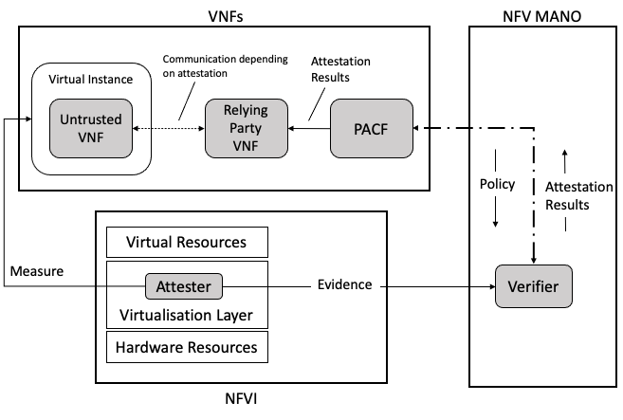
Figure 6.Y.2.4-1 Reference architecture with PACF integrated with NFV architecture
The PACF serves as a bridge between the 3GPP functional level and the attestation infrastructure outside its domain. The PACF requires a secure communication path to the Verifier. Policy information is sent from PACF to the Verifier. Attestation results are sent from the Verifier to the PACF. A trust relationship must be pre-established between the PACF and the Verifier. Other network functions acting as Relying Parties must also trust the Verifier. This solution assumes the Verifier is located within the NFV MANO domain.
Editor’s Note: Communication between the PACF and NFV MANO is FFS.

6.Y.2.5 NF Service Registration Procedure with Remote Attestation
This solution proposes to provide proof to the 3GPP functional domain that a new VNF has been successfully attested before registration occurs in the 5G Core.
Once successfully instantiated, a new VNF will register with the NRF. The original NF Service Registration procedure is detailed in [X], clause 4.17.1. The modified NF Service Registration procedure shown in Figure 6.Y.2.5-1 includes attestation by adding steps 2, 3, and 4. Steps 1, 5, and 6 are steps from the original procedure.

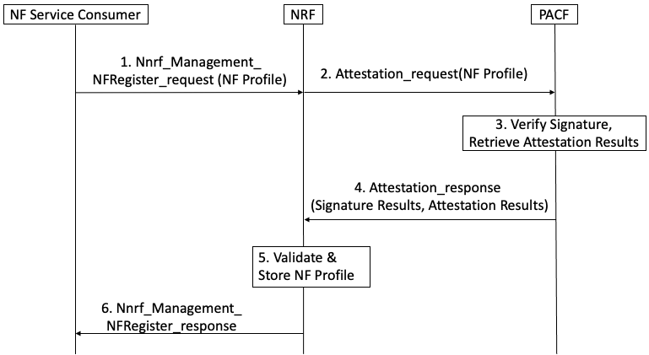
Figure 6.Y.2.5-1: NF Service Registration Procedure with PACF

When an NF requires attestation results to register, the following steps are proposed for the registration procedure:
Step 1: NF service consumer, i.e. an NF instance, sends Nnrf_NFManagement_NFRegister Request message to NRF to inform the NRF of its NF profile when the NF service consumer becomes operative for the first time.
NOTE: The NF service consumer’s profile is configured and signed by the NFV MANO
Step 2: The NRF initiates a request for attestation results and sends the signed NF profile to the PACF.
Step 3: The PACF uses the MANO’s public key to verify the signature on the NF profile and retrieves attestation results from the NFV MANO using the NF Instance ID from the NF profile.
Step 4: The PACF responds to the NRF with the NF profile signature verification results and attestation results it received from the NFV MANO.
Step 5: If the profile signature verification passes and the attestation results affirm successful attestation, the NF service consumer can be trusted. The NRF stores the NF profile of NF service consumer and marks the NF service consumer available.
Otherwise, if the signature fails verification and/or the attestation results affirm an unsuccessful attestation, the NF consumer cannot be trusted and a recovery procedure should be activated to handle an untrusted NF.
Step 6: The NRF acknowledge NF Registration is accepted via Nnrf_NFManagement_NFRegister response.

6.Y.3 Evaluation
Editor’s Note: To be added.
Editor’s Note: In cases where the NF does not need to register to NRF, the NRF cannot perform verification of the attestation results as proposed in the solution. Evaluation of this case is FFS.

****End of 2nd Change****

