3GPP TSG-SA3 Meeting #104e-Ad-hoc draft_S3-213397-r2

e-meeting, 27-30 Sept 2021 Revision of S3-20xxxx

Source: Huawei; HiSilicon

Title: Update to Solution #38

Document for: Approval
Agenda Item: 5.2

1 Decision/action requested
Kindly Request this contribution on TR 33.847 can be accepted by the group

2 References
N/A

3 Rationale
This contribution propose to address the ENs, as well as futher evaluate the solution. This contribution also fixs a typo on the figure (the abbrev of Announcing/Discoveree UE should be A-UE instead of M-UE).

4 Detailed proposal

**** 1st change****

6.38 Solution #38: Mitigating the conflict between security policies using restricted discovery procedures on network side

6.38.1 Introduction
This solution addresses Key Issue #12 and Key Issue #17, the mechanism in this solution relies on the Key Issue #1 related discovery procedures to avoid one-to-one communication failure caused by policy mismatch. Two UEs should finish the discovery authorisation and the direct one-to-one communication establishment before actually starting direct one-to-one communication (i.e. the discovery request procedures are prerequisite steps of direct one-to-one communication, except for the scenario in which UEs can start one-to-one communication directly).
In the referenced technology, eV2X unicast in 33.536 [8], security flexibility is provided by introducing on-demand PC5 one-to-one communication policies. The security policies for eV2X UEs may be provisioned by different PCFs and they might with different values (e.g. eV2X allows different security policies at different geographic locations). eV2X still has a mechanism to abort the PC5 unicast establishment upon policy mismatch (e.g. NOT NEED and REQUIRED) if the peer UE replies to the annunciation of the same v2x service from the initiating UE. This shows the security policies on each UE may not the same for the same service/ProSe Code. For the above reasons, UEs still need to negotiate final security activation status according to the real-time conditions and the network has no such real-time information.
The conflict between security policies may cause one-to-one communication establishment failure and make the previous discovery request procedures in vain. To avoid resource waste caused by the conflict between policies, this contribution proposes to distribute the same security policy with the help of the discovery procedures specified in TS 33.303 [6] for 5G ProSe restricted discovery.
NOTE: This solution does not work with the V2X based direct discovery.
NOTE: This solution requires network coverage to work.

6.38.2 Solution details
The UEs use the following discovery procedures to get the one-to-one communication security policy:
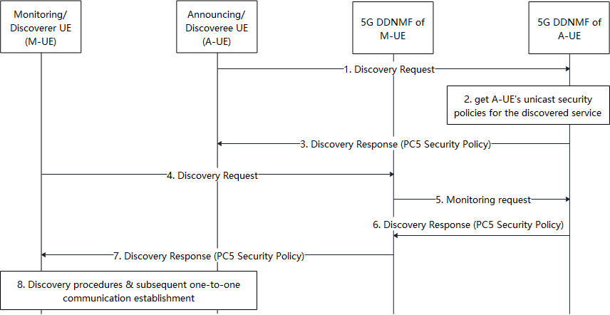
Figure 6.38.2-1: UEs get the security policy during the discovery procedures
The Step 1-3 show the discovery request procedures of Announcing UE or Discoveree UE (hereinafter called A-UE):
- The A-UE sends a Discovery Request message to the 5G DDNMF in its HPLMN (A-DDNMF) to get the discovery parameters and the associated security material for discovering the peer under specific ProSe service.
- The A-DDNMF may check for the authorization of A-UE to use the ProSe service. The A-DDNMF further gets one-to-one communication security policy of the ProSe service related to the Discovery Request in step 1. The security status of the one-to-one communication of the ProSe service is decided based on the security policy.
NOTE: A-DDNMF get the security policy from PCF, or other selected methods during the normative phase.
- The A-DDNMF returns the discovery parameters, the associated security materials and the security policy to the A-UE.
The Step 4-8 shows the discovery request procedures of Monitoring or Discoverer UE (M-UE):
- The M-UE sends a Discovery Request message to the 5G DDNMF in its HPLMN (M-DDNMF) to get the discovery parameters and security materials for discovering the peer under the same ProSe service in step 1-3.
- The M-DDNMF may check for the authorisation of M-UE to use the ProSe service. If the Discovery Request is authorised, The M-DDNMF sends a Monitor Request to the A-DDNMF to request the one-to-one communication security policy of the ProSe service which was got by A-DDNMF in step 2.
- The A-DDNMF responds to the M-DDNMF with a Monitor Response message including the discovery parameters, the associated security materials and the security policy.
- The M-DDNMF returns the discovery parameters, the associated security materials and the security policy to the M-UE.
- The A-UE and M-UE process to discovery each other and continue the subsequent one-to-one communication establishment procedures using the one-to-one communication security policy from A-DDNMF and M-DDNMF, respectively.

6.38.3 Evaluation
This solution involves the ProSe discovery procedure related to Key Issue #1 and one-to-one communication establishment procedure related to Key Issue #12. Specifically speaking, this solution prevents one-to-one communication failure caused by policy mismatch by provisioning the same security policy to the UEs, which addresses Key Issue #12, the mechanism in this solution relies on the Key Issue #1 related discovery procedures. This solution also addresses Key Issue #17 about provisioning PC5 security policies to UE. Security flexibility is provided by introducing on-demand PC5 one-to-one communication policies and the policy mismatch during one-to-one communication establishment makes the discovery signalling in vain, as well as network resource waste. To avoid resource waste caused by policy confliction during one-to-one communication establishment, this contribution to distribute the same security policy with the help of the discovery procedures.
The following security requirements in Key Issue #12 are addressed by this solution:
In this solution, UEs receive the security policies from 5G DDNMFs upon requesting the discovery parameters of specific ProSe service. Thus this solution is capable to address the security requirement in Key Issue #12 to provide security policies to UEs for a particular service: ‘The system shall support means of providing the signalling and user plane security policies to UEs for a particular PC5 one-to-one communication.’
The following security requirements in Key Issue #17 are addressed by this solution:
‘5G ProSe system shall support a means to securely provision the configured PC5 security policies to the UE for 5G Prose services.’

Editor’s Note: It is FFS how this solution supports V2X.
**** End of changes****

