3GPP TSG-SA3 Meeting #104-e- Ad-hoc draft_S3-213392-r1

e-meeting, 27 – 30 September 2021

Source: Huawei, HiSilicon

Title: Update to the clause 2 and 5.3.2

Document for: Approval
Agenda Item: 4.7

1 Decision/action requested
Acceptance of context for CR in UAS security.

2 Detailed proposal
*** BEGIN OF 1st CHANGE ***

2 References
The following documents contain provisions which, through reference in this text, constitute provisions of the present document.
- References are either specific (identified by date of publication, edition number, version number, etc.) or non-specific.
- For a specific reference, subsequent revisions do not apply.
- For a non-specific reference, the latest version applies. In the case of a reference to a 3GPP document (including a GSM document), a non-specific reference implicitly refers to the latest version of that document in the same Release as the present document.
[1] 3GPP TR 21.905: "Vocabulary for 3GPP Specifications".
[2] 3GPP TS 33.501: “Security architecture and procedures for 5G system”
[3] 3GPP TS 23.256: "Support of Uncrewed Aerial Systems (UAS) connectivity, identification and tracking; Stage 2".
…
*** END OF 1st CHANGE ***
*** BEGIN OF 2nd CHANGE ***

5.3.2 Location information veracity and location tracking authorization in 5GS
USS may receive the location information which is reported by UAV via the application layer. The USS may decide to check and verify the location information in order to prevent spoofed and forged location information. The location result from 5GS helps to verify the location information reported from UAV side. 5GS provides network-based location information by utilising the Location Services (LCS) supported by AMF or GMLC as specified in TS 23.273 [4] and 23.502 [5], and the detailed procedures of location information veracity and location tracking authorisation are described below.
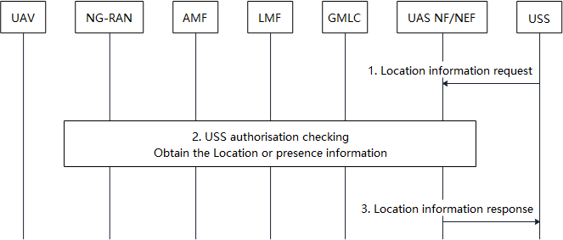
Figure 5.3.2-1: location information veracity and location tracking authorisation in 5GS
Step 1-3 shows the procedure for the USS to obtain a network-based location for UAV(s).
1. The USS sends the location request to UAS NF/NEF to request the UAV location or presence from network. The location request includes the GPSI of the UAV to request the location information or presence about an individual UE, or a geographic area when trying to find the information of all UAVs in an area. The LCS request also indicates the 5GS to obtain location information with high reliability.
If the USS/TPAE does not specify target 3GPP UAV ID and request UAS NF for a list of the UAVs in the geographic area and served by the PLMN, clause 5.3.1.3 and 5.3.4 in TS 23.256 [3] apply.
2. The UAS NF/NEF first verifies the request in step 1 is authorised. When the USS sends a GPSI, this is done by checking whether the identifier of the USS sending the request matches the previously associated mapping between the GPSI and the USS identifier. When the USS request UAS NF for a list of the UAVs in the geographic area, this is done by checking the USS is authorised to receive the CAA level ID of all UAVs in a geographic area indicated by the USS. The UAS NF/NEF gets the relevant UAV(s) location information or presence from AMF or GMLC by the current location services supported by AMF or GMLC if passes the above authorisation check. On the condition of the location services provided by AMF, the UE presence status is provided by reusing the Area of Interest mechanism. On the condition of the location services provided by GMLC, the GMLC indicates LMF via AMF to select Network Assisted Positioning method which relies on the location measurement from NG-RAN nodes, if receiving high reliability requirement in step 1.

NOTE: The USS may be authorized by UAS NF/NEF by means not specified in this release of the specification.
3. The UAS NF/NEF provides the UAV(s) location information or presence to the USS. When the USS request UAS NF for a list of the UAVs in the geographic area, the UAS NF checks the USS is authorized to receive such information before sending them. USS may make decisions to control the UAV based on the result output received from UAS NF/NEF.
Editor’s Note: How the UAS NF authorises the USS before providing UAV details is FFS.
Editor’s Note: It’s FFS how TPAE involve in this procedures
*** END OF 1nd CHANGE ***

