3GPP TSG-SA3 Meeting #100bis-e S3-202615

e-meeting, 12 - 16 October 2020 Revision of S3-20xxxx

Source: Samsung

Title: Transport security for the MSGin5G interfaces

Document for: Approval
Agenda Item: 2.15

1 Decision/action requested
It is proposed to approve this key issue on transport security for the MSGin5G interfaces for TR 33.862.

2 References
[1] 3GPP TR 33.862 Study on security aspects of the Message Service for MIoT over 5G System (5GMSG)

3 Rationale
New interfaces (i.e. MSGin5G-1-5) were introduced in the architecture for MSGin5G Service. This key issue studies the related transport security, i.e. confidentiality, integrity and replay-protection.

4 Detailed proposal

*****Start of 1st Changes*****

2 References
[xx] 3GPP TR 23.700-24 Study on support of the 5GMSG Service (Release 17)
[yy] 3GPP TS 23.222 Functional architecture and information flows to support Common API Framework for 3GPP Northbound APIs; Stage 2 (Release 17)

*****Start of 2ndChanges*****

5.X Key issue #X: Transport security for the MSGin5G interfaces

5.X.1 Key issue details
TR 23.700-24 [xx], clause 8.2 describes an application architecture of the MSGin5G Service.
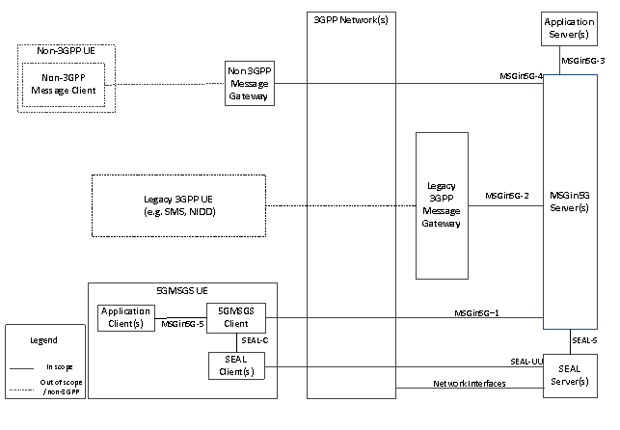

Figure 5.X-1: Application Architecture of the MSGin5G Service

New interfaces (i.e. MSGin5G-1-5) were introduced in the architecture for MSGin5G Service. This key issue studies the related transport security, i.e. confidentiality, integrity and replay-protection.
MSGin5G-1: Between a 5GMSGS client and a MSGin5G Server. This reference point supports:
  - Registration of a 5GMSGS client to a MSGin5G Server when not using IMS base solution; and the exchange of MSGin5G messages.
MSGin5G-2: Between a MSGin5G Server and the Legacy 3GPP Message. This reference point supports:
  - Indicating the underlying message delivery mechanism to the Legacy 3GPP Message Gateway; and exchange of MSGin5G messages; and registration of Legacy 3GPP Message Gateway to MSGin5G Server.
MSGin5G-3: Between an Application Server and a MSGin5G Server. This reference point supports:
  - Access to MSGin5G Server and APIs to enable sending and receiving of MSGin5G messages; and Adherence to CAPIF as specified in 3GPP TS 23.222[yy].
MSGin5G-4: Between a Non-3GPP Message Gateway and a MSGin5G server. This reference point supports:
  - Registration of Non-3GPP Message Gateway to MSGin5G Server; and the exchange of MSGin5G messages.
MSGin5G-5: Between an application client and a 5GMSGS client. This reference point supports:
  - Providing information from application clients required to enable the 5GMSGS client to construct a MSGin5G message to be delivered to other MSGin5G service endpoints.
  - Configuring application clients with information required to enable the 5GMSGS client and MSGin5G Server to exchange and route MSGin5G messages to other MSGin5G service endpoints.
  - Sending notifications and information in the incoming MSGin5G messages received by the 5GMSGS client to the application clients from other MSGin5G service endpoints.
NOTE: As MSGin5G-5 is an internal interface between application client and a 5GMSGS client within the UE, the protection should be taken care by the UE implementation.

5.X.2 Threats
Without confidentiality, integrity and replay protection, an attacker may eavesdrop or manipulate or replay the communication or initiate the MitM attacks on the interface.

5.X.3 Potential security requirements
Confidentiality protection, integrity protection and replay-protection shall be supported on the MSGin5G-1-4 interfaces.

*****End Change*****

