3GPP TSG-SA3 Meeting #100bis-e S3-202591

e-meeting, 12 - 16 October 2020 Revision of S3-20xxxx

Source: Ericsson

Title: Separate UP-keys per CU-UP instance

Document for: Approval
Agenda Item: 2.13

1 Decision/action requested
It is proposed to approve the pCR

2 References
[1] 3GPP TR 33.840 V0.0.3, Study on Security aspects of the disaggregated gNB architecture

3 Rationale
The system supporting disaggregated gNB-CU-UPs shall maintain the security principle of separate UP-keys per CU-UP instance. See below.

4 Detailed proposal
**** START OF CHANGES ****

5.X Key Issue #X: Separate UP-keys per CU-UP instance

5.X.1 Key issue details
3GPP TR 38.823 describes different deployment scenarios for CU-UPs, see Figure 5.X.1-1. One option is that all CU-UPs are centralized in a single location. Another option is that all CU-UPs are centralized, but in different locations. Yet another option is that some CU-UP is centralized while others are distributed.
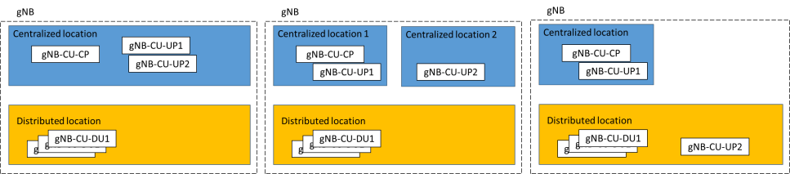
Figure 5.X.1-1: gNB-CU-UP deployment options (copied from 3GPP TR 38.823)

5.X.2 Security threats

When CU-UPs centralized in different locations if one CU-UP in a location is compromised, the attacker can also compromise other CU-UPs in other locations.

5.X.3 Potential security requirements

Different CU-UPs in different locations shall be achieved the same security level.
**** END OF CHANGES ****

