3GPP TSG-SA3 Meeting #100bis-e S3-202591

e-meeting, 12 - 16 October 2020 Revision of S3-20xxxx

Source: Ericsson

Title: Separate UP-keys per CU-UP instance

Document for: Approval
Agenda Item: 2.13

1 Decision/action requested
It is proposed to approve the pCR

2 References
[1] 3GPP TR 33.840 V0.0.3, Study on Security aspects of the disaggregated gNB architecture

3 Rationale
The system supporting disaggregated gNB-CU-UPs shall maintain the security principle of separate UP-keys per CU-UP instance. See below.

4 Detailed proposal
**** START OF CHANGES ****

5.X Key Issue #X: Separate UP-keys per CU-UP instance

5.X.1 Key issue details
3GPP TR 38.823 describes different deployment scenarios for CU-UPs, see Figure 5.X.1-1. One option is that all CU-UPs are centralized in a single location. Another option is that all CU-UPs are centralized, but in different locations. Yet another option is that some CU-UP is centralized while others are distributed. Clearly the deployment of CU-UPs can end up in different security domains which asks for security consideration.
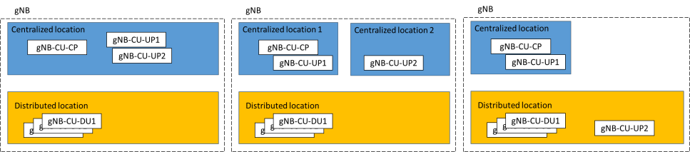
Figure 5.X.1-1: gNB-CU-UP deployment options (copied from 3GPP TR 38.823)

5.X.2 Security threats
Even when all CU-UPs are centralized in a single location, the level of trust does not need to be same for all of them. Each of them may be virtualized with different security hardenings or handled by different slice providers. If same security keys for UEs UP traffic are shared among all CU-UP instances, there is a threat that any breach in one of them means all of them are affected.
The above threat is also applicable to CU-UPs centralized in different locations.
The above threat is even clearer to mixed deployment of CU-UPs in centralized and distribution locations.

5.X.3 Potential security requirements
When disaggregated gNB-CU-UPs are deployed in different security zones, the 5GS supporting such disaggregated gNB-CU-UPs deployment should support the capability of separate UP keys per CU-CP instance..
**** END OF CHANGES ****

