3GPP TSG-SA WG3 Meeting #100bis-e S3-202451-r1
E-meeting, 12-16 October 2020

Source: Apple

Title: pCR: New solution on security protection against UE-to-UE relay

Document for: Approval
Agenda Item: 2.9 FS_5G_ProSe_Sec

1 Decision/action requested
This pCR proposes to add one solution for FS_5G_ProSe_Sec.

2 Rationale
A new key issue is proposed that the communication via the UE-to-UE Relay between source UE and target UE shall be confidentially and integrity protected. This contribution proposes a method to confidentially protect communication between source UE and target UE via UE-to-UE Relay using asymmetric cryptography.
It is brought up in August meeting (SA3#100-e) that, the public key can be used by anyone, but the public key is used for encryption, only the one owning the private key can decrypt the message. This is how this solution could address the issue of confidential protection.

3 Detailed proposal
SA3 is kindly requested to agree to the below pCR to TR33.847.

********************** First Change ****************************

6.Y Solution #Y: Confidential protection against UE-to-UE relay using asymmetric cryptography

6.Y.1 Introduction
This solution is targeting to address key issue#6, which is proposing that the communication via the UE-to-UE Relay between source UE and target UE shall be confidentially and integrity protected. This solution proposes a method to protect the communication between source UE and target UE using asymmetric cryptography. To be more specific, the Source UE and Target UE use their public key and private key to confidentially protect the communication.
The authentication between source UE and target UE is not included in this solution.

6.Y.2 Solution details

6.Y.2.1 Procedure

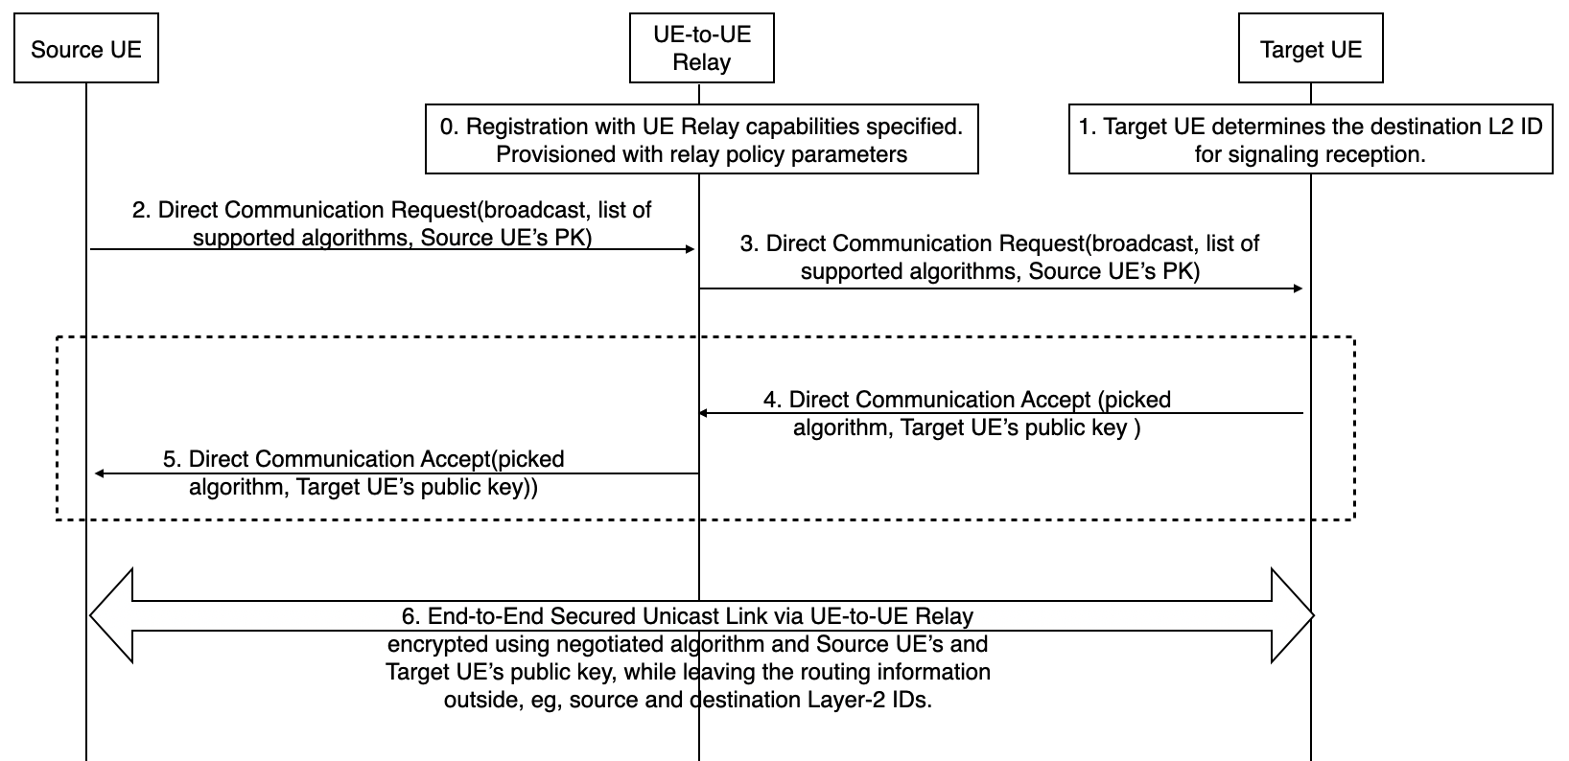
Figure 6.Y.2.1-1. Security protection via UE-to-UE Relay using asymmetric cryptography
The connection establishment procedure is based on TR 23.752, Clause 6.9. However, the seucirty procedure below is not limited to one connection establishment procedure defined in SA2.
The security procedure details are as following:
0. UE-to-UE Relay registers with the network and specifies its UE-to-UE Relay capabilities. UE-to-UE Relay is provisioned from the network with relay policy parameters and with a unique Relay identifier (RID). The assumption in this solution is source UE and target UE are presumed already authenticated.
1. The target UE determines the destination Layer-2 ID for signalling reception for PC5 unicast link establishment as specified in TS 23.287 clause 5.6.1.4. The destination Layer-2 ID is configured with the target UEs as specified in TS 23.287 clause 5.1.2.1.
2. On the source UE, the application layer provides information to the ProSe layer for PC5 unicast communication (e.g. broadcast Layer-2 ID, ProSe Application ID, UE's Application Layer ID, target UE's Application Layer ID, relay applicable indication), as specified in TS 23.287 clause 6.3.3.1. ProSe layer triggers the peer UE discovery mechanism by sending a broadcast Direct Communication Request message. The message is sent using the source Layer-2 ID and broadcast Layer-2 ID as destination, and includes other parameters related to the application offered. Source UE shall also include 2 IEs, which are list of source UE’s supported algorithms and the source UE’s public key.
3. The UE-to-UE Relay receives the broadcast Direct Communication Request message and verifies if it's configured to relay this application, i.e. it compares the announce ProSe Application ID with its provisioned relay policy/parameters and, if it matches, the UE-to-UE Relay assigns itself a Relay-Layer-2 ID (e.g. R-L2 ID-a) for source UE (i.e. related to source UE 's L2 ID).The UE-to-UE Relay proceeds in forwarding the broadcast Direct Communication Request message, which includes list of source UE’s supported algorithms and the source UE’s public key, received from the source UE.
4.Target UE is interested in the announced application thus, target UE will check whether it could support the security algorithms in the list of source UE’s supported algorithms, if yes, then it sends the Direct Communication Accept message to source UE, including the chosen algorithm, and also target UE’s public key.
5. UE-to-UE Relay forwarded the Direct Communication Accept message to source UE.
6. An "extended" unicast link is established between source UE and target UE, via the UE-to-UE Relay. The extended link is secured end to end using source UE’s and target UE’s public key, while the routing information will be left in the clear.
Editor’s Note: it is FFS how to bind the public key with a specific UE and how to revoke public keys.
Editor’s Note: it is FFS whether and (if yes, then)how to protect the privacy of the routing information.
Editor’s Note: it is FFS on how to make sure the DCA message can be trusted.
Editor’s Note: public/private keys provisioning into the peer UEs is FFS
Editor’s Note: The solution is under the assumption that only a single (ProSe) application is supported.
6.Y.3 Solution Evaluation
TBD.

********************** End of pCR********************

