3GPP TSG SA WG3 Meeting #100bis-e draft-S3-202349-1

e-meeting, 12-16 October 2020 revision S3-20abcd

Source: Huawei, Hisilicon

Title: New solution on Authentication between EEC and ECS

Document for: Approval
Agenda Item: 2.8

Decision/action requested
This contribution proposes a solution for authentication between the Edge Enabler Client (EEC) with the Edge Configuration Server in TR 33.839

References
TR33. 839 Study on Security Aspects of Enhancement of Support for Edge Computing in 5GC.

Rational
This contribution proposes the potential solution for authentication between the Edge Enabler Client (EEC) with the Edge Configuration Server.
Request SA3 to capture the proposed solution.

Detailed proposal
*************** Start of 1st Change ****************

2 References
The following documents contain provisions which, through reference in this text, constitute provisions of the present document.
- References are either specific (identified by date of publication, edition number, version number, etc.) or non-specific.
- For a specific reference, subsequent revisions do not apply.
- For a non-specific reference, the latest version applies. In the case of a reference to a 3GPP document (including a GSM document), a non-specific reference implicitly refers to the latest version of that document in the same Release as the present document.
[1] 3GPP TR 21.905: "Vocabulary for 3GPP Specifications".
[2] 3GPP TR 23.558: "Architecture for enabling Edge Applications."
[3] 3GPP TR 23.748: "Study on enhancement of support for Edge Computing in the 5G Core network (5GC)".
[4] 3GPP TR 23.758: "Study on application architecture for enabling Edge Applications".
[5] 3GPP TS 23.502: "Procedure for the 5G System; Stage 2".
[6] 3GPP TS 33.535: "Authentication and Key Management for Applications (AKMA) based on 3GPP credentials in the 5G System (5GS)".
[x] 3GPP TS 23.222: "Functional architecture and information flows to support Common API Framework for 3GPP Northbound APIs; Stage 2".

6.X Solution #X: Authentication between EEC and ECS

6.X.1 Solution overview
This solution addresses the security requirement for the Authentication between EEC and ECS in key issue #2.
In this solution, UE knows to use AKMA with ECS via interactions with 3GPP network before communication with ECS. If the ECS deployed by MNO is considered to be trusted by the operator, the ECS interacts directly with AAnF. Otherwise, the ECSs not allowed by the operator to access directly the Network Functions shall use the NEF to interact with AAnF.

6.X.2 Solution details
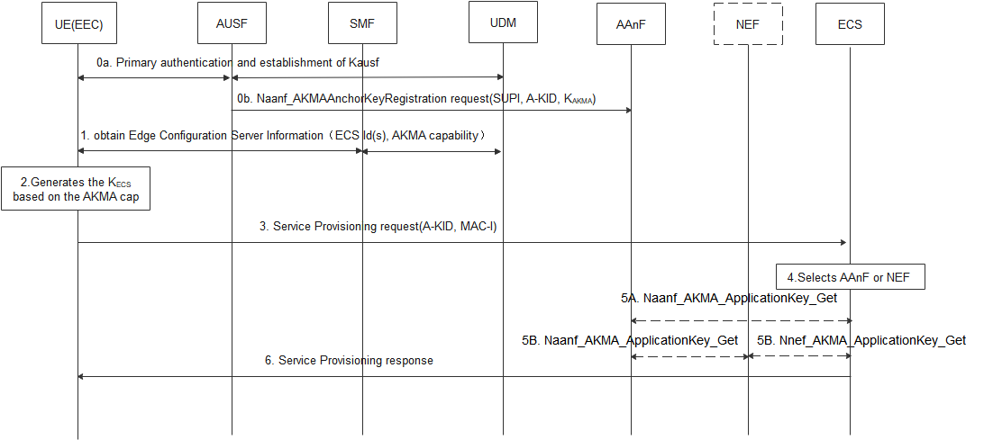
Figure 6.x.2-1 Authentication between the EEC and ECS based AKMA
0a. UE performs primary authentication with the network. Then K_{AUSF} is shared between UE and AUSF in Home network. If the AUSF receives the AKMA indication from the UDM, the AUSF shall generate the AKMA Anchor Key (K_{AKMA}) and the A-KID from K_{AUSF} after the primary authentication procedure is successfully completed.
0b. After AKMA key material is generated, the AUSF shall send the generated A-KID, and K_{AKMA} to the AAnF.
- During PDU Session Establishment, the SMF provides Edge Configuration Server Information (ECS ID (i.e. FQDN or IP address(es) of ECS), AKMA capability) to the UE. The AKMA capability indicates the ECS support to use AKMA.
- When the UE determines to communicate with ECS, if the UE supports AKMA, the UE derives the AKMA key and K_{ECS}(i.e K_{AF}) as specified in TS 33.535 [6] based on the received AKMA capability.
- UE computes the MAC-I over the request message using the K_{ECS} and sends service provision request with A-KID, MAC-I.
Editor’s Note: It is FFS whether TLS based on AKMA PSK can be used instead of MAC-I.
- Upon receiving the request, the Edge Configuration Server discovers the AAnF or NEF.
NOTE : In the case of architecture without CAPIF support, the ECS is locally configured with the API termination points for the service. In the case of architecture with CAPIF support, the ECS obtains the service API information from the CAPIF core function via the Availability of service APIs event notification or Service Discover Response as specified in TS 23.222 [54].
5A-5B. The ECS contacts AAnF directly or via NEF to obtain the corresponding key K_{ECS} (K_{AF}) of the UE(as defined in TS33.535).
6. The ECS verifies the MAC-I based on the K_{ECS}, when the verification is succeed, and if the UE is authorized to perform the operation. Then the ECS computes MAC-I over the response message using K_{ECS,} and sends a service provisioning response with the MAC-I to the UE.

6.X.3 Solution evaluation
TBD.
*************** End of 1st Change ****************

