3GPP TSG-SA3 Meeting #100bis-e draft_S3-202315-r1-Nokia comment

e-meeting, 12 - 16 October 2020 Revision of S3-20xxxx

Source: ZTE, Nokia, Nokia Shanghai Bell

Title: Update the solution#4.3 in TR 33.846

Document for: Approval
Agenda Item: 2.5

1 Decision/action requested
This contribution proposes to update the solution #4.3 in TR 33.846.

2 References
[1] 3GPP TR 33.846 v0.7.0

3 Rationale
At the UE side, when the UE verifies that SQN is greater than SQNMS, the USIM sets SQNMS as SQN. When the UE registers with 5G-GUTI or initiates the authentication process during the service request process, the USIM may set SQNMS as SQN. If the SQNMS in the UDM uses SUCI to contain SQNMS registration, the SQNms in the UE may be larger than the SQNMS in the UDM. If the UDM uses the authentication vector generated by the SQNms when the SUCI is registered to authenticate the UE, an error may occur to the UE due to SQN verification failure.
It is proposed to update the solution.

4 Detailed proposal
It is proposed that SA3 include the below pCR for inclusion into the TR [1].

**** START OF CHANGES ****

6.4.3 Solution #4.3: SQN protection by concealment with SUPI

6.4.3.1 Introduction
This solution addresses the key issue #4.1 Protection of SQN during AKA re-synchronisations.

6.4.3.2 Solution details
Current usage of ECIES for concealment of SUPI can be expanded to accommodate SQNMS and SUPI. Maximum allowed size of cipher text from concealment of protection scheme output is 3000 digits. SUPI utilizes only few bytes of those maximum allowed digits and still can adapt SQNMS.

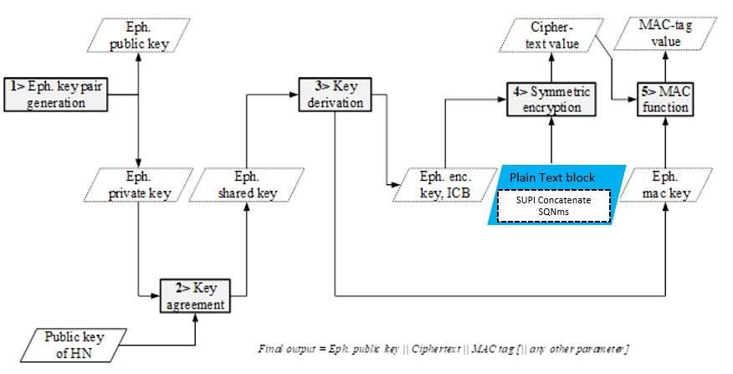
Figure 6.4.3.2-1 Encryption based on ECIES at UE

Figure 6.4.3.2-1 shows the encryption based on ECIES at UE side, where SUPI is concatenated with SQNMS and taken as one plain text block for symmetric encryption. In case of SUPI type as IMSI, then MSIN (9 to 10 digits) and SQN_{MS} (48 bits: 6 bytes) is concatenated in UE.

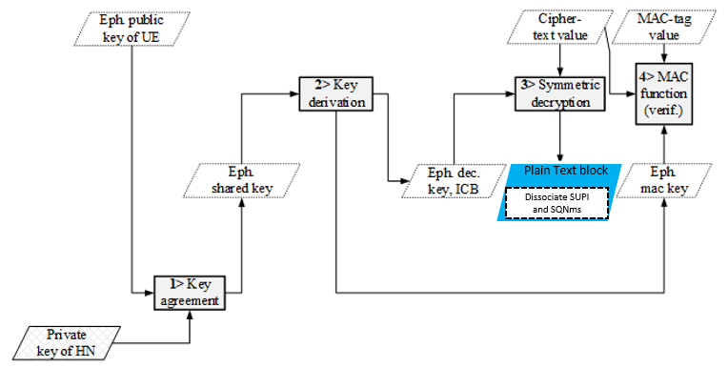
Figure 6.4.3.2-2 Decryption based on ECIES at home network

Figure 6.4.3.2-2 shows the decryption based on ECIES at home network, where SUPI and SQNMS is dissociated after the symmetric decryption.

Figure 6.4.3.2-3: Structure of SUCI
Figure 6.4.3.2-3 shows the structure of SUCI with SUPI Type, which consists values in the range 0 to 7 as specified in TS 23.003 [3]. SUPI Type identifies the type of the SUPI concealed in the SUCI.
For this solution, the encoding of SUCI for ‘SUPI plus SQN_{MS'} will be represented by a new SUPI Type value, e.g. value 4.
- 0: IMSI
- 1: Network Specific Identifier
- 2: Global Line Identifier (GLI)
- 3: Global Cable Identifier (GCI)
- 4: SUPI concatenate SQNMS
- 5 to 7: spare values for future use.

6.4.3.3 Adaptation of proposal in TS 33.501
The following sequence chart illustrates the text already specified in TS 33.501 clause 6.1.2 for the case of initiation of authentication and selection of authentication method. Changes are marked in blue.

2. <N1 message>
(SUCI containing SQNMS )
UE
3. Nausf_UEAuthentication_ Authenticate Request
(SUCI containing SQNMS or SUPI, SN-Name)
4. Nudm_UEAuthentication_ Get Request (SUCI containing SQNMS or SUPI, SN-Name)
UDM/ARPF
AMF/
SEAF
AUSF
1. Conceal SUPI and SQNMS
5. [SUCI to SUPI, SQNMS de-concealment].
Authentication Method selection.

Figure 6.4.3.3-4: Illustration of UE and HE is sharing SQN_{MS} along with SUCI

- During the primary authentication procedure, USIM concatenates SUPI and SQNMS. The concatenated plain text block is encrypted using ECIES method. New value is introduced for “SUPI Type”, for e.g. Value 4 represents SUCI encoded with SUPI plus SQNMS.
- UE shall use SUCI containing SQNMS in Registration request message, which is sent to AMF/SEAF.
- AMF/SEAF shall invoke the Nausf_UEAuthentication service by sending a Nausf_UEAuthentication_Authenticate Request message to the AUSF whenever the AMF/SEAF wishes to initiate an authentication.
The Nausf_UEAuthentication_Authenticate Request message shall contain either:
- SUCI containing SQN_{MS}, as defined in the current specification, or
- SUPI, as defined in TS 23.501 [2].
The AMF/SEAF shall include the SUPI in the Nausf_UEAuthentication_Authenticate Request message in case the AMF/SEAF has a valid 5G-GUTI and re-authenticates the UE. Otherwise the SUCI containing SQNMS is included in Nausf_UEAuthentication_Authenticate Request. SUPI/SUCI structure is part of stage 3 protocol design.
The Nausf_UEAuthentication_Authenticate Request shall furthermore contain:
- the serving network name, as defined in sub-clause 6.1.1.4 of the present document.
- Upon receiving the Nausf_UEAuthentication_Authenticate Request message, the AUSF shall check that the requesting AMF/SEAF in the serving network is entitled to use the serving network name in the Nausf_UEAuthentication_Authenticate Request by comparing the serving network name with the expected serving network name. The AUSF shall store the received serving network name temporarily. If the serving network is not authorized to use the serving network name, the AUSF shall respond with "serving network not authorized" in the Nausf_UEAuthentication_Authenticate Response.
The Nudm_UEAuthentication_Get Request sent from AUSF to UDM includes the following information:
- SUCI containing SQN_{MS} or SUPI;
- the serving network name;
- Upon reception of the Nudm_UEAuthentication_Get Request, the UDM shall invoke SIDF if a SUPI type is SUPI plus SQN_{MS}, then SIDF shall de-conceal SUCI to gain SUPI and SQN_{MS} before UDM can process the request.
- Based on SUPI, the UDM/ARPF shall choose the authentication method. SQN_{MS} is stored in UDM for future use. At UDM, Authentication vector is generated with existing SQN_{HE.}. The solution is restricted to 5G.

NOTE : The Nudm_UEAuthentication_Get Response in reply to the Nudm_UEAuthentication_Get Request and the Nausf_UEAuthentication_Authenticate Response message in reply to the Nausf_UEAuthentication_Authenticate Request message are described as part of the authentication procedures in clause 6.1.3.
Note: SQN_{MS} is not considered for Authentication vector generation on purpose.

1) Successful Authentication case:
In success case the Authentication procedure (considering example of 5G AKA) is the same as TS.33.501 section 6.1.3.2.0. The solution does not impact the existing call flow. The cached SQN_{MS} shall be deleted at UDM.
2) Authentication failure case:
Figure 6.4.3.3-2: Authentication procedure for 5G AKA (Failure case)

Figure 6.4.3.3-2 shows the failure case of Authentication procedure (considering example of 5G AKA). Changes are shown in blue.

1. For each Nudm_Authenticate_Get Request, the UDM/ARPF shall create a 5G HE AV. The UDM/ARPF does this by generating an AV with the Authentication Management Field (AMF) separation bit set to "1" as defined in TS 33.102 [9]. The UDM/ARPF shall then derive K_{AUSF} (as per Annex A.2) and calculate XRES* (as per Annex A.4). Finally, the UDM/ARPF shall create a 5G HE AV from RAND, AUTN, XRES*, and K_{AUSF}.
2. The UDM shall then return the 5G HE AV to the AUSF together with an indication that the 5G HE AV is to be used for 5G-AKA in a Nudm_UEAuthentication_Get Response. In case SUCI was included in the Nudm_UEAuthentication_Get Request, UDM will include the SUPI in the Nudm_UEAuthentication_Get Response.
3. The AUSF shall store the XRES* temporarily together with the received SUCI or SUPI.
4. The AUSF shall then generate the 5G AV from the 5G HE AV received from the UDM/ARPF by computing the HXRES* from XRES* (according to Annex A.5) and K_{SEAF} from K_{AUSF}(according to Annex A.6), and replacing the XRES* with the HXRES* and K_{AUSF} with K_{SEAF} in the 5G HE AV.
5. The AUSF shall then remove the K_{SEAF} return the 5G SE AV (RAND, AUTN, HXRES*) to the SEAF in a Nausf_UEAuthentication_Authenticate Response.
6. The SEAF shall send RAND, AUTN to the UE in a NAS message Authentication -Request. This message shall also include the ngKSI that will be used by the UE and AMF to identify the K_{AMF} and the partial native security context that is created if the authentication is successful. This message shall also include the ABBA parameter. The SEAF shall set the ABBA paremeter as defined in Annex A.7.1. The ME shall forward the RAND and AUTN received in NAS message Authentication Request to the USIM.
7. At receipt of the RAND and AUTN, the USIM shall verify the freshness of the 5G AV by checking whether AUTN can be accepted as described in TS 33.102[9]. If the verification of the AUTN fails, then the USIM indicates to the ME the reason for failure.
8. The ME shall respond with NAS message Authentication Failure only with a CAUSE value indicating the reason for failure (as SQN failure/mismatch). AUTS is not calculated by the UE and not shared to network.
9. Upon receiving an authentication failure message from the UE, the SEAF sends an Nausf_UEAuthentication_Authenticate Request message to the AUSF.
10. AUSF sends an Nudm_UEAuthentication_Get Request message to the UDM/ARPF.
11. When the UDM/ARPF receives an Nudm_UEAuthentication_Get Request message it acts as described in TS 33.102, clause 6.3.5 where ARPF is mapped to HE/AuC. The UDM/ARPF sends an Nudm_UEAuthentication_Get Response message with a new authentication vector by considering the SQNMS from database (i.e. SQNMS received in Nudm_UEAuthentication_ Get Request). At the UDM, if an authentication failure message with cause code (SQN failure) is received, the stored value of SQN_{MS} received at the very first step is processed. UDM synchronizes its value of SQN, i.e SQN_{HE} = SQN_{MS}. Sequence number management profiles detailed in Annex C in 33.102 is kept intact.
The AUSF runs a new authentication procedure with the UE according to clauses TS 33.501 section 6.1.3.1 or 6.1.3.2 depending on the authentication method applicable for the user.

In both cases, success and failure case of authentication, the authentication confirmation procedure is the same as TS.33.501 section 6.1.4.1a.

6.4.3.5 Solution summary
The solution adds a new SUPI type in 23.003 section 2.2B.
Encryption and decryption on ECIES consider plain text block as “SUPI and SQNms” at UE and UDM / ARPF in 33.501.
Registration request is sent with SUPI plus SQN_{MS}.
Sync failure during AKA challenge sends only failure cause and no AUTS is sent to the network.

Editor’s Note: It is ffs if this solution works for synchronization failure when AMF receives 5G-GUTI and decides to initiate authentication.
Editor’s Note: Backward compatibility analysis is FFS.

6.4.3.4 Evaluation
The solution only protects the sequence number in 5GS.
The solution requires changes on the USIM and the UDM.
- At USIM, during ECIES procedure of primary authentication, New SUPI type is added, SQNMS is concatenated with SUPI (plain text block).
At UDM, when the SUPI indicates ‘SUPI plus SQN_{MS}’ the de-concealment needs to disassociate SUPI and SQN_{MS}. UDM stores SQN_{MS}.
There is no change to any entities if the authentication succeeds.

**** END OF CHANGES ****

