3GPP TSG SA WG3 Meeting #100bis-e draft-S3-202351-r1

e-meeting, 12-16 October 2020 revision S3-20abcd

Source: Huawei, Hisilicon

Title: New solution on Security of Network Information Provisioning to Local Applications

Document for: Approval
Agenda Item: 2.8

Decision/action requested
This contribution proposes a solution for Security of Network Information Provisioning to Local Applications (KI #7) in TR 33.839

References
TR33. 839 Study on Security Aspects of Enhancement of Support for Edge Computing in 5GC.

Rational
This contribution proposes the potential solution for Security of Network Information Provisioning to Local Applications.
Request SA3 to capture the proposed solution.

Detailed proposal
*************** Start of 1st Change ****************

6.X Solution #X: Protection of Network Information Provisioning to Local AF directly

6.X.1 Solution overview
This solution addresses the security requirement for the case that the UPF exposes information to local AF directly in the key issue 7.
Editor’s Note: which interface for UPF and AF communicate over is FFS.

6.X.2 Solution details
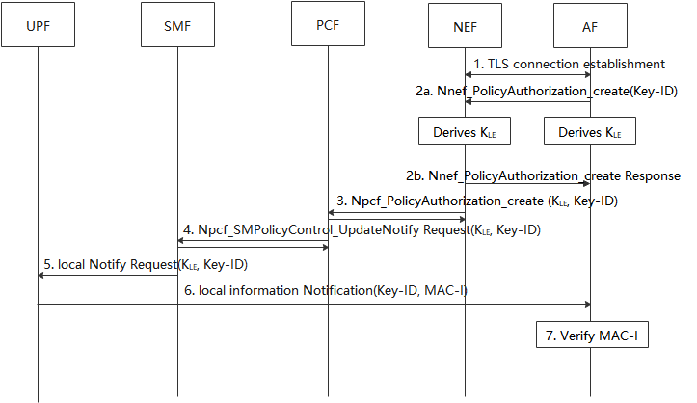
Figure 6.x.2-1 Protection of Network Information Provisioning to Local AF
- AF establish a TLS session with the NEF, to secure the communication between the AF and NEF.
2a-2b. The AF generates a Key-ID for the UE and derives a K_{LE}. The Key-ID is used to identify the K_{LE}, and the K_{LE} is used to protect the message transmission between UPF and AF. The AF provides the Key-ID to NEF in the request service.
3-4. The NEF initiates the policy authorization with PCF, including the K-ID and K_{LE} received from the AF. PCF initiates the PDU session modification procedure as defined in clause 4.3.3.2 of TS 23.502 [3] and provides the Key-ID and K_{LE} to the SMF.
5. SMF sends the notification information with Key-ID and K_{LE} to the UPF.
6. When the QoS monitoring information is received from RAN, the UPF generates MAC-I over the message using the K_{LE} to prove its authenticity. The UPF sends the message including Key-ID and MAC-I to AF.
7. The AF retrieves the K_{LE} based on the received Key-ID and verify the MAC-I.

6.X.3 Solution evaluation
TBD.
*************** End of 1st Change ****************

