3GPP TSG-SA WG6 Meeting #50-e S6-222067
e-meeting, 22nd – 31st Aug 2022

Source: Intel, CMCC
Title: pCR on UE identification with NATed IP
Spec: 3GPP TR 23.700-98 v1.1.1
Agenda item: 9.8
Document for: Approval
Contact: samar.shailendra@intel.com

1. Introduction
This contribution provides a solution to the KI#16. The proposed solution provides an alternate approach based upon the currently agreed solution #23 in the TR 23.700-98 v1.1.1.
2. Reason for Change
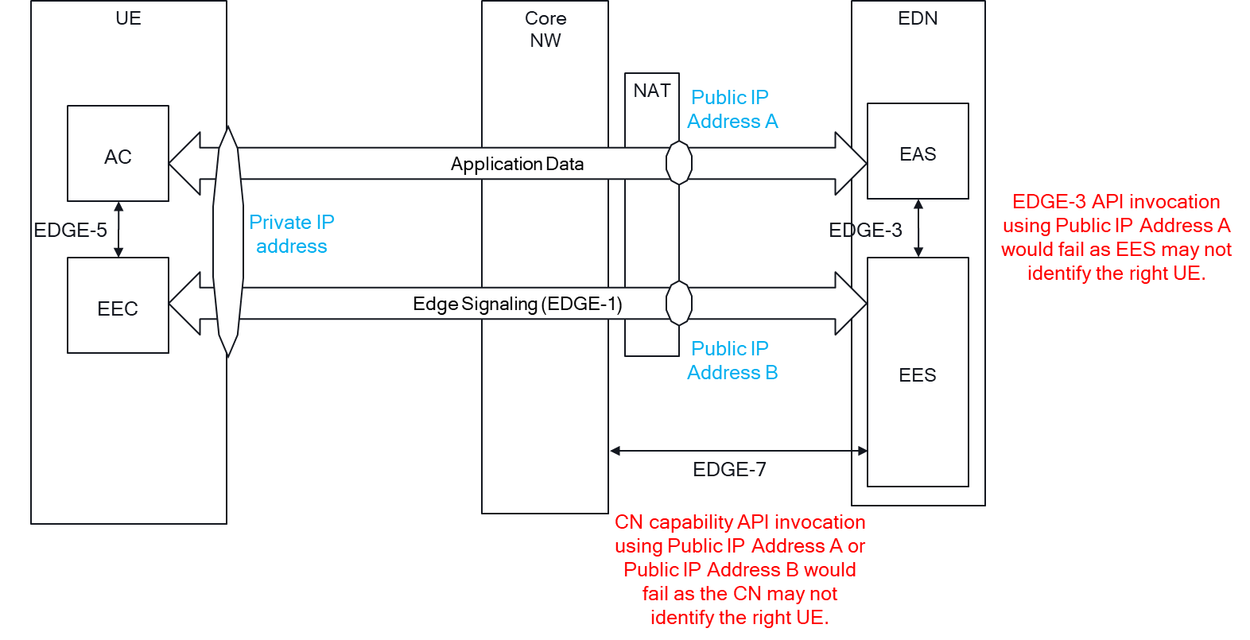
When a NAT is deployed by the MNO:
- EAS knows UE’s NATed or public IP address from the Application Data IP packets it receives i.e., Public IP Address A.
- EES knows UE’s NATed or public address from the Edge Signaling IP packets it receives i.e., Public IP Address B.
This results in UE identification issues, where the API invocation by the EAS and the EES would fail -
- If EAS invokes an EDGE-3 API with only Public IP Address A, the EES may not identify the UE, and therefore cannot serve the EAS.
- If EES invokes an CN API with only Public IP Address A or Public IP Address B, the CN may not uniquely identify the UE.

3. Proposal
It is proposed to agree the following changes to 3GPP TR 23.700-98 v1.1.1.

* * * First Change * * * *

7.23 Solution #23: UE identification with NAT

7.23.1 Architecture enhancements
None.

7.23.2 Solution description

7.23.2.1 General
This solution corresponds to KI#16 on support of NAT deployed within the edge data network.
In this solution, the EEC provides either the CN network assigned IP address (i.e., the private IP address of the UE) or its UE ID (if it already has one) to the EES to obtain the UE identifier (Edge UE ID) from the EES. If the UE ID is not provided, EES uses the private IP address of the UE provided by the EEC to invoke the CN capability to translate UE's IP address to its UE ID (e.g., UE'sExternal UE ID).
Once obtained, the EEC passes the Edge UE ID to the AC, which provides it to the EAS for use over EDGE-3 interface. This also allows the UE to protect its privacy by providing an option to obtain from the EES an Edge UE ID to share with the EAS(s) via the AC(s) instead of exposing its UE ID (if it already has one) to the AC(s). With EAS and EES both being aware of the Edge UE ID, issues pertaining to NAT and UE identification with privacy are resolved.
NOTE 1: The UE ID provided by EEC is in the form of MSISDN.
NOTE 2: SA3 coordination may be needed corresponding to privacy.

7.23.2.2 Procedure
Figure 7.23.2.2 illustrates the procedure for the EEC to obtain the Edge UE ID from the EES and provide to the AC.
Figure 7.23.2.2-1: EEC obtaining UE ID from the EES
1. AC sends an Edge UE ID request to the EEC. The request may include the list of EASIDs for which the AC is requesting the Edge UE ID information.
2. The EEC upon receiving the request validates if AC is authorized to request this information. If AC is authorised, the EEC sends the Edge UE ID request to the EES. The request includes either the CN assigned private IP address of the UE or its UE ID (if it already has one) and may include the list of EASIDs if provided by the AC.
NOTE 1: EEC can also send this request without receiving a request from AC in step 1.
NOTE 2: Private IP address used by AC and private IP address used by EEC can be the same or different (if different PDU sessions are used). The request from EEC can include either of the IP addresses.
3a. Upon receiving the request from EEC, the EES authorizes the EEC. If authorized and the UE ID is not included in the request the EES invokes the CN capability Nnef_UEId_Get for translating the UE's IP address to its UE ID as defined in 3GPP TS 23.502 [08] clause 4.15.10. If the request from EEC includes a list of EASIDs, the EES may invoke the Nnef_UEId_Get API for each EAS individually to obtain EAS specific UE ID(s). The EES generates temporary Edge UE ID(s) which may be the same as the 3GPP CN provided UE ID or may be assigned by the EES itself. If UE ID is included in the request received from EEC, the EES generates temporary Edge UE ID. The temporary Edge UE ID may be specific for the EASs included in request received from EEC in step 2, in which case upon receiving a request on EDGE-3 interface, the EES matches the EASID in the request with EASIDs to which the Edge UE ID was assigned before processing the request.
3b. Optionally, EES invokes the CN capability for translating UE’s NATed IP Address, and the port number to its UE ID. However, this requires coordination with SA2 to support the translation between UE’s NATed/public IP address and the UE External ID as part of alignment work in Rel-18.

4. The EES sends the Edge UE ID response to the EEC including the Edge UE ID(s).
5. Upon receiving the response from the EES, the EEC provides the Edge UE ID information to the AC by sending the Edge UE ID response.
6. The AC provides the Edge UE ID information to the EAS.
NOTE 3: Details on how the AC provides the information to the EAS is out of scope.
7. Once received from the AC, the EAS uses the Edge UE ID to invoke the APIs provided by the EES over EDGE-3 interface (e.g., T-EAS Discovery, UE location request, ACR request, and EELManangedACR services).
8. Once received from the EES, the EEC uses the Edge UE ID to invoke API provided by the EES over EDGE-1 interface (e.g., EAS Discovery and ACR request services).
9. The EES uses the UE ID received from the EEC or obtained from the CN in step 3 to invoke the 3GPP CN capabilities as in TS 23.558, Clause 8.10.3. This step can be performed following triggers that require 3GPP CN capabilities to be invoked (e.g., on receiving a request over EDGE-1 or EDGE-3), in which case, to invoke the 3GPP CN capabilities the EES uses the UE ID associated with the Edge UE ID included in the trigger.
NOTE 4: This procedure has impacts on EDGE-5 interface.

7.23.3 Solution evaluation
This solution solves open issues of KI#16. The solution provides two approaches to obtain UE Id. In the first approach of this solution, EES translates the EEC provided UE's private IP address to its UE ID using the CN provided capability (Nnef_UEId_Get). This UE ID is then shared back to the EEC, which provides it to the AC. AC can then share the UE ID with the EAS for use over EDGE-3 interface.
The solution also allows the EES to convert the CN or EEC provided UE ID to Edge UE ID, which is managed by the EES. Edge UE ID ensures privacy of the UE ID and allows the EES to assign EAS specific IDs for controlled access over EDGE-3 interface. EEC can request the Edge UE ID on its own, this allows the EEC to use the received Edge UE ID over EDGE-1 interface.
In some network deployments, there may be a private IP address overlap issue where more than one UE is assigned the same private IP address. Support from SA2 is required in such cases.
In another approach (as captured in step 3b of Clause 7.23.2.2) EES uses NATed/public IP of the UE to obtain the UE Id. This approach requires enhancement of 3GPP CN.
NOTE: This will require coordination with SA2 to handle this as part of the alignment work in Rel-18.
Coordination with SA3 is required to check whether there is a security issue if the EEC shares its private IP address or MSISDN with a trusted 3rd party EES.
In this solution, whether EESs use the same or different algorithms to generate Edge UE ID and weather the Edge UE ID should be unique should be specified in normative work.

