3GPP TSG-SA WG6 Meeting #49-e S6-221186
e-meeting, 16th – 25th May 2022 (revision of S6-22xxxx)

Source: Qualcomm
Title: Pseudo-CR on Enhanced ECS for federation and roaming
Spec: 3GPP TR 23.700-98 v0.6.0
Agenda item: 9.8
Document for: Approval
Contact: Nishant Gupta <gnishant@qti.qualcomm.com>

1. Introduction
This solution provides enhancements to the ECS and procedures to support federation of services, UE roaming, and federation of services across PLMNs for roaming UEs.
2. Reason for Change
Federation of services require sharing of Edge Computing resource information (such as EDN configuration data) across ECSPs, in order to enable consumer of one ECSP to access services of a partner ECSP. Also, a UE may roam to a V-PLMN and should still be able to access Edge Computing services. For the purpose of federation, this pCR proposes the following definition of the primary and partner ECSs:
Primary ECS: An ECS whose address information is configured with the EEC. EEC is authorized to communicate with the Primary ECS directly.
Partner ECS: A federation partner of the Primary ECS. EEC is not configured with the address information of Partner ECSs.
While roaming, the UE may connect to a Primary ECS in the hPLMN or the vPLMN i.e., roam without federation. Or it could obtain service from a partner ECS i.e., roam with federation.
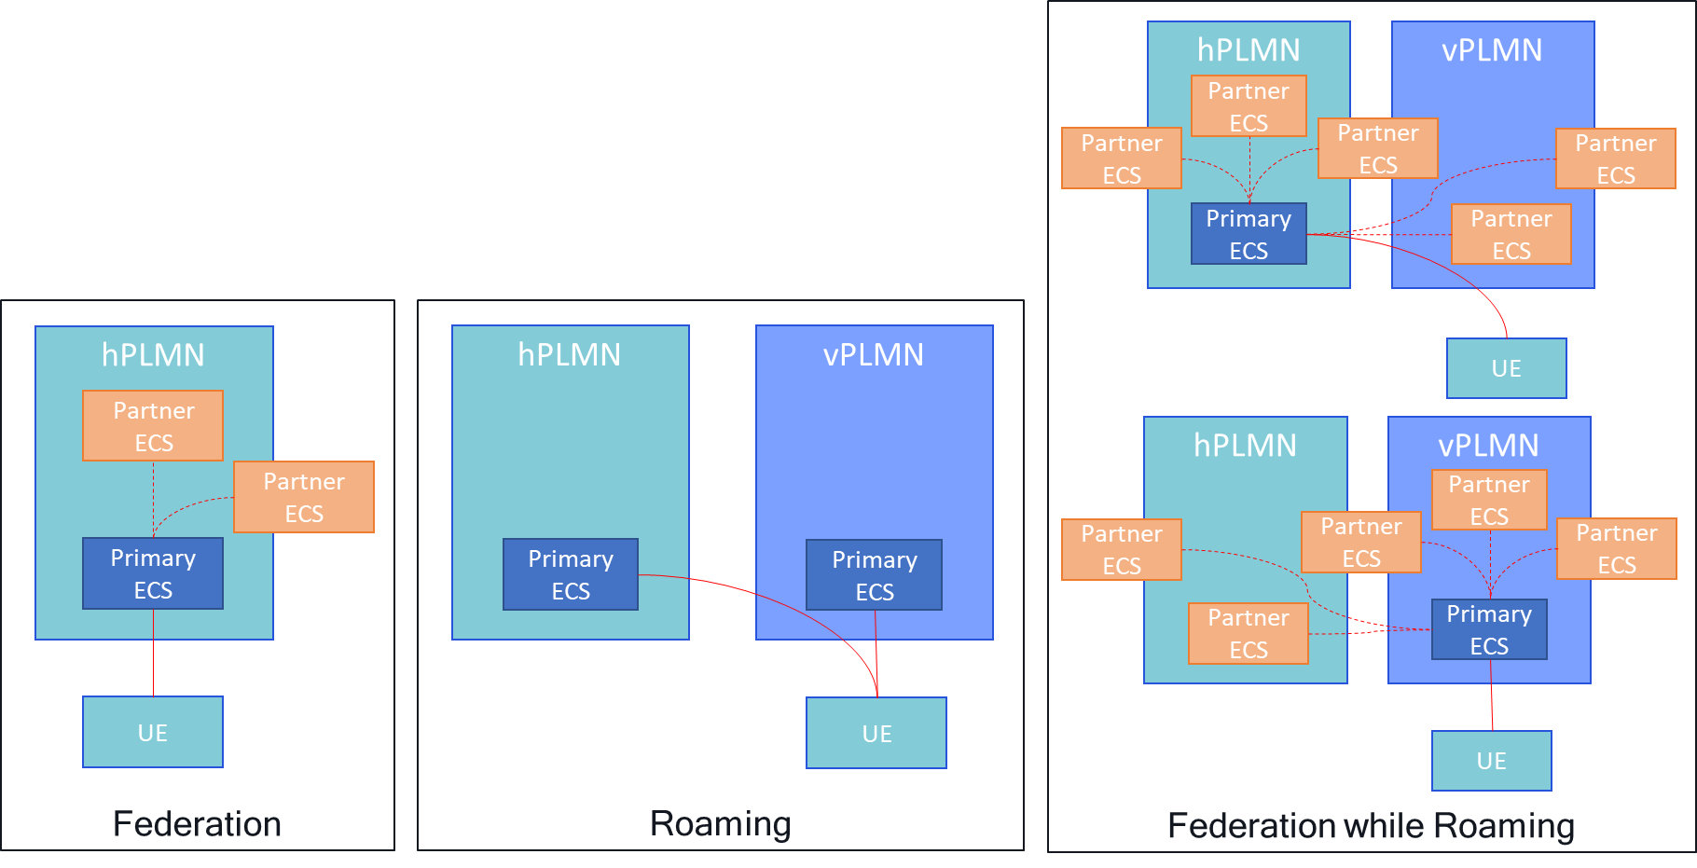
Following points should be considered when enabling the above described scenarios:
1. A federation can involve multiple ECSPs. Considering MNOs, hyperscalars, microservice providers, private installations etc., 10 ECSPs federating in a big city is a conservative guesstimate.

2. In a simple deployment, let’s consider that each ECSP has deployed only one ECS per region, making 10 ECS available for that region of the federation.
3. In such a deployment there are 2 options for EAS discovery within the federation:
Approach 1  a. Preconfigure all 10 ECSs of the federation with ECS address information* of other 9 ECSs of the federation.  b. When federation wide EAS discovery is required, the ECS should perform discovery with pre-configured partner ECS addresses until a suitable candidate is found.  c. In worst case, the ECS will have to check with all 9 partner ECSs before a conclusion can be reached. | Approach 2  a. One ECS amongst the 10 federated ECSs plays the role of a ‘designated ECS’. Address information of the designated ECS is preconfigured in other ECSs of the federation.  b. ECSs of the federation register and store information of federated edges at the designated ECS.  c. When federation wide EAS discovery is required, the ECS queries the designated ECS.  d. With a single request/response a conclusion is reached, saving time and resources.

5. With Approach 2, considerable resources and time are saved, which is crucial to maintain service continuity across federation.
*Only ECS address information can be pre-configured as the EES and EAS information stored in ECSs are dynamic in nature. New EASs can be instantiated on demand, resulting in EAS registration on relevant EES. This update in EES information triggers an EES registration update with relevant ECS, updating the EDN information stored in the ECS. Similarly, new EESs can be instantiated on demand of ECSPs, updating the EDN information stored in the ECS. Also, existing EASs and EESs can shut down for different reasons, again resulting in update of EDN information at the ECS.
Example deployment based on Rel-17:
Below is an example deployment with 4 ECSPs, with the areas they serve. Each ECSP has deployed a single ECS. If a user is at the pinned location (and has authorization), it can get services from all 4 ECSPs – even as per Rel-17.
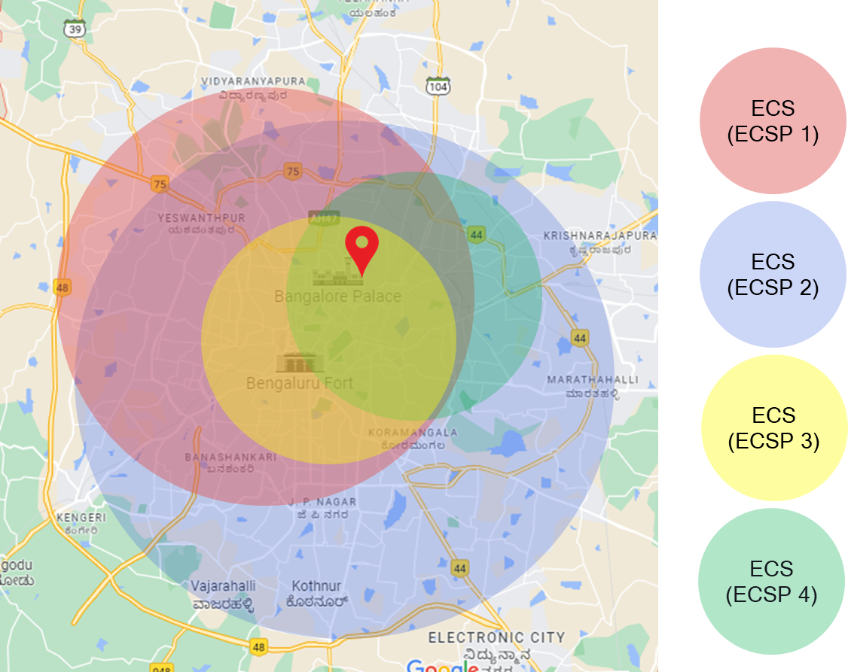
This is a simple example, more complex deployments with many more ECSPs is allowed by the architecture. And with federation and roaming, it gets further complicated, as there can be some ECSPs for which user does not have a direct authorization but still it can get service via federation.
Quote from Rel-17 23.558 to support such deployments, clause 8.3.1.:
“An EEC that is aware of multiple ECSP's ECS endpoint addresses may perform the service provisioning procedure per ECS of each ECSP multiple times.”
Also, other than this requirement for ECS selection in case of 5GC provisioning, there is no requirement on how the EEC/EES selects the ECS, EES or the EAS; it’s all up to implementation:
“If the ECS configuration information is provided by 5GC and available at the EEC, the EEC shall use the information for the initial provisioning request.”
And note that even in 5GC case, the ePCO can include multiple ECSs’ information. How EEC selects one out of that is again up to EEC implementation.
3. Proposal
It is proposed to agree the following changes based on approach 2, to 3GPP TR 23.700-98 v0.6.0.

* * * First Change * * * *

3.1 Terms
For the purposes of the present document, the terms given in 3GPP TR 21.905 [1], 3GPP TS 23.558 [2] and the following apply. A term defined in the present document takes precedence over the definition of the same term, if any, in 3GPP TR 21.905 [1] and 3GPP TS 23.558 [2].
<defined term>: <definition>.
Primary ECS: An ECS whose address information is configured with the EEC. EEC is authorized to communicate with the Primary ECS directly.
Primary ECSP: An ECSP for which the UE has authorization to obtain service.
Partner ECS: A federation partner of the Primary ECS. EEC is not configured with the address information of Partner ECSs.
Partner ECSP: An ECSP with whom the Primary ECSP has a service level agreement for resource sharing i.e., a federation partner of the Primary ECSP.
example: text used to clarify abstract rules by applying them literally.
* * * Next Change * * * *

7.0 Mapping of solutions to key issues
Table 7.0-1 Mapping of solutions to key issues
 | KI #1 | KI #2 | KI #3 | KI #4 | KI #5 | KI #6 | KI #7 | KI #8 | KI #9 | KI #10 | KI #11
Sol #1 | X
Sol #2 |  |  |  |  |  |  | X
Sol #4 |  |  |  |  |  | X |  |  |  | X
Sol #5 |  |  |  |  |  | X |  |  |  | X
Sol #6 |  |  | X
Sol #8 |  | X
Sol#x |  |  |  |  |  | X |  |  |  | X
…

* * * Next Change * * * *

6.x Option #x: Architecture for Federation and Roaming

6.x.1 Architecture enhancements
A federation can include multiple ECSP(s) where both, MNOs and the ECSPs can deploy multiple ECSs each. ECSs provide EES and EAS deployment information to the requestor.ECSs, EESs and EASs can be enabled or disabled dynamically based on prevailing requirements, available resources etc., so relying on pre-configuration or policy-based federation may result in use of stale pre-configurations and policies. Therefore, it is essential to maintain this information in real-time and enable an ECS to discover it on a need basis.
This architecture option requires that the federation of ECSPs designate one ECS as the center of information for that federation. This designated ECS acts as the edge repository (ECS-ER) of the federation. It stores and maintains up to date information about edge deployments of the federation. ECSs deployed by the ECSPs of the federation register and provide edge deployment information to this designated ECS.
Following figure illustrates the enhanced architecture:
Figure 6.x.1-1: Architecture enhanced with Edge repository
NOTE 1: There can be an EDGE-4 interface between the EEC and the Edge Configuration Server (Edge Repository).
There can be alternate deployments for this edge repository, for e.g.:
- each ECSP can deploy its own edge repository; or
- each MNO can deploy an edge repository for all ECSPs associated with the MNO.
NOTE 2: In deployments where each ECSP deploys its own edge repository, or each MNO deploys an edge repository for all the ECSPs associated with the MNO, there may be a need for inter-edge repository communication.
NOTE 3: Address information of partner ECSs in a federation can be locally configured in the primary ECS.

6.x.2 Enhanced functional entities

6.x.2.1 Edge Configuration Server (Edge Repository)
ECS that acts as edge repository (ECS-ER) provides supporting functions needed for roaming and federation.
Functionalities of ECS-ER are:
a) Receiving and storing information about edge computing resources from other ECS(s) of the federation;
b) Providing information about Edge computing resources to other ECS(s) of the federation.

6.x.3 Reference point

6.x.3.1 EDGE-10
EDGE-10 reference point enables interactions between the ECS and the ECS acting as edge repository. It supports:
a) registration and de-registration of the ECS to the ECS acting as edge repository; and
b) retrieval or discovery of information about other ECS(s) of the federation.

6.x.4 Cardinality rules
Following cardinality rules apply to the ECS that acts as edge repository:
a) One ECS may be deployed to support the federation;
Following cardinality rules apply for EDGE-10:
a) One or more ECS may communicate with the ECS that acts as edge repository.
* * * Next Change * * * *

7.x Solution #x: Enhanced ECS for federation of services

7.x.1 Architecture enhancements
This solution uses the architecture option specified in clause 6.x.

7.x.2 Solution description
Editor’s Note: Impacts on these procedures if ECS-ER is a primary ECS are FFS.
Editor’s Note: Whether ECS-ER can publish information to other ECSs if FFS.

7.x.2.1 ECS registration with the ECS-ER
ECS registers with the ECS-ER and provides the information such as EDN configuration information, applications available via the ECS etc. Figure 7.x.2.1-1 illustrates the procedure.
Pre-conditions:
1. The ECS has the address (e.g., URI) of the ECS-ER.
Figure 7.x.2.1-1: ECS registration with ECS-ER
1. The ECS sends the ECS registration request to the ECS-ER. The request from the ECS includes the ECS configuration information (ECS address and the ECS provider information) along with its security credentials, and may include a list of EASs available via the ECS, EDN configuration information etc. The request may include a proposed expiration time for the registration.
2. Upon receiving the request from the ECS, the ECS-ER verifies the security credentials of the ECS and stores the ECS registration information obtained in step 1.
3. The ECS-ER sends an ECS registration response indicating success or failure of the registration operation. The ECS-ER may provide an expiration time to indicate to the ECS when the registration will automatically expire. To maintain the registration, the ECS shall send a registration update request prior to the expiration time. If a registration update request is not received prior to the expiration time, the ECS-ER treats the ECS as implicitly de-registered.
NOTE: An ECS registration update and ECS deregistration procedure is required.

7.x.2.2 ECS discovery for Federation and/or Roaming
ECS uses the ECS-ER to discover information of other available ECS when the ECS is unable to fulfil the Service Provisioning request of an EEC. Figure 7.x.2.2-1 illustrates the procedure.
Pre-conditions:
1. The Primary ECS is part of a federation and has the address information of the ECS-ER of that federation.
Figure 7.x.2.2-1: ECS discovery for Federation and/or Roaming
1. The EEC sends a service provisioning request to the Primary ECS. This request is same as the service provisioning request specified in 3GPP TS 23.558 [2]. Additionally, in case the UE hosting the EEC is roaming to a V-PLMN, the service provisioning request may include the V-PLMN ID.
2. Upon receiving the request, the Primary ECS performs authorization and policy enforcement as specified in 3GPP TS 23.558 [2].
3. The Primary ECS identifies required EDN configuration information based on the received request in step 1 and checks in step 2. The ECS determines that at least one of the required applications (i.e., EAS) is not available via the Primary ECS.
4. Based on the determination in step 3, the Primary ECS sends a ECS discovery request to the ECS-ER. The request contains the information of the Primary ECS, Service Provisioning filters received from the EEC in step 1 and checked by the Primary ECS in step 2 and UE’s current location. If the UE hosting the EEC is roaming in a V-PLMN (determined using the serving PLMN information in the received service provisioning request in step 1, or by interacting with the H-PLMN), then the ECS discovery request includes the information of the serving PLMN i.e., the V-PLMN.
5. The ECS-ER authorizes the received request. If authorized, the ECS-ER processes the request and gathers the information of ECS(s) that can satisfy the query parameters received in step 4.
6. The ECS-ER sends a ECS discovery response to the Primary ECS. The response includes information of the Partner ECS(s) available in the H-PLMN and/or the V-PLMN, depending on the serving PLMN of the UE as indicated in step 4. The Primary ECS caches the received information for further use.
7. On receiving the ECS discovery response, the Primary ECS applies any local policy or EEC profile-based filtering for service differentiation.
8. The Primary ECS sends service provisioning response to the EEC. The response is same as specified in 3GPP TS 23.558 [2]. Additionally, it includes the list of Partner ECS(s) which provide the applications required by the EEC. The information includes ECS provider information, list of EAS(s) available via the ECS etc. The response either includes the ECS address information, if the EEC is authorized to communicate directly with the Partner ECS, or it includes an indication that the Partner ECS must be reached via the Primary ECS. For the Partner ECS(s) that may be communicated directly, the response also includes authorization information required by the EEC to communicate with the Partner ECS. The response may also include EDN configuration information received from the ECS-ER, if any.
The response may also include EDN configuration information for the EAS(s) available via the Primary ECS, if any.

7.x.2.3 Service provisioning from a partner ECS
For EEC to retrieve service provisioning information from a partner ECS, the partner ECS needs to authenticate and authorize the request from the EEC. Further, the partner ECS is required to apply any service differentiation policies specific to the EEC. In most realistic deployments it is not feasible for ECS(s) to obtain the information required for authentication, authorization and policy enforcement of EECs related to all its partners. Further, maintenance of this information such as service differentiation policy updates, change in EEC’s authorizations etc. is a resource intensive task.
Therefore, authentication, authorization, and service differentiation policy enforcement for service provisioning requests of an EEC should be performed by the Primary ECS. Figure 7.x.2.3-1 illustrates the procedure for obtaining service provisioning information from a partner ECS, with the help of Primary ECS.
Preconditions:
1. EEC has received the information of Partner ECS(s) from a Primary ECS.
2. EEC has selected the Partner ECS to be used for service provisioning, where the selected Partner ECS must be reached via the Primary ECS.
Figure 7.x.2.3-1: Service provisioning from a partner ECS
1. The EEC sends a proxy service provisioning request to the Primary ECS. The service provisioning request includes the security credentials of the EEC received during EEC authorization procedure and may include the UE identifier such as GPSI, connectivity information, UE location and AC profile(s) information. The request also includes the details of the Partner ECS selected by the EEC for service provisioning. The request may also include a notification destination address if the EEC intends to subscribe for the service provisioning information. In case the UE hosting the EEC is roaming to a V-PLMN, the service provisioning request may include the V-PLMN ID.
2. Upon receiving the request, the Primary ECS performs an authorization check to verify whether the EEC has authorization to perform the operation. The Primary ECS may utilize the capabilities (e.g., UE location, serving PLMN ID check) of the 3GPP core network. The Primary ECS also enforces any policy for service differentiation.
3. The Primary ECS sends a Relayed service provisioning request to the Partner ECS indicated in the request received in step 1. The request includes the filters received in step 1 after processing in step 2 and may include the EEC ID received in step 1. If the request received in step 1 is to create a service provisioning subscription and includes a notification destination address, then the relayed service provisioning request includes the notification destination address received from the EEC.
4. The Partner ECS checks if the request by the Primary ECS is authorized. If authorized, the Partner ECS process the request. If the request is to create a subscription, the Partner ECS creates the subscription and stores the relevant information received in step 3. It provides the subscription identifier to the Primary ECS as part of the Relayed service provisioning response. If the request received in step 3 is for one-time provisioning and does not include a notification destination address, the Partner ECS determines the relevant EDN configuration information and provide to the Primary ECS as part of the Relayed service provisioning response.
5. On receiving the Relayed service provisioning response in step 4, the Primary ECS caches the received information for further usage.
6. The Primary ECS sends a Proxy service provisioning response to the EEC. If the response received in step 4 includes the EDN configuration information, the Primary ECS includes it in the Proxy service provisioning response. Otherwise, if the response received in step 4 includes a subscription identifier, the Primary ECS includes them in the Proxy service provisioning response.
7. In case of Service provisioning subscription, the Partner ECS sends the service provisioning notification containing the EDN configuration information to the notification destination address received from the Primary ECS. The notification includes the EDN configuration information
Editor’s Note: Security concerns related to delivery of direct notification from partner ECS to EEC and information exchange between EEC and EES of partner ECSP is SA3’s responsibility.
Editor’s Note: Whether it is a proxied notification via Primary ECS or can be sent directly to EEC is FFS.
NOTE 1: On receiving the EDN configuration information, the EEC proceeds with EAS discovery with one or more available EES(s).
NOTE 2: Proxy service provisioning subscription update and unsubscribe follow the same path via the Primary ECS.

7.x.3 Solution evaluation
TBD.

