3GPP TSG-SA WG6 Meeting #49-e S6-221175r2
e-meeting, 16th – 25th May 2022 (revision of S6-22xxxx)

Source: InterDigital
Title: Solution for KI#3 – Service Switch
Spec: 3GPP TR 23.700-78
Agenda item: 9.13
Document for: Approval
Contact: Atle Monrad (atle.monrad@interdigital.com)

1. Introduction
This pCR proposes a solution for KI#3.
2. Reason for Change
This solution addresses aspects of Key Issue #3. “How to support application mechanism for service switching in a PIN between different PIN applications for achieving better service experience?”

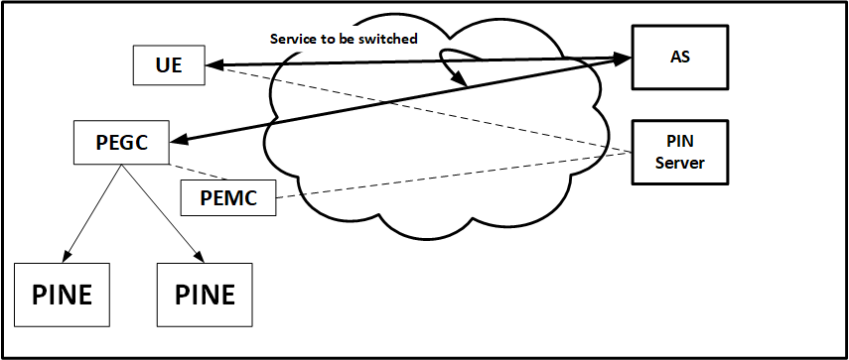
In the above diagram, an Application Session between the AS and the UE is switched to a PIN, through a PEGC.
To enable the switch, the PIN Client in UE contacts the PIN server and requests to switch.
The PIN server facilitates the switch by identifying the correct PIN and contacting the PIN Management Client to enable the switch. To enable the service switch, PIN Server and PIN Management Client exchange relevant end point identifiers and PINE information.
This contribution describes how:
- the appropriate PIN can be identified for service switch?
- service switch execution can be enabled by providing appropriate information of the service end points to the PIN Management Client and PIN Gateway Client?
3. Conclusions
N/A
4. Proposal
It is proposed to agree the following changes to 3GPP TR 23.700-78 v 0.2.0.

* * * First Change * * * *

7 Solutions

7.1 Mapping of solutions to key issues
Table 7.2-1 Mapping of solutions to key issues
 | KI #1 | KI #2 | KI #3 | KI #4 | KI #5
Sol #1 | X
Sol #2 | X
Sol #X |  |  | X

* * * * Next Change * * * *

7.X Solution #X: Service switch in a PIN

7.X.1 Architecture assumptions
The architecture assumptions of Solution #1 are also assumed in this solution.

7.X.2 Solution description

7.X.2.1 General
This solution addresses Key Issue #3. The principles of this solution are:
- The PIN Application Client in UE can discover or get notified about available PINs where an application service can be switched to.
- Once the PIN Application Client selects the PIN, it can request that the PIN Server trigger service switch procedure and obtain the necessary information for performing the service switch from the PIN Server.
- The PIN server can identify the PIN Applications in PINE, where the service can be split and terminated.
- The PIN Server instructs PIN Management Client to execute service switch procedure.
- The PIN Management client configures PIN Gateway client and PINEs for service switch.

7.X.2.2 Procedure
This procedure presents a high-level overview of Solution #X.

7.X.2.2.1 Functional entities
PIN Application Client: A PINAPP function in UE, PINE, which initiates discovery, service switch, configuration.
PIN Management Client: A PINAPP in PEMC, configures PEGC and PINE for service switch.
PIN Gateway Client: A PINAPP in PEGC, obtains configuration from PEMC and executes service switch.
PIN Server: Supports PIN Application Client by providing PIN information and executes service switch procedure when requested by PIN Application Client.

7.X.2.2.2 Procedures of PIN Service Switch
Figure 7.X.2.2.2.-1 illustrates a discovery and service switch procedure based on request/response model.

Figure 7.X.2.2.2-1: PIN Service Switch
Pre-conditions:
- The PIN Client in UE has been pre-configured or has discovered the address (e.g. IP address, FQDN, URI) of the PIN server;
- The PIN Client in UE has been authorized to communicate with the PIN server;
- The PIN Management Client supports functionality to execute the service switch procedure;
- The PIN Gateway Client supports functionality to execute the service switch procedure;
- The PIN Server has capability to communicate with Application server to identify application session and provide information about any changes to the end points of the session;
- There is an ongoing application session from AS to UE.
- A PIN Client in a UE, triggered by an Application Client, sends a discovery request to a PIN Server. The purpose of the discovery request is to discover a PIN that can support a certain application in a certain location. The discovery request includes Location information, Application requirements such as Display characteristics, Audio characteristics, etc. The PIN Client can also subscribe to be notified when a PIN is available in a location and can support the application requirements.
- The PIN Server based on Location and application service requirement can send a notification to the PIN Client with the following information: discovered PIN ID, details of PINAPP capabilities and corresponding PE IDs, such as Device ID, IP address and Port number.
- The PIN Client sends a “Service switch request” to the PIN Server with information about the service to be switched. The information about the service to be switched includes Application session ID, Destination PIN ID, and an IP 4 Tuple that describes the session. The IP 4 tuple may include the IP Address of the UE, the IP Address of the Server that provides the service, and the UE port numbers that are associated with the service, and the port numbers on the server that are associated with the service.
- PIN Server sends the “Switch Application Session” request to the PIN Management Client. The request includes information such as
- The Application Session Id,
- The, Destination PINE: PE IDs (1..N), can include IP address, Port number, URL etc.
- If the Application session needs to be split among multiple PINEs (i.e. split into sub-flows), it is indicated by setting the flag SPLIT == FALSE or TRUE. SPLIT can be set to TRUE only if the request includes multiple PINEs.
- The IP 4 Tuple
- Security related information elements required to successfully transfer the session context.
NOTE: Security related information elements are in the scope of SA WG3
- The PIN Management Client starts configuring PEGC by sending “Configure Service Switch” to PIN Gateway Client, which includes:
- The Session ID
- A token that the PGEC can use to prove to the Application Server that the PEGC should now be the end point for the streaming session.
- Destination PINE information, which is a list of PEID, IP address, Port number or URL, where the sub-flows will be terminated.
- The flag SPLIT is set to TRUE or FALSE, if the session needs to be split to multiple PINEs and more than one PINE information is included in the TerminatingPineList. It can also include information about PINE to sub-flow mapping.
- The PIN Management Client also configures PINE to prepare for terminating application session
- The PIN Management Client responds to PIN server to indicate that configuration of PEGC and PINE has happened successfully, with information such as
- The Terminating PEGC ID and
- The Terminating PEGC reachability information, such as IP address, port number, URL etc.
- The Terminating Destination PINE reachability information, such as IP address, port number, URL etc.
- PIN Server informs Application Server to switch the application session to a new destination IP address. PIN Server provides information such as:
- Application Session ID: identifies the application session to be switched to new end point
- TermIP Address: IP address of the PEGC where the application session will be terminated.
.
- PIN Gateway Client informs Application Server that it is ready to receive the application session with identification information from step 4.

- The PEGC may trigger a PDU Session Modification procedure in order to obtain QoS Rules for the new flow. PEGC can split the main session flow into sub-flows which are terminated at multiple PINEs. PEGC can also interact with PIN Server to maintain synchronization among the sub-flows.

7.x.3 Solution evaluation
This solution addresses KI#3 about "How to support application mechanism for service switching in a PIN between different PIN applications for achieving better service experience".
The application-level mechanism described here allows the Application server, PEGC and PINEs to become aware of the new endpoints to execute service switch. Based on these information, PINE, PEGC, 5GS and Application Server executes session setup, modify procedures.
* * * * End-of Changes * * * *

