3GPP TSG-SA WG6 Meeting #48-e S6-220697
e-meeting, 5th – 14th April 2022 (revision of S6-22xxxx)

Source: Qualcomm, KPN? Ericsson
Title: Pseudo-CR on UE identification with NAT
Spec: 3GPP TR 23.700-98 v0.5.1
Agenda item: 9.8
Document for: Approval
Contact: Nishant Gupta <gnishant@qti.qualcomm.com>

1. Introduction
This contribution provides a solution for the KI#16 on support of NAT deployed within the edge data network.
2. Reason for Change
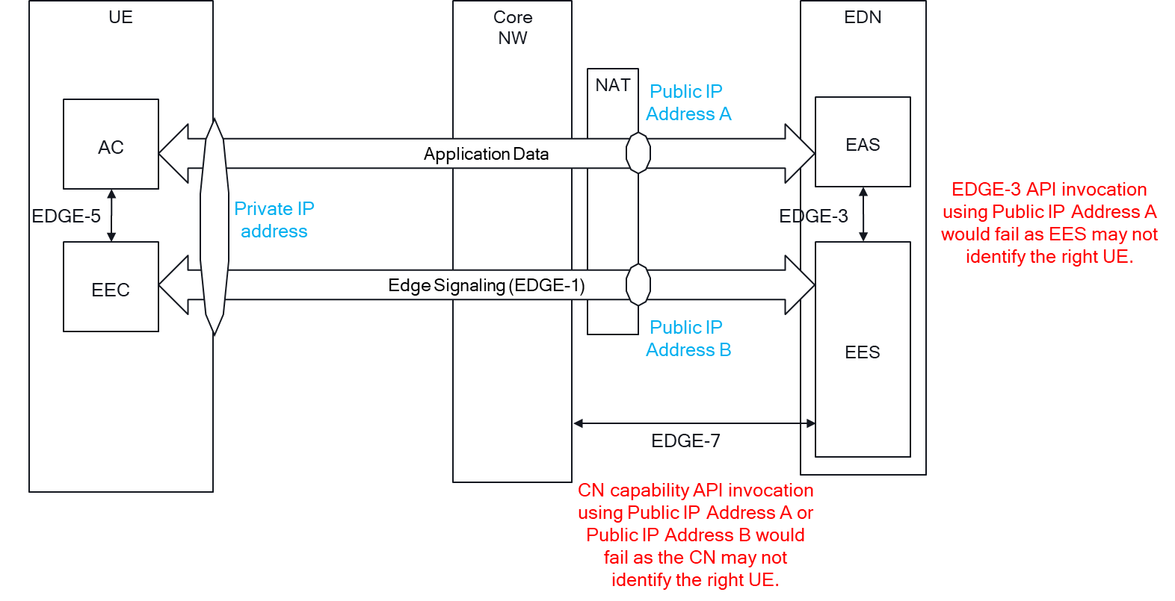
When a NAT is deployed by the MNO:
- EAS knows UE’s public address from the Application Data IP packets it receives i.e., Public IP Address A.
- EES knows UE’s public address from the Edge Signaling IP packets it receives i.e., Public IP Address B.
This results in UE identification issues, where the API invocation by the EAS and the EES would fail -
- If EAS invokes an EDGE-3 API with Public IP Address A, the EES may not identify the UE, and therefore cannot serve the EAS.
- If EES invokes an CN capability API with Public IP Address A received from the EAS or with Public IP Address B as seen by the EES, the CN may not identify the UE, and therefore cannot serve the EES.
3. Proposal
It is proposed to agree the following changes to 3GPP TR 23.700-98 v0.5.1.

* * * First Change * * * *

4.16 Key issue #16: support of NAT deployed within the edge data network
In operational deployments of cloud infrastructures including at the edge, Network Address Translation (NAT) are oftentimes deployed.
Such an operational constraint will prevent the EES to have an IP address of the UE that is known by the underlying 3GPP network.
Open issue:
- How the EES can access 3GPP network services pertaining to a UE when the edge data network employs Network Address Translators (NATs).
- How AF specific and temporary UE IDs can be manged at the Edge Enabler Layer?
Editor's Note: Whether EAS requires to be addressed in the key issue is FFS
* * * Next Change * * * *

7.x Solution #x: UE identification with NAT

7.x.1 Architecture enhancements
None.

7.x.2 Solution description

7.x.2.1 General
This solution corresponds to KI#16 on support of NAT deployed within the edge data network.
In this solution, the EEC provides the CN network assigned IP address i.e., the private IP address of the UE to the EES to obtain the UE identifier from the EES. EES uses the private IP address of the UE provided by the EEC to invoke the CN capability to translate UE’s IP address to its UE ID (e.g., UE’s GPSI).
Once obtained, the EEC passes the UE ID to the AC, which provides it to the EAS for use over EDGE-3 interface. With EAS and EES both being aware of the UE ID, issues pertaining to NAT and UE identification are resolved.

7.x.2.2 Procedure
Figure 7.x.2.2 illustrates the procedure for the EEC to obtain the UE ID from the EES and provide to the AC.
Figure 7.x.2.2-1: EEC obtaining UE ID from the EES
1. [Optionally] AC sends an Edge UE ID request to the EEC. The request may include the list of EASIDs for which the AC is requesting the Edge UE ID information and private IP address of the UE assigned by CN.
2. The EEC upon receiving the request validates if AC is authorized to request this information if step 1 is executed. If AC is authorised, the EEC sends the Edge UE ID request to the EES. The request includes the CN assigned private IP address of the UE and may include the list of EASIDs if provided by the AC. EEC may also trigger step 2 with its private IP address.
NOTE: private IP address used by AC and private IP address used by EEC can be the same or different (if different PDU sessions are used)
3. Upon receiving the request from EEC, the EES authorizes the EEC. If authorized the EES invokes the CN capability Nnef_UEId_Get for translating the UE’s IP address to its UE ID as defined in 3GPP TS 23.502 [08]. If the request from EEC includes a list of EASIDs, the EES may invoke the Nnef_UEId_Get API for each EAS individually to obtain EAS specific UE ID(s). The EES generates temporary Edge UE ID(s) which may be the same as the 3GPP CN provided UE ID or may be assigned by the EES itself.
4. [Optionally] The EES sends the Edge UE ID response to the EEC including the Edge UE ID(s).
5. Upon receiving the response from the EES, the EEC provides the Edge UE ID information to the AC by sending the Edge UE ID response.
6. The AC provides the Edge UE ID information to the EAS.
NOTE: Details on how the AC provides the information to the EAS is out of scope.
7. Once received from the AC, the EAS uses the Edge UE ID to invoke the APIs provided by the EES over EDGE-3 interface requiring 3GPP CN interaction (e.g., T-EAS Discovery, UE location request,, and EELManangedACR services).
8. The EES invokes the 3GPP CN capabilities (if required) using the UE ID provided by EEC upon receipt of API invocation over EDGE-1 interface (e.g. EAS discovery, ACR request).

7.x.3 Solution evaluation

