3GPP TSG-SA WG6 Meeting #48-e S6-220695
e-meeting, 5th – 14th April 2022 (revision of S6-22xxxx)

Source: Qualcomm
Title: Pseudo-CR on Federation and roaming
Spec: 3GPP TR 23.700-98 v0.4.0
Agenda item: 9.9
Document for: Approval
Contact: Nishant Gupta <gnishant@qti.qualcomm.com>

1. Introduction
This solution provides architecture enhancements and procedures for service provisioning to support federation of services, UE roaming, and federation of services across PLMNs for roaming UEs.
2. Reason for Change
Federation of services require sharing of Edge Computing resource information (such as EDN configuration data) across ECSPs, in order to enable consumer of one ECSP to access services of a partner ECSP. Also, a UE may roam to a V-PLMN and should still be able to access Edge Computing services. For the purpose of federation, this pCR proposes the following definition of the primary and partner ECSs:
Primary ECS: An ECS whose address information is configured with the EEC. EEC is authorized to communicate with the Primary ECS directly.
Partner ECS: A federation partner of the Primary ECS. EEC is not configured with the address information of Partner ECSs.
While roaming, the UE may connect to a Primary ECS in the hPLMN or the vPLMN i.e., roam without federation. Or it could obtain service from a partner ECS i.e., roam with federation.
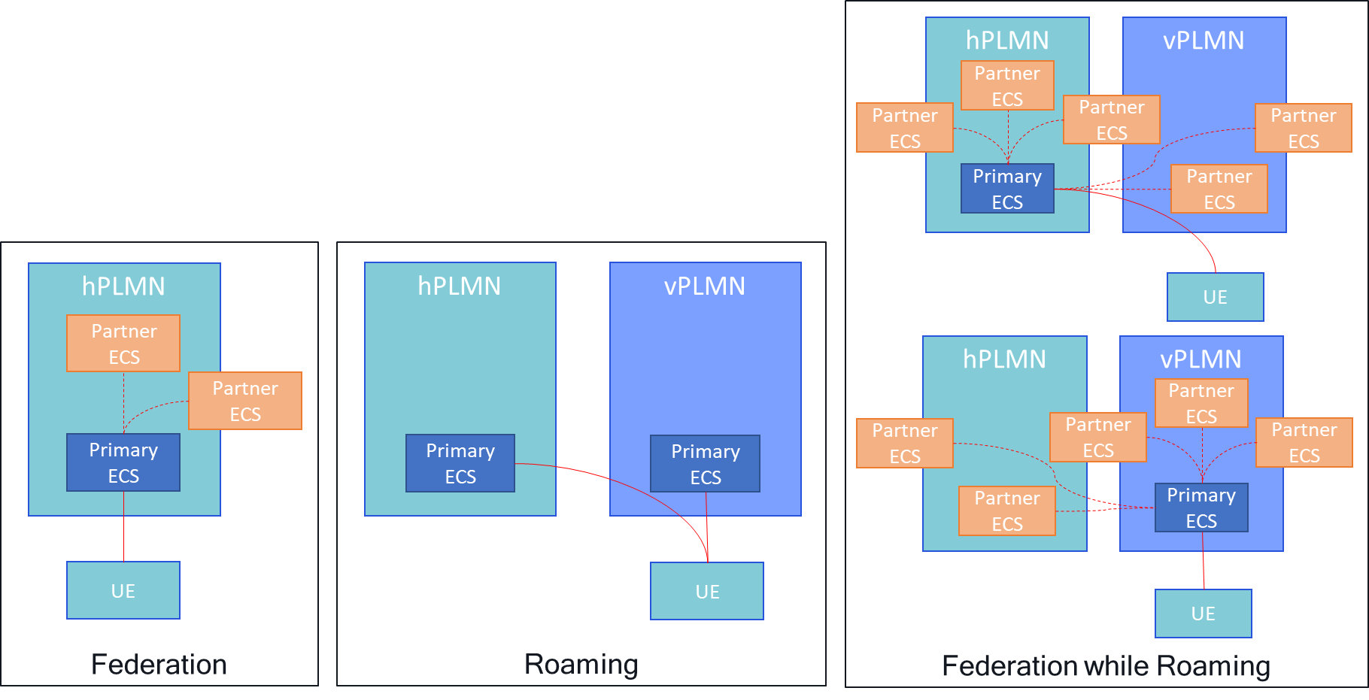
Following aspects should be considered to enable federation, roaming and federation while roaming:
1. Cardinality of the ECS
According to Rel-17 TS 23.558, there can be more than one ECSPs associated with a PLMN. Also, one ECSP can deploy multiple ECSs. When services are not available with the Primary ECS, the Primary ECS should be able to determine which ECS amongst all the partner ECSs can serve the UE.
TS 23.558:
6.6.2.4 ECS
The following cardinality rules apply for ECSs:
a) One or more ECS(s) may be deployed to support one EDN;
b) One ECS may be deployed to support one or more EDN(s);
c) One or more ECS(s) may be deployed by a PLMN operator; and
d) One or more ECS(s) may be deployed by an ECSP.

Annex B (Informative): Involved entities and relationships
A single PLMN operator can have the PLMN operator service agreement with a single or multiple edge computing service providers.

2. Edge computing resources are dynamic in nature
ECSPs can dynamically decide to deploy new Edge Data Networks or instantiate new Edge Application Servers based on prevailing demands, available resources etc. Also, there can be more than one ECSP within a PLMN, and each such ECSP may deploy any number of ECSs. Given the dynamic nature and the large amount of information, it is not practical to preconfigure this information within the ECSs.
3. Authentication/authorization and policy enforcement for service differentiation
Consumer UEs will be authorized for edge computing services from only a specific set of ECSPs (Primary ECSPs). Authentication and authorization by the partner ECSPs to provide edge services or service differentiation is a challenge.
4. EEC should always be in control of the service
Similar to Rel-17, where EEC has the liberty to choose the ECS and the EES for service provisioning and EAS discovery based on available services, service providers, user preferences etc., Rel-18 should also continue to provide such choices to the consumers.
Considering these aspects this solution suggests adding a new functional entity in the architecture that should be used for the purpose of federation and service provisioning support.
To understand the need for a dedicated functional entity to solve this key issue, consider a typical deployment based on the cardinality rules:
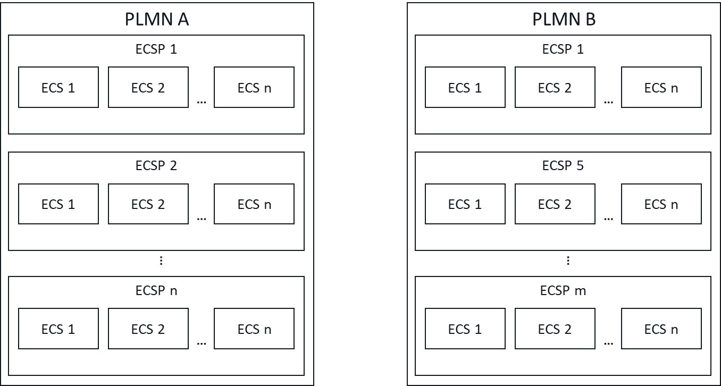
In the above example deployment:
- PLMN A has ‘n’ ECSPs associated with it.
- PLMN B has ‘m’ ECSPs associated with it. Some are common with PLMN A (e.g., ECSP 1)
- Each ECSP has one or more ECSs associated with it.
Catering to federation and roaming, there can be multiple ways for a primary ECS in PLMN A to find an ECS of a partner ECSP that can fulfil the application requirements. Note that this partner ECS can be in PLMN A when the UE, which is subscriber of PLMN A, is not roaming, and in PLMN A or PLMN B, when this UE is roaming to PLMN B.
Considering the above, following are the options to enable discovery of a partner ECS:
1. No further enhancements. In this option, we rely on EDGE-10 between the ECSs to find the right partner ECS. However, this is highly inefficient because:
a. The primary ECS is limited to only the preconfigured partner ECS information. This can be a configuration nightmare and will result in usage of obsolete information.
b. The primary ECS will have to cycle through the preconfigured partner ECSs to find out if the application needs can be fulfilled. This will result in huge waste of resources and time, which will be fatal for many ACR situations.
2. Designate one ECS of each ECSP as the ‘center of information’ or ‘repository’ of that ECSP and enhance EDGE-10 so that other ECSs of that ECSP can register and maintain latest information on the ‘designated ECS’. With that the primary ECS can use EDGE-10 to query the ‘designated ECS’ and find if any ECS of that ECSP can fulfil the application requirements. This is better than option 1, but still inefficient because:
a. The primary ECS is still limited to preconfigured information about the ‘designated ECSs’. Considering a large combination of MNOs and PLMNs, this will still be large set of preconfigurations.
b. The primary ECS will have to cycle through the preconfigured ‘designated ECSs’ to find out if the application needs can be fulfilled. This will still result in waste of resources and time (though lesser than option 1), which will still be fatal for many ACR situations.
3. Introduce a new functional entity, edge repository, associated with the MNO. ECSs of all the ECSPs associated with the MNO register with this central edge repository and store their information using a new interface (EDGE-11). MNOs that are part of a federation have their central edge repositories connected via an interface between them (EDGE-12). This option is highly efficient compared to option 1 and option 2, because:
a. The primary ECS is not limited to preconfigured partner ECSP information.
b. Minimum preconfiguration is required – ECS just needs to know the edge repository of the MNO it is associated with.
c. The primary ECS needs to issue only one request to find all ECSs of all partner ECSPs, both in hPLMN and vPLMN, that can serve the application requirements saving both resources and critical time.
d. Information about other PLMNs and associated ECSPs can be cached in the edge repository making discovery of a partner ECS much faster.
Given the improvements option 3 brings, this pCR advocates introducing the new functional entity in the architecture and introduce associated functionalities.
3. Proposal
It is proposed to agree the following changes to 3GPP TR 23.700-98 v0.4.0.

* * * First Change * * * *

3.1 Terms
For the purposes of the present document, the terms given in 3GPP TR 21.905 [1], 3GPP TS 23.558 [2] and the following apply. A term defined in the present document takes precedence over the definition of the same term, if any, in 3GPP TR 21.905 [1] and 3GPP TS 23.558 [2].
<defined term>: <definition>.
Primary ECS: An ECS whose address information is configured with the EEC. EEC is authorized to communicate with the Primary ECS directly.
Primary ECSP: An ECSP for which the UE has authorization to obtain service.
Partner ECS: A federation partner of the Primary ECS. EEC is not configured with the address information of Partner ECSs.
Partner ECSP: An ECSP with whom the Primary ECSP has a service level agreement for resource sharing i.e., a federation partner of the Primary ECSP.
example: text used to clarify abstract rules by applying them literally.
* * * Next Change * * * *

7.0 Mapping of solutions to key issues
Table 7.0-1 Mapping of solutions to key issues
 | KI #1 | KI #2 | KI #3 | KI #4 | KI #5 | KI #6 | KI #7 | KI #8 | KI #9 | KI #10 | KI #11
Sol #1 | X
Sol #2 |  |  |  |  |  |  | X
Sol #4 |  |  |  |  |  | X |  |  |  | X
Sol #5 |  |  |  |  |  | X |  |  |  | X
Sol #6 |  |  | X
Sol #8 |  | X
Sol#x |  |  |  |  |  | X |  |  |  | X
…

* * * Next Change * * * *

7.x Solution #x: Federation of services

7.x.1 Architecture enhancements

7.x.1.1 Architecture
Since a PLMN can host multiple ECSP(s) where both, MNO and the ECSP can deploy multiple ECSs each, it is not possible for the Primary ECS to rely on pre-configuration or policy-based federation. Additionally, ECSs, EESs and EASs can be enabled or disabled dynamically based on prevailing requirements, available resources etc., resulting in stale pre-configurations and policies. Therefore, it is essential to maintain this information in real-time and enable an ECS to discover it on a need basis.
This solution requires a new functional entity in the architecture called Edge repository. It is a central repository of all Edge Computing resources available within a PLMN.
The Edge repository interfaces with:
- ECS: ECS(s) available within the PLMN register with the Edge repository, providing information of EASs available via the ECS. This information can be collected by the ECS using the EES registrations. ECS(s) can also discover the information available at the Edge repository.
- Other Edge repositories: Edge repository of one PLMN interfaces with Edge repositories of other PLMNs to share information about available Edge Computing resources.
Following figure illustrates the enhanced architecture:
Figure 7.x.1.1-1: Architecture enhanced with Edge repository
NOTE: In a deployment an ECS (e.g., MNO’s ECS) can act as the Edge Repository. In which case, functions defined for EDGE-11 and EDGE-12 reference points will merge with EDGE-10.

7.x.1.2 Functional entities

7.x.1.2.1 Edge Repository
Edge repository provides supporting functions needed for roaming and federation.
Functionalities of Edge repository are:
a) Receiving and storing information about Edge computing resources from ECS(s) within the PLMN;
b) Retrieving and caching information about Edge computing resources from Edge repositories of other PLMNs; and
c) Providing information about Edge computing resources to the ECS(s) within the PLMN and to the Edge repositories of other PLMNs.

7.x.1.3 Reference Points

7.x.1.3.1 EDGE-11
EDGE-11 reference point enables interactions between the ECS and the Edge repository. It supports:
a) registration and de-registration of the ECS to the Edge repository; and
b) retrieval or discovery of information about other ECS(s) available within the PLMN or a different PLMN.

7.x.1.3.2 EDGE-12
EDGE-12 reference point enables interactions between the Edge repository of one PLMN and the Edge repository of another PLMN. It supports:
a) retrieval or discovery of information about ECS(s) available in a different PLMN.

7.x.1.4 Cardinality

7.x.1.4.1 Edge repository
The following cardinality rules apply for Edge repository:
a) One Edge Repository is deployed by a PLMN operator.

7.x.1.4.2 EDGE-11
The following cardinality rules apply for EDGE-11:
a) One or more ECS may communicate with the Edge repository.

7.x.1.4.3 EDGE-12
The following cardinality rules apply for EDGE-12:
a) Edge repository of one PLMN may communicate with Edge repositories of one or more PLMNs

7.x.2 Solution description

7.x.2.1 ECS registration with the Edge repository
ECS registers with the Edge repository and provides the Edge repository with information such as ECS configuration information, applications available via the ECS, list of Partner ECSPs etc. Figure 7.x.2.1-1 illustrates the procedure.
Pre-conditions:
1. The ECS has the address (e.g., URI) of the Edge repository.
Figure 7.x.2.1-1: ECS registration with the Edge repository
1. The ECS sends the ECS registration request to the Edge repository. The request from the ECS includes the ECS configuration information (ECS address and the ECS provider information) along with its security credentials, and may include a list of EASs available via the ECS, a list of Partner ECSPs, an ordered list of preferred Partner ECSPs, EDN configuration information etc. The request may include a proposed expiration time for the registration.
2. Upon receiving the request from the ECS, the Edge repository verifies the security credentials of the ECS and stores the ECS registration information obtained in step 1. If the received request contains a list of Partner ECSPs, the Edge repository ensures that the information of the ECS is shared only with the Partner ECSPs. Also, when the ECS tries to retrieve information of other ECSPs from the Edge repository, the Edge repository ensures that information of only the Partner ECSPs is shared. It also considers the preferred Partner ECSP list, if received from the ECS.
3. The Edge repository sends an ECS registration response indicating success or failure of the registration operation. The Edge repository may provide an expiration time to indicate to the ECS when the registration will automatically expire. To maintain the registration, the ECS shall send a registration update request prior to the expiration time. If a registration update request is not received prior to the expiration time, the Edge repository treats the ECS as implicitly de-registered.
NOTE: An ECS registration update and ECS deregistration procedure is required.

7.x.2.2 ECS discovery for Federation and/or Roaming
ECS uses the Edge repository to discover information of other available ECS when the ECS is unable to fulfil the Service Provisioning request of an EEC. Figure 7.x.2.2-1 illustrates the procedure.
Figure 7.x.2.2-1: ECS discovery for Federation and/or Roaming
1. The EEC sends a service provisioning request to the Primary ECS. The service provisioning request includes the security credentials of the EEC received during EEC authorization procedure and may include the UE identifier such as GPSI, connectivity information, UE location and AC profile(s) information. In case the UE hosting the EEC is roaming to a V-PLMN, the service provisioning request may include the V-PLMN ID.
2. Upon receiving the request, the Primary ECS performs an authorization check to verify whether the EEC has authorization to perform the operation. The Primary ECS may utilize the capabilities (e.g., UE location, serving PLMN ID check) of the 3GPP core network. The Primary ECS also enforces any policy for service differentiation.
3. The Primary ECS identifies required EDN configuration information based on the received request in step 1 and checks in step 2. The ECS determines that at least one of the required applications (i.e., EAS) is not available via the Primary ECSP.
4. Based on the determination in step 3, the Primary ECS sends a ECS discovery request to the Edge repository. The request contains the information of the Primary ECS, information of any preferred Partner ECSP(s), Service Provisioning filters received from the EEC in step 1 and checked by the Primary ECS in step 2 and UE’s current location. If the UE hosting the EEC is roaming in a V-PLMN (determined using the serving PLMN information in the received service provisioning request in step 1, or by interacting with the H-PLMN), then the ECS discovery request includes the information of the serving PLMN i.e., the V-PLMN.
5. The Edge repository authorizes the received request. If authorized, the Edge repository processes the request.
6. If the ECS discovery request includes a PLMN ID which is different than the H-PLMN ID, the Edge repository sends a ECS discovery request to the Edge repository of the serving PLMN i.e., the V-PLMN. The request includes the ECS discovery filters received in step 4. If the serving PLMN is same as the H-PLMN, then this step is skipped.
NOTE: The H-PLMN and the V-PLMN have service level agreement to share Edge Computing resources. Given this service level agreement, the H-PLMN is configured with the endpoint information of the Edge repository of the V-PLMN.
7. The Edge repository of the V-PLMN on receiving the request in step 6, authorizes the request. If authorized, the Edge repository of the V-PLMN responds with the information of the ECS(s) available in the V-PLMN, satisfying the query parameters received in step 6. Information of the ECS includes the ECS configuration information and may include related EDN configuration information.
8. The Edge repository of the H-PLMN gathers the information of ECS(s) that can satisfy the query parameters received in step 4 and sends a ECS discovery response to the Primary ECS. The response includes information of the Partner ECS(s) available in the H-PLMN and/or the V-PLMN, depending on the serving PLMN of the UE as indicated in step 4. The Primary ECS caches the received information for further use.
9. On receiving the ECS discovery response, the Primary ECS applies any local policy or EEC profile-based filtering for service differentiation.
10. The Primary ECS sends the list of Partner ECS(s) which provide the applications required by the EEC. The information includes ECS provider information, list of EAS(s) available via the ECS etc. The response either includes the ECS address information, if the EEC is authorized to communicate directly with the Partner ECS, or it includes an indication that the Partner ECS must be reached via the Primary ECS. For the Partner ECS(s) that may be communicated directly, the response also includes authorization information required by the EEC to communicate with the Partner ECS. The response may also include EDN configuration information received from the Edge repository, if any.
The response may also include EDN configuration information for the EAS(s) available via the Primary ECS, if any.

7.x.2.3 Service provisioning from a partner ECS
For EEC to retrieve service provisioning information from a partner ECS, the partner ECS needs to authenticate and authorize the request from the EEC. Further, the partner ECS is required to apply any service differentiation policies specific to the EEC. In most realistic deployments it is not feasible for ECS(s) to obtain the information required for authentication, authorization and policy enforcement of EECs related to all its partners. Further, maintenance of this information such as service differentiation policy updates, change in EEC’s authorizations etc. is a resource intensive task.
Therefore, authentication, authorization, and service differentiation policy enforcement for service provisioning requests of an EEC should be performed by the Primary ECS. Figure 7.x.2.3-1 illustrates the procedure for obtaining service provisioning information from a partner ECS, with the help of Primary ECS.
Preconditions:
1. EEC has received the information of Partner ECS(s) from a Primary ECS.
2. EEC has selected the Partner ECS to be used for service provisioning, where the selected Partner ECS must be reached via the Primary ECS.
Figure 7.x.2.3-1: Service provisioning from a partner ECS
1. The EEC sends a proxy service provisioning request to the Primary ECS. The service provisioning request includes the security credentials of the EEC received during EEC authorization procedure and may include the UE identifier such as GPSI, connectivity information, UE location and AC profile(s) information. The request also includes the details of the Partner ECS selected by the EEC for service provisioning. The request may also include a notification destination address if the EEC intends to subscribe for the service provisioning information. In case the UE hosting the EEC is roaming to a V-PLMN, the service provisioning request may include the V-PLMN ID.
2. Upon receiving the request, the Primary ECS performs an authorization check to verify whether the EEC has authorization to perform the operation. The Primary ECS may utilize the capabilities (e.g., UE location, serving PLMN ID check) of the 3GPP core network. The Primary ECS also enforces any policy for service differentiation.
3. The Primary ECS sends a Relayed service provisioning request to the Partner ECS indicated in the request received in step 1. The request includes the filters received in step 1 after processing in step 2 and may include the EEC ID received in step 1. If the request received in step 1 is to create a service provisioning subscription and includes a notification destination address, then the relayed service provisioning request includes the notification destination address received from the EEC.
4. The Partner ECS checks if the request by the Primary ECS is authorized. If authorized, the Partner ECS process the request. If the request is to create a subscription, the Partner ECS creates the subscription and stores the relevant information received in step 3. It provides the subscription identifier and a Partner ECS identification token to the Primary ECS as part of the Relayed service provisioning response. If the request received in step 3 is for one-time provisioning and does not include a notification destination address, the Partner ECS determines the relevant EDN configuration information and provide to the Primary ECS as part of the Relayed service provisioning response. The EDN configuration information also includes a token authorizing EEC’s communication with the EES(s) provided via the Partner ECS.
5. On receiving the Relayed service provisioning response in step 4, the Primary ECS caches the received information for further usage.
6. The Primary ECS sends a Proxy service provisioning response to the EEC. If the response received in step 4 includes the EDN configuration information, the Primary ECS includes it in the Proxy service provisioning response. Otherwise, if the response received in step 4 includes a subscription identifier and a Partner ECS identification token, the Primary ECS includes them in the Proxy service provisioning response.
7. In case of Service provisioning subscription, the Partner ECS sends the service provisioning notification containing the EDN configuration information to the notification destination address received from the Primary ECS. The notification includes the EDN configuration information and the Partner ECS identification token. The EDN configuration information also includes a token authorizing the EEC to communicate with the EES(s). On receiving this notification, the EEC verifies the Partner ECS identification token and processes the received information accordingly.
NOTE 1: On receiving the EDN configuration information, the EEC proceeds with EAS discovery with one or more available EES(s).
NOTE 2: Proxy service provisioning subscription update and unsubscribe follow the same path via the Primary ECS.

7.x.3 Solution evaluation
TBD.
* * * Next Change * * * *
<Proposed change in revision marks>

