3GPP TSG-SA WG6 Meeting #42-bis-e meeting S6-211xxx
12th – 20th April 2021 (revision of S6-210878, 1009 and merge of 974)

Source: Huawei, Hisilicon, China Telecom, [Intel, Samsung, Convida Wireless, AT&T, Verizon, Qualcomm, InterDigital, Apple, Deutsche Telekom, Ericsson, Softil, ETRI]?
Title: Corrections to the SBA representation of the architecture
Spec: 3GPP TS 23.558 v2.0.0
Agenda item: 7.6
Document for: Approval
Contact: Niranth Amogh (namogh@huawei.com), Roya Rezagah (roya.rezagah@huawei.com), Danny Moses (danny.moses@intel.com)

1. Introduction
This contribution provides corrections to the service based representation of the architecture to resolve the issue of the working agreement.
2. Way Forward for the Issue of the Working Agreement
SA6 chair proposed two documents, S6-210949 and S6-210950 as compromise proposals during the formal conference call. As there were objections to both, they are NOTED.
Further all involved companies are continually putting their best efforts to resolve the architecture agreed by the working agreement irrespective of the voting. Huawei fully supports the efforts from the companies to resolve the working agreement in this meeting itself with consensus on a compromise. Considering this direction,
- Huawei has withdrawn its objection on S6-210949 and proposes to consider the proposal in S6-210949 as the Way Forward to resolve the Working Agreement.
- Further, Huawei has withdrawn the challenge to the working agreement as the voting is now not necessary to resolve the issue of the working agreement.
This contribution now only contains the proposal aligned with S6-210949 as the Way Forward for resolving the issue of the Working Agreement.
3. Proposal
It is proposed to agree the following changes to 3GPP TS 23.558 v2.0.0.

* * * First Change * * * *

6.2 Architecture
This clause describes the architecture for enabling edge applications in the following representations:
- A service-based representation, where the Edge Enabler Layer functions (e.g. ECS) enable other authorized Edge Enabler Layer functions (e.g. EES) to access their services. This representation also includes point-to-point reference points where necessary;
- A service-based representation as specified in 3GPP TS 23.501 [2], where the Network Functions (e.g. NEF) enable authorized Edge Enabler Layer functions (e.g. ECS) i.e. Application Functions, to access their services;
- A service-based representation, where the Core Network Northbound APIs as specified in 3GPP TS 23.501 [2] and 3GPP TS 23.502 [3], are utilized by authorized Edge Enabler Layer functions via CAPIF core function specified in 3GPP TS 23.222 [6]; and
- A reference point representation, where existing interactions between any two functions (e.g. EES, ECS) is shown by an appropriate point-to-point reference point (e.g. EDGE-6, EDGE-7).
Edge Enabler Layer functions shown in the service-based representation of the edge architecture shall only use service-based interfaces for their interactions.
Figure 6.2-1 illustrates the service based representation of architecture for enabling edge applications.

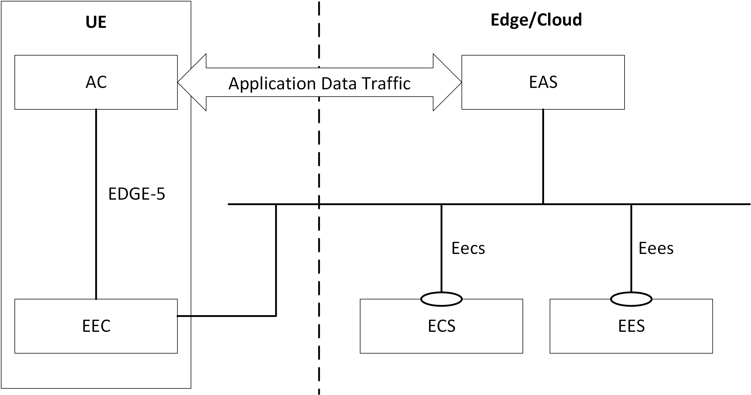
Figure 6.2-1: Architecture for enabling edge applications - service-based representation
NOTE: The EEC function and EAS function in figure 6.2-1 are only service consumers and do not provide any service.
Editor's note: Whether the meaning of the term SBA in this clause needs to be modified based upon the above representation is FFS.
Editor's note: How the possible deployment models of the ECS affect the above representation is FFS.
The mechanisms for service discovery in the SBA represented by figure 6.2-1 are as follows:
- The EES discovers the ECS via pre-configuration or by using CAPIF as specified in 3GPP TS 23.222 [6].
- The EAS discovers the EES via pre-configuration or by using CAPIF as specified in 3GPP TS 23.222 [6].
- The EAS discovers the other EAS(s) as specified in clause 8.8.3.2.
- The EEC discovers the ECS as specified in clause 8.3.2.
- The EEC discovers the EES via service provisioning as specified in clause 8.3.3.
Figure 6.2-2 illustrates the service-based representation for utilization of the 5GS network services based on 5GS SBA specified in 3GPP TS 23.501 [2].
Figure 6.2-2: Utilization of 5GS network services based on 5GS SBA – service based representation
The ECS, EES and EAS acts as AFs for consuming network services directly from the 3GPP 5G Core Network entities over the service based architecture specified in 3GPP TS 23.501 [7].
The ECS, EES and EAS can simultaneously consume network services from the 5GS SBA as represented in the figure 6.2-2 and interact in the SBA represented in figure 6.2-1.
Figure 6.2-3 illustrates the service-based representation for utilization of the Core Network (5GC, EPC) northbound APIs via CAPIF.
Figure 6.2-3: Utilization of Core Network Northbound APIs via CAPIF – service based representation
The ECS, EES and EAS may act as authorized API invoker to consume services from the Core Network (5GC, EPC) northbound API entities like SCEF, NEF, SCEF+NEF which act as API Exposing Function as specified in 3GPP TS 23.222 [6].
The mechanism for northbound APIs discovery in the SBA represented by figure 6.2-3 is as specified in 3GPP TS 23.222 [6].
The ECS, EES and EAS can simultaneously consume Core Network northbound APIs via CAPIF as represented in the figure 6.2-3 and interact in the SBA represented in figure 6.2-1.
Figure 6.2-4 illustrates the reference point representation of the architecture for edge enabling applications

Figure 6.2-4: Architecture for enabling edge applications - reference points representation
The EDN is a local Data Network. EAS(s) and the EES are contained within the EDN. The ECS provides configurations related to the EES, including details of the EDN hosting the EES. The UE contains AC(s) and the EEC. The EAS(s), the EES and the ECS may interact with the 3GPP Core Network.

