3GPP TSG-SA WG6 Meeting #42-BIS-e S6-210996r1
e-meeting, 12th – 20th April 2021 (revision of S6-210750)

Source: Tencent
Title: Procedure for Real-Time UAV Connection Status Monitoring and Location Reporting
Spec: 3GPP TS 23.255 v0.3.0
Agenda item: 7.10
Document for: Approval
Contact: Shuai Zhao, <shuaiizhao@tencent.com>

1. Introduction
This contribution proposes the procedures for Real-Time UAV Connection Monitoring And Location Reporting.
2. Reason for Change
Per Study in FS_UASAPP TR 23.755, Real-time networking monitor and location reporting play an important role to fulfill stage 1 requirements. In TR 23.755, solution#12 aims to address the KI#1 and #3 and provides real-time monitoring, loss of communication, and location reporting for given UAS operations.
The current agreement for Solution#12 in TR 23.755 is as following:
Sulotion#12 provides a viable technical approach to enable UAE-S to 1) obtain near real-time UAV locations by actively monitoring the network connection status using services provided by SEAL 2) directly react on 3GPP CN monitoring events. This solution may also be used as an enhanced step for solutions for key issue#3 and key issue#11 with provided real-time network connectivity status.
However, some procedural support is missing from SEAL:
1. For unicast traffic, currently, SEAL NRM-S does not have procedures to:
1.1) Allow UAE-S to request network connection status from NRM-S.
1.2) Report network connection status back to UAE-S.
1.3) Detect connection loss or status with NRM-C.
2. The LMS location report does not have support to indicate the location timeliness.

3. Proposal
It is proposed for adoption to 3GPP TS 23.255 v0.3.0. The corresponding miss features from SEAL are proposed as follows:
- Real-time network connection monitoring support in S6-210752
- Proposed location report timestamp support in S6-210751

* * * First Change * * * *

6.x Real-Time UAV Connection Status Monitoring and Location reporting

6.x.1 General
This clause enables the UAE server to provide a real-time view of UAV network status and location reporting based on current network connection status, in particular with the supporting of following use cases:
- Support of real-time monitor the 3GPP network connection with UAVs.
- Support of reporting of loss of communication with UAVs.
- Support of location reporting such as last known location after loss of communication.
Editor's Note: How this procedure is used by UAS application specific layer is FFS

6.x.2 Procedures

6.x.2.1 Procedure for real-time UAV network connection status monitoring and location update
Figure 6.x.2.1-1 illustrates the real-time network monitoring and location update support for UAV operations.
Pre-conditions:
- UAE server has subscribed to the connection monitoring service of the NRM server for both UAV and/or UAV client and also for the location information of UAV from LM server as per the clause 9.3.7 specified in 3GPP TS 23.434 [11]
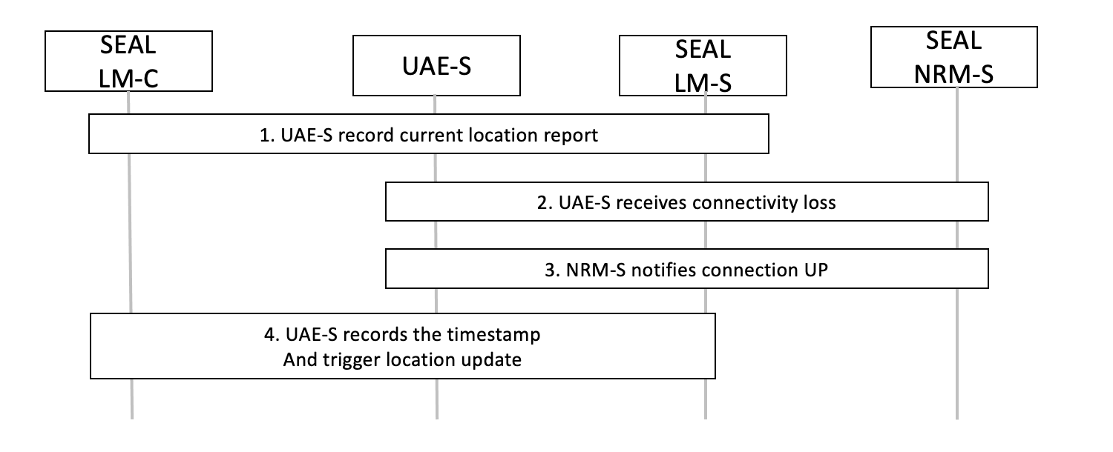
Figure 6.x.2.1-1: real-time UAV network connection status monitoring and location update
- The UAE server receives location report from LM client as specified in clause 9.3.8 in 3GPP TS 23.434 [11]. UAE server shall record the current location reporting timestamp as specified in clause 9.3.2.2 of 3GPP TS 23.434 [11] .
- The UAE server receives networking events notification as specified in clause 14.3.X.3.2 of 3GPP TS 23.434 [11]. If events are regarding loss of UE reachability such as when received Loss_of_connectivity_notification, the UAE server shall record such event with current timestamp.
- NRM server sends notification when UE re-connected status is detected as specified in clause 14.3.X.3.2 of 3GPP TS 23.434 [11].
- the UAE server shall record such event with current timestamp, plus with last known location information and timestamp as specified in clause 9.3.2.7 of 3GPP TS 23.434 [11] and trigger location update as specified in clause 9.3.4 of 3GPP TS 23.434 [11].

6.x.3 Information flows
Editor's Note: This clause will describe the information flow tables

