3GPP TSG-SA WG6 Meeting #41-e S6-210908
e-meeting, 18th – 26th January 2021 (revision of S6-21xxxx)

Source: Huawei, Hisilicon, ZTE
Title: New solution to key issue#3 on Data delivery
Spec: 3GPP TR 23.783 v1.2.0
Agenda item: 8.1
Document for: Approval
Contact: Cuili – Ge <gecuili@huawei.com>

1. Introduction
This pCR is proposed to introduce a new solution to key issue #3 on data delivery aspect.
2. Reason for Change
Not only the DL media (i.e., RTP packets) can be delivered over MBS, also the application level control signalling e.g., floor taken or floor idle and the group status, which targets to the affiliated members can be delivered over the MBS.
This pCR is proposed to use the MBS delivery to tranfer the application leve; controlling signalling and group status.
In addition, the FEC and ROHC should also be supported when using the MBS delivery for the MC service. This pCR is proposed to support the FEC and ROHC at the MC service server.
3. Conclusions
4. Proposal
It is proposed to agree the following changes to 3GPP TR 23.783 v1.2.0.

* * * First Change * * * *

6.x Solution x: Data transfer aspect for MC service over 5G MBS

6.x.1 Description
This solution is to address the key issue #3 on data transfer over 5G MBS delivery aspects including :
- transferring the application level control signallings (e.g., floor control messages) and group status to the affiliated group members, and
- processing the FEC and ROHC at the MC service server.
Editor’s note: The interfaces from MC service server towards MB-SMF and MB-UPF may be updated if necessary to align with 5G MBS architecture specified by SA2.
Editor’s note: Potential update to the solution is FFS if impacted by the corresponding 5G MBS features are still being specified in SA2.

6.x.1.1 Use of MBS delivery for application level control signalling

6.x.1.1.1 General
The MC service server may use the MBS delivery for application level control signalling, according to this clause. Application level control signalling over MBS delivery is typically for the purposes beyond the benefit for using MBS for resource efficiency, e.g. for improved MC service performance (KPIs), handling of high load scenarios.
The MBS MBS QoS flow(s) for application level control signalling may be used to transmit the following messages:
- Transmission control (e.g. call setup and floor control)
- MBS service announcement
- Group application paging
- Group dynamic data (e.g. status of the group, group call is on-going or not)
- Group state (e.g. emergency alerts)
For MBS QoS flow(s) for application level control signalling, it is activated in a service area that is larger than the estimated service for media (broadcast delivery) or for the specific group (multicast delivery). The service area for the media mainly based on counting of group members in each defined service area. The MBS QoS flow(s) for application level control signalling is also activated with a QoS that is better than MBS QoS flow(s) for media since the packet loss requirements are much stricter.
The MC service client shall not send responses to group-addressed application level control signalling unless instructed or configured to respond.

6.x.1.1.2 Procedure
The procedure in figure 6.x.1.1.2-1 shows only one of the receiving MC service clients using MBS QoS flow(s).
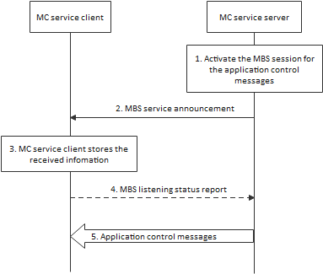
Figure 6.x.1.1.2-1: Use of MBS delivery for application level control signalling
1. The MC service server determines to activate MBS session for application level control signalling. The activation of the MBS session is done on the N29/Nmbsmf/N33 reference point and according to 3GPP TS 23.247 [x]. The MBS session is either a multicast MBS session or a broadcast MBS session.
2. The MC service server passes the MBS service infomation for the service description associated MBS session to the MC service client. The MC service client obtains the MBS Session ID (i.e., TMGI or the source specific IP multicast address), identifying the MBS session, from the service description.
3. The MC service client stores the information recevied.
4. [Conditional] When broadcast QoS flow is used, this step is performed, else it is skipped.
The MC service client that enters or is in the service area of the announced TMGI indicates to the MC service server that the MC service client is able to receive application level control messages over the broadcast delivery. The MC service client may also indicate at which MBS reception quality level it has received the MC service media on the broadcast QoS flow. Hence, the MC service server may decide to use the broadcast QoS flow for MC application control messages.
5. The MC service server transmit MC application control messages over the MBS QoS flow(s).
The MCPTT server may use the MBS QoS flow(s) to inform the group dynamic data (indicating the group call is on-going or not) when the group call is set up on unicast QoS flow. The affiliated clients that will perform late entry chat group calls or rejoin calls may use this group status information to decide whether to join the calls.

6.x.1.2 Use of FEC to protect MBS transmissions

6.x.1.2.1 General
Application layer FEC can be used to recover the packet losses when delivering a MC service over MBS, to reach its required level of QoS.
Support of FEC is optional for the MC service servers and MC service clients
Adding FEC introduces an extra latency in the end to end media transport. This extra latency is bounded to fulfil the low latency requirements for mission critical services.

The MC service server may consider the listening status reports from previous MBS reception quality detection procedures to adjust the FEC parameters when delivering over a new MBS QoS flow.

6.x.1.2.2 FEC encoding by the MC service server
In this procedure, depicted in figure 6.x.1.2.2-1, FEC encoding is performed by the MC service server. The MC service server includes the FEC information within the MBS service announcement. The FEC decoding is performed by the MC service client.

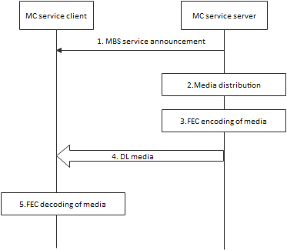
Figure 6.x.1.2.2-1: Application of FEC by the MC service server
1. The MC service server sends MBS service announcement message with FEC information to the MC service clients.
2. As media packets arrive from the originating MC service UE (not shown in diagram), the media is processed by the media distribution function on the MC service server.
3. The MC service server performs FEC encoding and processing in accordance with the selected FEC algorithm.
4. The MC service server sends the media with FEC to the MC service client (both payload source packets and the FEC repair packets are sent on the N6 to MB-UPF, which transparently forwards them unmodified to the MC service client).
5. MC service client performs FEC decoding and processing in accordance with the selected FEC algorithm

6.x.1.3 Header compression over MBS session with ROHC

6.x.1.3.1 General
Support of ROHC over MBS is optional for the MC service servers and MC service clients. If header compression and FEC are both applied to a communication over MBS, the header compression shall be performed after the FEC encoding.

6.x.1.3.2 Header compression by the MC service server
In this procedure, depicted in figure 6.x.1.3.3.2-1, header compression is performed by the MC service server. The MC service server includes the ROHC information within the MBS service announcement. The header decompression is performed by the MC service client.
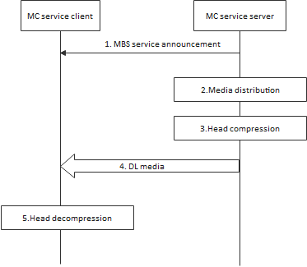
Figure 6.x.1.3.2-1: Header compression by the MC service server
1. The MC service server sends MBS service announcement message with ROHC information to the MC service clients. The ROHC information contains the list of ROHC profiles and the ROHC context identifier range).
2. As media packets arrive from the originating MC service UE (not shown in diagram), the media is processed by the media distribution function on the MC service server.
3. The MC service server performs header compression in accordance with the ROHC information.
4. The MC service server sends the header compressed media to the MC service client
5. The MC service UE performs header decompression in accordance to the ROHC information

6.x.2 Impacts on existing nodes and functionality

MC service server and MC service client needs to support the 5G MBS application layer functionalities.

6.x.3 Solution evaluation

This solution is derived from the MBMS mechanism in 3GPP TS 23.280 to deliver the application lever control messges to the affiliated group members which improves the resource efficiency.

