3GPP TSG-SA WG6 Meeting #41-e S6-210907
e-meeting, 18th – 26th January 2021 (revision of S6-21xxxx)

Source: Huawei, Hisilicon, CBN, ZTE
Title: New solution to key issue#3 on application layer architecture over 5G MBS
Spec: 3GPP TR 23.783 v1.2.0
Agenda item: 8.1
Document for: Approval
Contact: Cuili – Ge <gecuili@huawei.com>

1. Introduction
This pCR is proposed to introduce a new solution to key issue #3 on the application layer architecture over 5G MBS.
2. Reason for Change
In key issue #3, which 5G MBS features and configuration options is applicable and selected for MC service needs to be addressed.
The solution in this pCR proposes the 5G MBS features, options for MC service and also an application layer architecture over 5G MBS.
(1) The MC service requirements on broadcast/multicast
For the MC service server over LTE MBMS, all the MC service servers support the service layer functionalities (e.g., service authorization, membership, security, service announcement, unicast/multicast switching). When it comes to 5G MBS, the same condition is also valid. Another fact needs to be considered is that the MBSF/MBSTF are defined by SA4 with a slow progress.
It can be concluded that Transport Only Mode can satisfy all the MC services.
Proposal #1: To support the basic/minimum set of MBS features to enable MC service..
(2) Selection of configuration options
As analyzed above, transport only mode is used for group communication, and MBSF is not necessary for transport only mode. The MC service server is the media anchor for media distribution. So the configuration option #1 can fully satisfy the MC service requirements and should be selected for MC service for all the services.
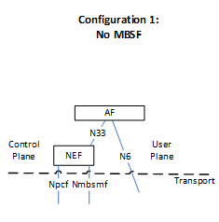
Proposal #2: The configuration option #1 is applicable and selected for MC service.

(3) MC service architecture over 5G MBS
Based on above observations, the following MC service architecture over 5G MBS is proposed.
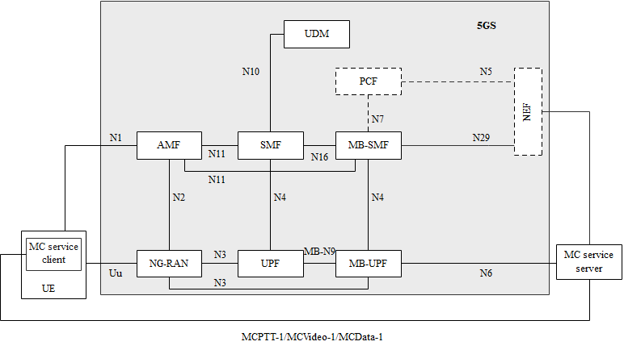
Reference point representation

3. Conclusions
4. Proposal
It is proposed to agree the following changes to 3GPP TR 23.783 v1.2.0.

* * * First Change * * * *

3.1 Definitions
For the purposes of the present document, the terms and definitions given in 3GPP TR 21.905 [1] and the following apply. A term defined in the present document takes precedence over the definition of the same term, if any, in 3GPP TR 21.905 [1].
example: text used to clarify abstract rules by applying them literally.
Editor's note: Example line above to be deleted and replaced by definitions as needed.
For the purposes of the present document, the following terms given in 3GPP TS 23.247 [x] apply
MBS QoS Flow
Multicast MBS session
Broadcast MBS session
Broadcast service area

:
* * * Next Change * * * *

6.x Solution x: Application architecture over 5G MBS

6.x.1 Description
5G MBS is designed to support multiple services (e.g., MC service, V2X service, media streaming service), and not all the MBS features are required for MC services. This solution is to address the key issue #x on selection of 5G configuration options, 5G MBS features for MC Over 5G MBS.
This solution introduces an MC service application architecture over 5G MBS and specifies the necessary 5G MBS features applicable for MC service based on the Transport Only Mode.
Editor's note: The solution relies on the specification of the corresponding aspects in the TS 23.247 [x] and any potential updates is FFS.
The figure 6.x.1-1 and 6.x.1-2 illustrates an MC service application architecture over 5G MBS.

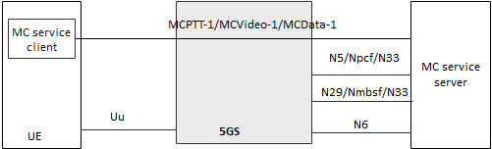
Figure 6.x.1-1 MC service application architecture over 5G MBS in reference point representation
In this architecture, the Transport Only Mode are used for MC service. MC service media content, application level control messages is transmitted via MBS QoS flow(s), which are communication pipes with one end in the MC service server and the other end in the MC service UE. The uplink are always allocated as unicast QoS flow, but the downlink can be allocated as unicast QoS flow or as MBS QoS flow(s), or both.
For 5G Multicast MBS service, a multicast MBS session is uniquely identified via the MBS session ID (i.e, a TMGI or source specific IP multicast address). The MC service server is capable, via the N29/Nmbsmf/N33 interface towards MB-SMF, to configure the multicast MBS session.
For 5G Broadcast MBS service, a broadcast MBS session (both network and radio part) is uniquely identified via a TMGI or via a combination of a TMGI and an Area Session ID. The MC service server is capable, via the N29/Nmbsmf/N33 interface towards MB-SMF, to configure, establish, update, and release the broadcast MBS session and associate a unique TMGI or a combination of a TMGI and a Area Session ID. The MC service server may determine the broadcast service area based on the cell identities of the affiliated group members. The MC service server may determine for a user the switching from broadcast QoS flow to unicast QoS flow based on the information reported over MCPTT-1/MCVideo-1/MCData-1.
Editor’s note: The interfaces from MC service server towards MB-SMF and MB-UPF may be updated if necessary to align with 5G MBS architecture specified by SA2.
The MC service server performs the following functions to enable the group communication over 5G MBS:
- determining whether to use 5G Multicast, Broadcast, or/and unicast of each group call;
- interfacing the PCF/NEF to configure the MBS service information/QoS requirements if dynamic PCC is applicable;
- interfacing with the MB-SMF/NEF to allocate the TMGI, configure the 5G MBS session, and manage the 5G MBS session to request the multicast/broadcast resource for media distribution;
- announcing the MBS service information to MCPTT UEs involved in the group communication;
- announcing the assignment of broadcast QoS flow for a specific group call to involved MCPTT UEs;
- determining for each MCPTT UE involved in a given call whether to use unicast or MBS delivery; and
- informing the media distribution function of the media streams requiring support for a given call.

The update to existing functional model for MCPTT, MCVideo and MCData to support 5G MBS are shown in figure 6.x.1-2, 6.x.1-3, and 6.x.1-4.
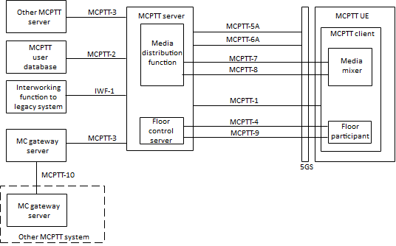
Figure 6.x.1-2 MCPTT functional model for application plane supporting MBS
The following reference point descriptions are applied:
Reference point MCPTT-5A (between the MCPTT server and the 5GS)
The MCPTT-5A reference point, which exists between the MCPTT server and the 5GS, is used, subject to the conditions below, by the MCPTT server to obtain unicast QoS flow with appropriate QoS from the 5GS. It utilises the N5/Npcf/N33 interface of the 5GS according to 3GPP TS 23.503 [y].
MCPTT-5A is not used when the MCPTT service provider and the PLMN operator do not have an operational agreement for QoS control to be provided directly from the MCPTT service provider domain.
MCPTT-5A may be used when the MCPTT service provider and the PLMN operator have an operational agreement where QoS control is provided directly from the MCPTT service provider domain.
MCPTT-5A is also used by the MCPTT server to configure the MBS service information/QoS requirements if dynamic PCC is applicable.
NOTE: Any coordination between the P-CSCF use of N5 and the MCPTT server use of N5 (via MCPTT-5A) from the MCPTT service provider domain is not specified in this release of this specification.
Reference point MCPTT-6A (between the MCPTT server and the 5GS)
The MCPTT-6A reference point, which exists between the MCPTT server and the 5GS, is used to request the allocation and activation of MBS transport resources for MCPTT application usage. The MCPTT-6A reference point uses the N29/Nmbsmf/N33 interface as defined in 3GPP TS 23.247 [x].
Reference point MCPTT-8 (between the media distribution function and the media mixer)
The MCPTT-8 reference point definition in 3GPP TS 23.379 [a] is applied. And when MC service is over 5GS, the MCPTT-8 reference point uses the N6 interface defined in 3GPP TS 23.247[x].
Reference point MCPTT-9 (between the floor control server and the floor participant)
The MCPTT-9 reference pointpoint definition in 3GPP TS 23.379 [a] is applied. And when MC service is over 5GS, the MCPTT-9 reference point uses the N6 interface defined in 3GPP TS 23.247 [x].

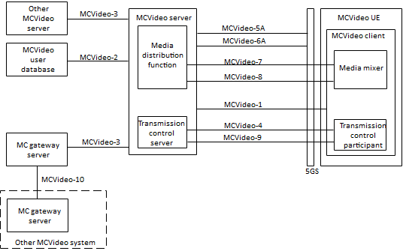
Fgiure 6.x.1-2 MCVideo functional model for application plane suppoting MBS
The following reference point descriptions are applied:
Reference point MCVideo-5A (between the MCVideo Server and the 5GS)
The MCVideo-5A reference point, which exists between the MCVideo server and the 5GS, is used, subject to the conditions below, by the MCVideo server to obtain unicast bearers with appropriate QoS from the 5GS. It utilises the N5/Npcf/N33 interface of the 5GS according to 3GPP TS 23.503 [y].
MCVideo-5A is not used when the MCVideo service provider and the PLMN operator do not have an operational agreement for QoS control to be provided directly from the MCVideo service provider domain.
MCVideo-5A may be used when the MCVideo service provider and the PLMN operator have an operational agreement where QoS control is provided directly from the MCVideo service provider domain.
MCVideo-5A is also used by the MVideo server to configure the MBS service information/QoS requirements if dynamic PCC is applicable.
NOTE: Any coordination between the P-CSCF use of N5 and the MCVideo server use of N5 (via MCVideo-5A) from the MCVideo service provider domain is not specified in this release of this specification.
Reference point MCVideo-6A (between the MCVideo server and the 5GS)
The MCVideo-6A reference point, which exists between the MCVideo server and the 5GS, is used to request the allocation and activation of MBS transport resources for MCVideo application usage. The MCVideo-6A reference point uses the N29/Nmbsmf/N33 interface as defined in 3GPP TS 23.247 [x].
Reference point MCVideo-8 (between the media distribution function and the media mixer)
The MCVideo-8 reference point definition in 3GPP TS 23.281 [b] is applied. And when MC service is over 5GS, the MCVideo-8 reference point uses the N6 interface defined in 3GPP TS 23.247 [x].
Reference point MCVideo-9 (between the transmission control participant and the transmission control server)
The MCVideo-9 reference point definition in 3GPP TS 23.281 [b] is applied. And when MC service is over 5GS, the MCVideo-9 reference point uses the N6 interface defined in 3GPP TS 23.247 [x].

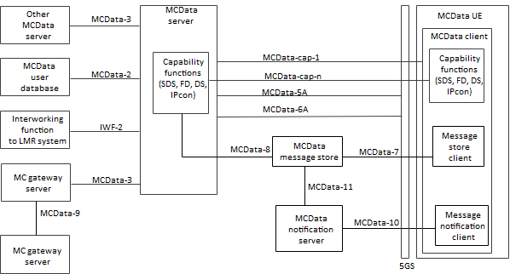
Figure 6.x.1-3 MCData functional model for application plane suppoting MBS
The following reference point descriptions are applied:
Reference point MCData-5A (between the MCData server and the 5GS)
The MCData-5A reference point, which exists between the MCData server and the 5GS, is used, subject to the conditions below, by the MCData server to obtain unicast QoS with appropriate QoS from the 5GS. It utilises the N5/Npcf/N33 interface of the 5GS according to 3GPP TS 23.503 [y].
MCData-5A is not used when the MCData service provider and the PLMN operator do not have an operational agreement for QoS control to be provided directly from the MCData service provider domain.
MCData-5A may be used when the MCData service provider and the PLMN operator have an operational agreement where QoS control is provided directly from the MCData service provider domain.
MCVideo-5A is also used by the MVideo server to configure the MBS service information/QoS requirements if dynamic PCC is applicable.
NOTE: Any coordination between the P-CSCF use of N5 and the MCData server use of N5 (via MCData-5A) from the MCData service provider domain is not specified in this release of this specification.
Reference point MCData-6A (between the MCData server and the 5GS)
The MCData-6A reference point, which exists between the MCData server and the 5GS, is used to request the allocation and activation of MBS transport resources for MCData application usage. The MCData-6A reference point uses the N29/Nmbsmf/N33 interface as defined in 3GPP TS 23.247 [x].

6.x.2 Impacts on existing nodes and functionality

MC service server functionality impact:
- support the 5G MBS related functionalities by acting the AF/AS in the 5G MBS architecture in TS 23.247;
Reference points impact:
- the MC service server supports to interface with the MB-SMF for TMGI allocation, MBS session configuration and management;
- the MC service server supports to interface with PCF for QoS aspect if dynamic QCC is applicable.
- the MC service server supports to distribute the media over MBS deliver to MB-UPF.

6.x.3 Solution evaluation
Editor's Note: Use this section for evaluation at solution level.
This solution is proposed the MC service over 5G MBS architecture with Transport Only Mode based on the TS 23.247, wherein the MC service server acting as the AF/AS and interfacing with the 5GC network functions to request the MBS QoS flow(s) for group communication delivery.
With this solution, the MC service can utilize the Transport Only Mode to deliver the group communications over 5G MBS.

