3GPP TSG-SA WG6 Meeting #42-bis-e S6-210790 (covida)
e-meeting, 12th – 20th April 2021 (revision of S6-21xxxx)

Source: Samsung
Title: Update on ACR initiation procedure
Spec: 3GPP TS 23.558 v2.0.0
Agenda item: 7.6
Document for: Approval
Contact: Hyesung Kim <hs1207.kim@samsung.com>

1. Introduction
This pCR provides updates on ACR initiation procedure and clarifies its use for each ACR scenarios in clause 8.8.2.
2. Reason for Change
This pCR provides updates on ACR initiation procedure to clarify the use of ACR determination and ACR initiation data. Also, it proposes to add description on the use of ACR initiation procedure in each ACR scenarios.
3. Conclusions
<Conclusion part (optional)>
4. Proposal
It is proposed to agree the following changes to 3GPP TS 23.558 v2.0.0

* * * First Change * * * *

8.8.3.4 ACR launching procedure
Figure 8.8.3.4-1 illustrates the procedure for the ACR launching procedure by the EEC. Depending on the ACR action indicated in the ACR request, the procedure is used for either ACR initiation or ACR determination.
Pre-condition:
1. The EEC has been authorized to communicate with the EES as specified in clause 8.10.

Figure 8.8.3.4-1: ACR initiation procedure
- The EEC sends an ACR request message to the EES The ACR request message includes ACR action to indicate either ACR initiation request or ACR determination request. .
An ACR request for ACR initiation:
- includes an indication of whether the EEC requests the EES to perform EAS notification; and
- provides optional information used by EES to perform application traffic.

An ACR request for ACR determination informs the EES that the need for ACR has been determined at EEC.
- The EES checks if the EEC is authorized for this operation. If authorized, the EES processes the request and performs the required operations.
If the request in step 1 is for ACR initiation:
- the EES may use information provided in the request to apply the AF traffic influence with the N6 routing information of the T-EAS in the 3GPP Core Network (if applicable), as described in 3GPP TS 23.501 [2], clause 5.6.7.1.; and

- if the EAS notification indication is provided in the step 1 request and the EAS has subscribed to receive such notification, the EES shall notify the EAS about the need to start ACR.
3. The EES responds to the EEC's request with an ACR response message.

* * * Next Change * * * *

8.8.2.2 Initiation by EEC using regular EAS Discovery
This procedure handles ACR as a result of the UE moving to, or the UE expecting to move to, a new location which is outside the service area of the serving EAS. It further relies on the EEC being triggered as a result of the UE's movement.
This procedure is based on Service Provisioning (as specified in clause 8.3) and EAS Discovery (as specified in clause 8.5) procedures to discover the T-EESs and EASs that shall serve the ACs as a result of the UE's new location, and that shall receive the Application Context from the serving EASs.
The procedure in the following clause describes the relocation of a single application context to a new EAS. It should be repeated for each active AC in the UE
This procedure relies on an interface between the EEC and ACs over EDGE-5, which is out of the scope of this specification.
Pre-conditions:
1. The AC in the UE already has a connection to a corresponding S-EAS;
2. The preconditions listed in clause 8.3.3.2.2 with regards to the EEC are fulfilled; and
3. The EEC is triggered when it obtains the UE's new location, or is triggered by another entity such as an ECS notification.
NOTE 1: This procedure is applicable only for Edge-aware ACs and EASs.
Figure 8.8.2.2-1: ACR initiated by the EEC and ACs
Phase I: ACR Detection
1. The EEC is triggered as a result of a UE mobility event, and provided with the UE's new location as described in clause 8.8.1.
NOTE 2: If the EEC is triggered by an external entity such as by a notification from the ECS, a list of new EESs (to be used as T-EESs) is provided by that notification and step 2 below is skipped.
Phase II: ACR Decision
2. The EEC performs Service Provisioning (as specified in clause 8.3) for all active applications that require ACR. Since the location of the UE has changed, this procedure results in a list of T-EESs that are relevant to the supplied applications and the new location of the UE. If this procedure is used for service continuity planning, then the Connectivity information and UE Location in the Service Provisioning (as specified in clause 8.3) procedure contains the expected Connectivity information and expected UE Location.
NOTE 3: Which applications require ACR can be decided by the EEC and can be based on the application profile, e.g. requirement of service continuity of the application.
NOTE 4: If the change in UE's location does not trigger a need to change the serving EAS, the subsequent steps will not take place. The EEC remains connected to the serving EESs and the ACs remain connected to their corresponding serving EASs.
3. Using the provisioned T-EESs, the EEC performs EAS discovery (as specified in clause 8.5) for the desired T-EASs by querying the T-EESs that were established in step 2 (or provided in the notification from the ECS – if it was the trigger)
Phase III: ACR Execution
4. The AC and EEC select the T-EAS to be used for the application traffic, as described in clause 8.5.1 EAS discovery. Step 4 is skipped if EEC selects only one T-EAS.
5. The EEC performs ACR launching procedure (as described in 8.8.3.4) with the ACR action indicating ACR initiation. The ACR request message includes ACR initiation data indicating no need to notify the EAS and optional information for the S-EES, based on which the S-EES may apply the AF traffic influence with the N6 routing information of the T-EAS in the 3GPP Core Network (if applicable), as described in clause 8.8.3.4.
6. The AC is triggered by the EEC to start ACT. The AC decides to initiate the transfer of application context from the S-EAS to the T-EAS. There may be different ways of transferring context and they are all outside the scope of this specification. After the ACR is completed, the AC remains connected to the T-EAS and disconnects from the S-EAS; the EEC is informed of the completion.
NOTE 4: Whether and how the AC initiates the ACT is out of scope of the present document
NOTE 5: It is out of scope of this specification how the AC informs the source and T-EAS that state transfer was part of service continuity planning. When used for service continuity planning, the next step is performed after the UE moves to the predicted location.
Phase IV: Post-ACR Clean up
7. All required entities perform clean-up
Editor's note: Evaluate the need of an appropriate step for supporting EEC context transfer from S-EES(s) to T-EES(s)

* * * Next Change * * * *

8.8.2.5 S-EES executed ACR
Figure 8.8.2.5-1 illustrates the procedure for the S-EES to detect, decide and execute the ACR from the S-EAS to the T-EAS. This procedure may support automated ACR by S-EES when initiated by S-EAS as per clause 8.8.3.7.
Editor's note: Usage of network path information for the scenarios in clause 8.8.2.5 is FFS.
Pre-condition:
1. The AC at the UE already has a connection to the S-EAS; and
2. The EEC is able to communicate with the S-EES.
Figure 8.8.2.5-1: S-EES executed ACR procedure
1. The S-EAS may initiate Automated ACR with S-EES as specified in clause 8.8.3.7. In this step, the S-EAS and S-EES negotiate an address of the Application Context storage to S-EES. The S-EAS puts the Application Context at this address which can be further accessed by the S-EES when the ACT is required.
In this case, the S-EES executes steps 2, 4, 5, 6, 7, 8, 9 and 11. Rest of steps are skipped.
Phase I: ACR Detection
2. Detection entities (S-EAS, S-EES, EEC) detects that ACR may be required as described in clause 8.8.1. The detection by the S-EES may be triggered by the User Plane path change notification received from the 3GPP Core Network due to S-EAS request for "ACR facilitation" event (see clause 8.6.3).
3. The detection entity performs ACR launching procedure (as described in 8.8.3.4) with the ACR action indicating ACR determination and the corresponding determination data .
Phase II: ACR Decision
4. The S-EES authorises the received message from step 2. The S-EES decides to execute ACR based on the information received in step 2 and the information of EEC context or EAS profile, and then proceed the below steps.
Phase III: ACR Execution
5. The S-EES determines T-EES and T-EAS via the Discover T-EAS procedure in clause 8.8.3.2 of the present document. If this procedure is used for service continuity planning, then UE Location and Target DNAI values provided in the Retrieve T-EES procedure contain the expected UE Location and expected Target DNAI. The S-EES may decide not to perform ACR if T-EAS is not available.
6. The S-EES sends the target information notification to the EEC as described in clause 8.8.3.6.
7. The S-EES may apply the AF traffic influence with the N6 routing information of the T-EAS in the 3GPP Core Network (if applicable).
8. The S-EES sends the ACR Notify message (e.g. as notification for "ACR facilitation" event) to the S-EAS to initiate ACT between the S-EAS and the T-EAS.
9. The Application Context is transferred from S-EAS to the T-EAS at implementation specific time. In the case of automated ACR, the S-EES accesses the Application Context from the address as per step 1 and the S-EES and T-EES engage in the ACT from S-EAS to the T-EAS (obtained as per step 5) in a secure way. Further the T-EAS accesses the Application Context made available by the T-EES. If S-EAS performs the ACT directly with T-EAS, the specification of such process is out of scope of the present document.
NOTE 1: The Application Context is encrypted and protected by the application layer. The S-EES and the T-EES engage in the packet level transport of the Application Context and they have no visibility to the content of the Application Context.
NOTE 2: If used for service continuity planning, post-ACR clean up would only be performed after the UE moves to the expected location.
Phase IV: Post-ACR Clean up
10. The S-EAS sends the ACR Complete message to the S-EES to confirm that the ACR has completed.
11. The S-EES sends the ACR Complete message to the EEC to confirm that the ACR has completed.
NOTE 3: The Application Client mechanism to support switchover of the application traffic to T-EAS is out of scope of the specification.

* * * Next Change * * * *

8.8.2.3 EEC executed ACR via S-EES
Figure 8.8.2.3-1 illustrates the procedure for the EEC to execute the ACR via S-EES.
Pre-condition:
1. The AC at the UE already has a connection to the S-EAS; and
2. The EEC is able to communicate with the S-EES.

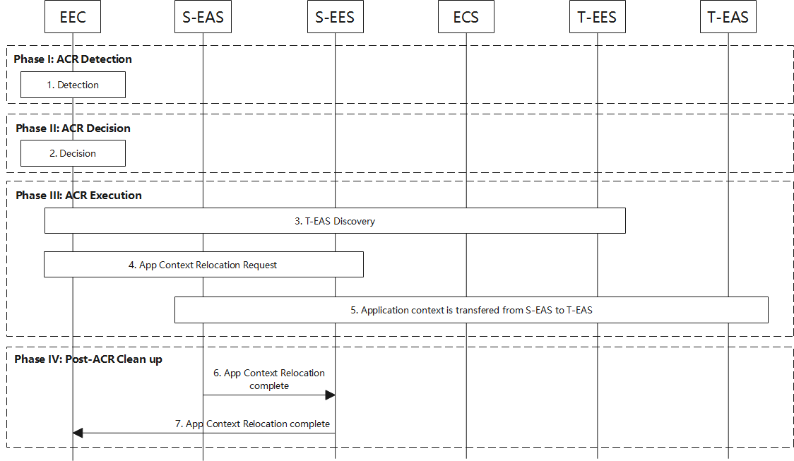
Figure 8.8.2.3-1: EEC executed ACR procedure
Phase I: ACR Detection
1. The EEC detects that ACR may be required as described in clause 8.8.1.
Phase II: ACR Decision
2. The EEC decides to proceed required procedures for triggering ACR.
3. The EEC determines the T-EES by using the provisioned information or performing service provisioning procedure per clause 8.3 of the present document. If this procedure is used for service continuity planning, then the Connectivity information and UE Location in the Service Provisioning (as specified in clause 8.3) procedure contains the expected Connectivity information and expected UE Location. Upon selecting T-EES the UE may need to establish a new PDU connection to the target EDN. The EEC can then discover and select T-EAS by performing EAS Discovery with the T-EES per clause 8.5.2 of the present document.
4. The EEC performs ACR launching procedure (as described in 8.8.3.4) with the ACR action indicating ACR initiation. The ACR Request message includes ACR initiation data indicating the need to notify the EAS. The S-EES authorises the request from the EEC. The S-EES decides to execute ACR based on the information received from the EEC, EEC context and/or EAS profile. The S-EES may apply the AF traffic influence with the N6 routing information of the T-EAS in the 3GPP Core Network (if applicable) and sends the ACR Notify message to the S-EAS to initiate ACT between the S-EAS and the T-EAS.

5. The S-EAS transfers the application context to the T-EAS at implementation specific time. This process is out of scope of the present specification.
NOTE: If used for service continuity planning then the next step is performed after the UE moves to the predicted location.
Phase IV: Post-ACR Clean up
6. The S-EAS sends the ACR Complete message to the S-EES to confirm that the ACR has completed.
7. The S-EES sends the ACR Complete message to the EEC to confirm that the ACR has completed.
Editor's Note: Definition of the Information Flows in these procedures is FFS.

* * * Next Change * * * *

8.8.2.6 EEC executed ACR via T-EES
Figure 8.8.2.6-1 illustrates the procedure for the EEC to execute the ACR via T-EES.
Pre-condition:
1. The EEC has the S-EAS information that serves the AC.

Figure 8.8.2.6-1: EEC executed ACR via T-EES
Phase I: ACR Detection
1. The EEC detects that ACR may be required as described in clause 8.8.1.
Phase II: ACR Decision
2. The EEC decides to proceed with required procedures for ACR.
NOTE 1: If supported, the AC can be involved in the decision. It is out of scope of the present document how the AC is involved.
Phase III: ACR Execution
3. The EEC determines the T-EES by using the provisioned information or performing service provisioning procedure per clause 8.3. If the EEC performs the service provisioning procedure for service continuity planning, then the Connectivity information and UE Location used in that procedure contain the expected Connectivity information and expected UE Location. Upon selecting the T-EES the UE may need to establish a new PDU connection to the target EDN. The EEC performs EAS Discovery with the T-EES per clause 8.5.2.
4. The EEC performs ACR launching procedure (as described in 8.8.3.4) with the ACR action indicating ACR initiation. The ACR Request message to the T-EES includes ACR initiation data indicating the need to notify the EAS and containing the S-EAS and T-EAS information. The T-EES may apply the AF traffic influence with the N6 routing information of the T-EAS in the 3GPP Core Network (if applicable). Then the T-EES sends the ACR Notify message to the T-EAS.
5. The T-EAS initiates ACT between the S-EAS and the T-EAS. This process is out of scope of the present specification.
NOTE 2: If used for service continuity planning, post-ACR clean up would only be performed after the UE moves to the expected location.
Phase IV: Post-ACR clean up
6. The T-EAS sends the ACR Complete message to the T-EES to confirm that the ACR has completed.
7. The T-EES sends the ACR Complete message to the EEC.
If the procedure fails after step 4, it will be terminated with an appropriate cause in the ACR Response message to the EEC in step 7. The EEC may then proceed attempting to obtain services from the T-EAS discovered in step 3 without service continuity support. Alternatively, the EEC may resume the present procedure starting with step 3 and selecting a different T-EES.
NOTE 3: The support of ACR between EDNs operated by different ECSPs is dependent on business agreement between the ECSPs.
Editor's note: When the procedure fails, the use of other mechanisms to alleviate this failure is FFS.

* * * End of Change * * * *

