3GPP TSG-SA WG6 Meeting #42-bis-e S6-210765
e-meeting, 12th – 20th April 2021 (revision of S6-21xxxx)

Source: China Mobile，China Southern Power Grid
Title: EES traffic influence at ECS
Spec: TS 23.558 v1.4.0
Agenda item: 7.6
Document for: Approval
Contact: Shaowen Zheng, zhengshaowen@chinamobile.com

1. Introduction
This contribution propose a solution about EES traffic influence at ECS.
- Reason for Change
To clarify what we are solving, let’s take the picture below as an example, if a UE want to get service from EAS1 which registered to EES1. After service provisioning, UE gets the information of EDN A1, EES1(including DNAI) and everything it needs. Then, the UE sends a PDU session establish request to connect with EES1. However, during the PDU session establishment, the UPF is selected based on DNN and S-NSSAI only, so in this example, for the DNN with multiple EDN, the established PDU session may connect to EES1 with a path through DNAI A2 which is closer to the UE but cannot provide the optimal path.
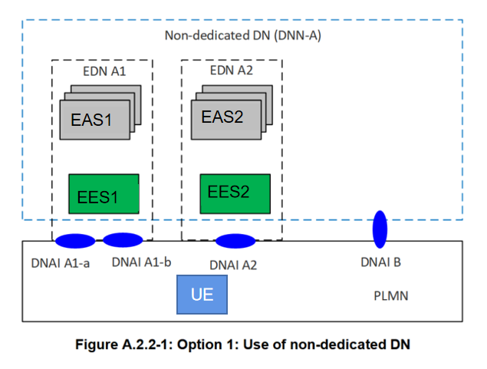
Usually, the UE would have no idea which DNAI is selected and whether the established path is optimal, by requesting this service, the optimal path can be guaranteed. And it will lead to a better E2E delay.
EES can issue AF request with appropriate traffic description with target UE as any UE accessing the combination of DNN/S-NSSAI/DNAI as per clause 5.6.7 in TS 23.501. The timing of issuing the AF request would be the moment when EES is instantiated or registered to ECS, so a NOTE is been added.
————————————————————————————————————————————————
In the service provisioning procedure, ECS responds to the EEC with a list of EDN configuration information. Then, EEC establishes a PDU session with the selected EES using the given EDN information. However, when there are multiple EDNs in a DNN, for example in the deployment option A and option B, the established path only realize the message reach-ability rather than optimal path. It will result in the dissatisfaction on required quality of service of some delay-sensitive applications such as V2X.
In the PDU establish procedure, the UPF will be chosen according to DNN and slice information. For the scenario that one DNN have multiple EDNs, the EDN will be chosen according to the ECMP's policy (such as location). As a result, a detour path is established to undesired EDN. Unless user device has the information mapping the EDN and DNN, otherwise the stringent QoS will not be met.
Therefore, in order to meet user service quality requirements, a network collaboration solution is needed to help establish the best transmission path. The AF traffic influence with the DNAI(s) of the selected EES executed by ECS can help EEC visit the EES through optimal path.
- Proposal
It is proposed to agree the following changes to 3GPP in TS 23.558.

* * * First Change * * * *

8.3.3.2.2 Request-response model
Figure 8.3.3.2.2-1 illustrates service provisioning procedure based on request/response model.
Pre-conditions:
1. The EEC has been pre-configured or has discovered the address (e.g. URI) of the ECS;
2. The EEC has been authorized to communicate with the ECS;
3. The UE Identifier is either preconfigured or resulted from a successful authorization; and
4. The ECS is configured with ECSP's policy for service provisioning.
NOTE 1: Details of ECSP's policy are out of scope.
Editor's Note: [SA2] [SA3] Whether the UE's subscription data may contain the endpoint information of ECS is FFS and requires SA2 and SA3 coordination.
Editor's Note: [SA3] The authorization procedure required to enable communication with the ECS is FFS.
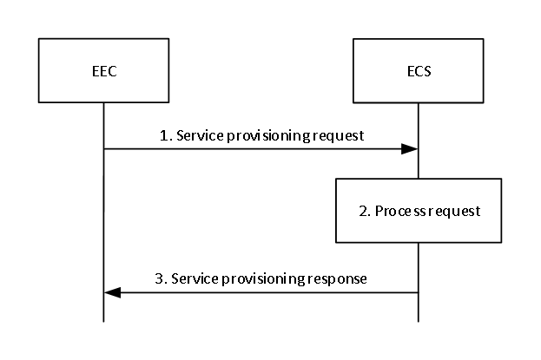
Figure 8.3.3.2.2-1: Service provisioning – Request/Response
1. The EEC sends a service provisioning request to the ECS. The service provisioning request includes the security credentials of the EEC received during EEC authorization procedure and may include the UE identifier such as GPSI, connectivity information, UE location and AC profile(s) information.
2. Upon receiving the request, the ECS performs an authorization check to verify whether the EEC has authorization to perform the operation. The ECS may utilize the capabilities (e.g. UE location) of the 3GPP core network as specified in clause 8.9.2. If AC profile(s) are provided by the EEC, the ECS identifies the EES(s) based on the provided AC profile(s) and the UE location. When AC profiles(s) are not provided, then:
- if available, the ECS identifies the EES(s) based on the UE-specific service information at the ECS and the UE location;
- ECS identifies the EES(s) by applying the ECSP policy (e.g. based only on the UE location);
NOTE 2: Details of the UE-specific service information and how it is available at the ECS is out of scope.
NOTE 3: Both steps are evaluated prior to sending a response.
The ECS also determines other information that needs to be provisioned, e.g. identification of the EDN, EDN service area, EES endpoints.
3. If the processing of the request was successful, the ECS responds to the EEC's request with a service provisioning response which includes a list of EDN configuration information, e.g. identification of the EDN, EDN service area, and the required information (e.g. URI, IP address) for establishing a connection to the EES.
If the ECS is not provisioned with any EDN configuration information or is unable to determine the EES information using the inputs in service provisioning request, UE-specific service information at the ECS or the ECSP's policy, the ECS shall reject the service provisioning request and respond with an appropriate failure cause.
If the EDN configuration information includes an LADN DNN as an identifier for the EDN, the EEC considers the LADN as the EDN. Therefore, the service area of EDN is the LADN Service Area which can be discovered using the UE Registration Procedure. The EEC may cache the service provisioning information (e.g. EES endpoint) for subsequent use and avoid the need to repeat step 1. If the Lifetime IE is included in the Service provisioning response, then the EEC may cache and reuse the Service provisioning information only for the duration specified by the Lifetime IE, without the need to repeat step 1.
NOTE 4: If the service provisioning request fails, the EEC can resend the service provisioning request again, taking into account the received failure cause.
NOTE5: Even after the EEC establishes a connection to the EES using information received in Step 3, the EES can issue AF request to influence traffic routing from EEC to EES as specified in 3GPP TS 23.502[2] clause 5.6.7.
* * * Next Change * * * *

8.3.3.2.3.3 Notify
Figure 8.3.3.2.3.3-1 illustrates the service provisioning notification procedure between the EEC and the ECS.
Pre-conditions:
1. The EEC has subscribed with the ECS for the provisioning information as specified in clause 8.3.3.2.3.2.
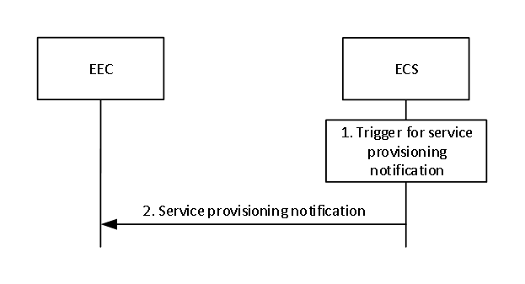
Figure 8.3.3.2.3.3-1: Service provisioning notification
1. An event occurs at the ECS that satisfies trigger conditions for updating service provisioning of a subscribed EEC. If UE's location information is not available, the ECS may obtain the UE location by utilizing the capabilities of the 3GPP core network as specified in clause 8.9.2. If AC profile(s) were provided by the EEC during subscription creation, the ECS identifies the EES(s) based on the provided AC profile(s) and the UE location. If AC profiles(s) were not provided, then:
- if available, the ECS identifies the EES(s) based on the UE-specific service information at the ECS and the UE location;
- ECS identifies the EES(s) by applying the ECSP policy (e.g. based only on the UE location);
NOTE 1: Details of the UE-specific service information and how it is available at the ECS is out of scope.
NOTE 2: Both steps are evaluated prior to sending a response.
The ECS also determines other information that needs to be provisioned, e.g. identification of the EDN, EDN service area, EES endpoints.
2. The ECS sends a provisioning notification to the EEC with the list of EDN configuration information determined in step 1.
If the EDN configuration information in the service provisioning notification includes an LADN DNN as an identifier for the EDN, the EEC considers the LADN as the EDN. Therefore, the service area of EDN is the LADN Service Area, which can be discovered using the UE Registration Procedure.
NOTE3: Even after the EEC establishes a connection to the EES using information received in Step 2, the EES/ECS can issue AF request to influence traffic routing from EEC to EES which targeting the existing or future PDU Sessions of multiple UE(w) as specified in 3GPP TS 23.502[2] clause 5.6.7.

