3GPP TSG-SA WG6 Meeting #42-bis-e S6-210765
e-meeting, 12th – 20th April 2021 (revision of S6-21xxxx)

Source: China Mobile
Title: EES traffic influence at ECS
Spec: TS 23.558 v1.4.0
Agenda item: 7.6
Document for: Approval
Contact: Shaowen Zheng, zhengshaowen@chinamobile.com

1. Introduction
This contribution propose a solution about EES traffic influence at ECS.
- Reason for Change
To clarify what we are solving, let’s take the picture below as an example, if a UE want to get service from EAS1 which registered to EES1. After service provisioning, UE gets the information of EDN A1, EES1(including DNAI) and everything it needs. Then, the UE sends a PDU session establish request to connect with EES1. However, during the PDU session establishment, the UPF is selected based on DNN and S-NSSAI only, so in this example, for the DNN with multiple EDN, the established PDU session may connect to EES1 with a path through DNAI A2 which is closer to the UE but cannot provide the optimal path.
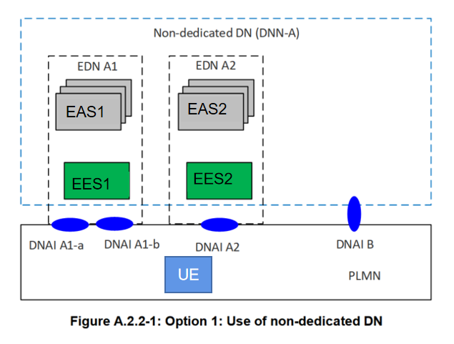
Usually, the UE would have no idea which DNAI is selected and whether the established path is optimal, by requesting this service, the optimal path can be guaranteed. And it will lead to a better E2E delay.
EES can issue AF request with appropriate traffic description with target UE as any UE accessing the combination of DNN/S-NSSAI/DNAI as per clause 5.6.7 in TS 23.501. The timing of issuing the AF request would be the moment when EES is instantiated or registered to ECS, so a NOTE is been added.
————————————————————————————————————————————————
In the service provisioning procedure, ECS responds to the EEC with a list of EDN configuration information. Then, EEC establishes a PDU session with the selected EES using the given EDN information. However, when there are multiple EDNs in a DNN, for example in the deployment option A and option B, the established path only realize the message reach-ability rather than optimal path. It will result in the dissatisfaction on required quality of service of some delay-sensitive applications such as V2X.
In the PDU establish procedure, the UPF will be chosen according to DNN and slice information. For the scenario that one DNN have multiple EDNs, the EDN will be chosen according to the ECMP's policy (such as location). As a result, a detour path is established to undesired EDN. Unless user device has the information mapping the EDN and DNN, otherwise the stringent QoS will not be met.
Therefore, in order to meet user service quality requirements, a network collaboration solution is needed to help establish the best transmission path. The AF traffic influence with the DNAI(s) of the selected EES executed by ECS can help EEC visit the EES through optimal path.
- Proposal
It is proposed to agree the following changes to 3GPP in TS 23.558.

* * * First Change * * * *

8.4.4 EES Registration

8.4.4.1 General
The EES Registration procedure allows an EES to provide information to an ECS in order to enable provisioning EES(s) to an EEC.
The EES registration update procedure allows an EES to update the ECS, if there is a change in the information at the EES.
The EES uses the EES de-registration procedure to remove its information from the ECS.
NOTE: The EES can issue AF request to influence traffic routing from EEC to EES which targeting the existing or future PDU Sessions of multiple UE(w) as spcified in 3GPP TS 23.502[2] clause 5.6.7.

