3GPP TSG-SA WG6 Meeting #42-BIS-e S6-210747
e-meeting, 12th – 20th April 2021 (revision of S6-21xxxx)

Source: Tencent
Title: Procedure for UAS media session management
Spec: 3GPP TS 23.255 v0.3.0
Agenda item: 7.10
Document for: Approval
Contact: Shuai Zhao, <shuaiizhao@tencent.com>

1. Introduction
This contribution adds a new feature in UASAPP TS 23.255 for UAS media application session management.
2. Reason for Change
In TR 23.755, solution#15 provides a viable technical workflow to manage media SIP sessions based on parameters carried in SDP such as bandwidth requirement. This feature enables the UAE server (acts as VAL server) to request the SEAL NRM server to fulfill the session establishment.
However, based on evaluation for solution#15, the following feature is missing from SEAL:
a) the current UAE-S does not support SDP interpretation; and
b) the NRM Server does not have a procedure to determine SIP session requests based on network bandwidth requirement from the SDP passed from UAE-S.
Therefore, missing features from SEAL is also proposed in S6-210748
3. Proposal
It is proposed for adoption to 3GPP TS 23.255 v0.3.0. The missing feature from SEAL is proposed in S6-210748.

* * * Change * * * *

6.x UAS media application session management

6.x.1 General
This clause describes the procedure for UAS media application session management. It enables the UAE-S to 1) act as a SIP AS 2) manage the SIP session establishment 3) negotiate SIP session with SEAL NRM-S based on SDP media information.

6.x.2 Procedures

6.x.2.1 Procedure for UAS media application session management with UAE-S
Pre-conditions:
- A UAS-C tries to establish a SIP session between UAV media payload with UAV-C or USS/UTM using the 3GPP core network via the UAE server with the indication of resource requirements for the media session using SIP SDP.
- UAE-S is deployed to manage the SIP session triggered by UAE-C

Figure 6.x.2.1-1 illustrates a SIP session management based on network resource requirement.
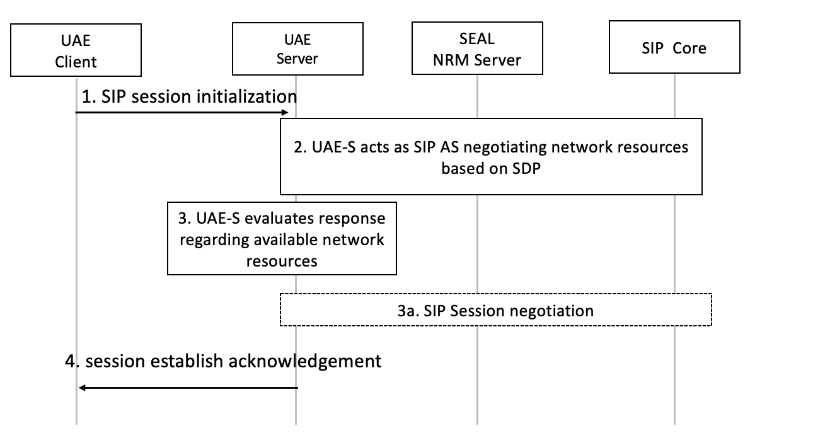
Figure 6.x.2.1-1: Procedure for UAE-S SIP session management based on network resource requirement
- The UAE-C acts as a SIP user agent and sends SIP session initialization requests to UAE-S. The SDP offer information should be included in the SIP payload.
- The UAE server acts as a SIP AS and sends an SDP offer with parameters as specified in clause 14.3.2.6 of TS 23.434 [11]. The NRM server evaluates the request as specified in clause 14.3.3.2.1 of 3GPP TS 23.434 [11]. The NRM server may choose to deny the SIP session request due to a lack of available network resources. Or in another case, the NRM server may determine the session resources can be granted from the SIP core by using clause 14.3.3.2.1 of 3GPP TS 23.434 [11]. In either case, an SDP answer is returned to UAE-S as specified in 14.3.2.7 of TS 23.434 [11].
- The UAE-S evaluates the SDP answer from step 2. If a session is granted and no further SDP negotiation is needed, the UAE-S sends the session establishment acknowledgment as specified in step 4.
3a. In case when SIP is not granted from step 2, the UAE-S acts as SIP AS and sends another SIP negotiation based on returned SDP answer. A new SDP offer is sent with parameters as specified in clause 14.3.2.6 of TS 23.434 [11]. The steps between 2 to 3a can happen multiple cycles until NRM-S grants the SIP session initiation request. The UAE-S evaluates the SDP answer for each request and decides to either continue to send to SIP session negotiation or terminate the request.
Editor’s Note: The details of the SDP evaluation from UAE-S are FFS.
- The UAE-S sends back session initialization acknowledgment.

6.x.3 Information flows
Editor's Note: This clause will describe the information flow tables

