3GPP TSG-SA WG6 Meeting #42-BIS-e S6-210749
e-meeting, 12th – 20th April 2021 (revision of S6-21xxxx)

Source: Tencent
Title: Procedure for UAV and UAV-C Pairing and C2 QoS Provisioning using Group ID
Spec: 3GPP TS 23.255 v0.3.0
Agenda item: 7.10
Document for: Approval
Contact: Shuai Zhao, <shuaiizhao@tencent.com>

1. Introduction
This contribution adds a new feature in UASAPP TS 23.255 for UAV and UAV-C grouping.
2. Reason for Change
In TR 23.755, solution#5 provides a grouping approach for C2 QoS provisioning. Based on the study evaluations, the proposed group method enables UAE-S for QoS management using a group-based approach.

3. Proposal
It is proposed for adoption to 3GPP TS 23.255 v0.3.0.

* * * Change * * * *

6.x UAV and UAV-C Pairing and C2 QoS Provisioning using Group ID

6.x.1 General
This clause describes the procedure for UAV and UAV-C grouping C2 QoS provisioning using subsequent group id.

6.x.2 Procedures

6.x.2.1 Procedure for group creation for one pair of UAV and UAV-C
Pre-conditions:
- Both UAV-C and UAV have successfully connected to the UAE server.
- A CAA-level UAV ID may be assigned during the 3GPP network registration process.
Editor’s Note: UAV-C is a 3GPP UE.
Figure 6.x.2.1-1 illustrates a high-level procedure for group creation.
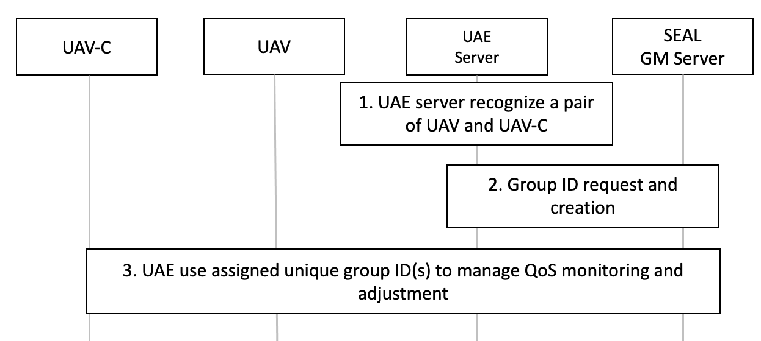
Figure 6.x.2.1-1: Procedure for group creation for one pair of UAV and UAV-C
- The UAE server recognizes a unique pair of UAV and UAV-C either by 3GPP UE ID or CAA-level UAV ID.
Editor’s Note: How UAE-S recongizes a pair of UAV-C and UAV is FFS
- The UAE server sends a group creation request to the SEAL GM server, if there is no pre-assigned group ID, by using the GM-S reference link as specified in 3GPP TS 23.434 [11] using the procedure defined in clause 10.3. The SEAL GM server creates one group ID for one pair of UAV and UAV-C as specified in 3GPP TS 23.434 [11].
3. The UAE server uses the returned group ID for UAS for QoS management.

6.x.2.2 Procedure for group-based approach for C2 QoS provisioning
Figure 6.x.2.2-1 illustrates a high-level workflow of group-based C2 QoS provisioning.
Editor's note: QoS provisioning when C2 is in dynamically changing mode is FFS.
Pre-conditions:
- Both UAV and UAV-C have registered to 3GPP 5G network respectively. C2 communication is established.
- The SEAL group manager has been configured and a group ID for a pair of UAV and UAV-C has been assigned using procedure specified in 6.x.2.1.
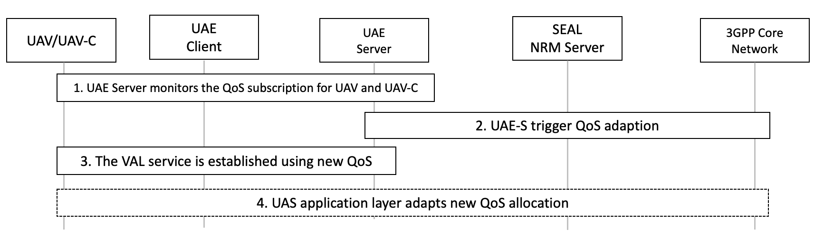
Figure 6.x.2.2-1: Procedure of group-based approach for C2 QoS provisioning.
- The UAE server monitors the QoS for a UAV and UAV-C.
Editor’s Note: The details of UAE-S QoS minitoring is FFS
2. In cases where the network condition for C2 communication does not satisfy the pre-defined QoS requirement, the UAE server may choose to send QoS adaptation request to the SEAL NRM server using the NRM-S reference point as specified in 3GPP TS 23.434 [11]. The QoS adaptation request needs to be sent per group ID for a pair of UAV and UAV-C created in precedure specified in 6.x.2.1. The SEAL NRM server performs network resource adaptation as specified in the 3GPP TS 23.434 [11] clause 14.3.2.1. The NRM server notifies the QoS update to the UAE server using the procedure defined in 3GPP TS 23.434 [11] clause 14.3.2.2.
3. The UAE-C and UAE-S establised communication based on new QoS requirement as specified in clause 14.3.3.2.1.2-1 of 3GPP TS 23.434 [11].
4. UAS application layer adapts the updated QoS assignment.
Editor’s Note: How the UAS application layer is adpating newly assigned QoS out of 3GPP’s scope.

6.x.3 Information flows
Editor's Note: This clause will describe the information flow tables

