3GPP TSG-SA WG6 Meeting #41-e S6-210165
e-meeting, 18th – 26th January 2021 (revision of S6-201xxx)

Source: Tencent
Title: Solution to Key issue #9: Support for UAS media application session monitoring and management
Spec: 3GPP TR 23.755 v0.11.0
Agenda item: 8.3
Document for: Approval
Contact: Shuai Zhao (Shuaiizhao AT Tencent DOT com)

1. Introduction
Following up on the Key Issue#9, with regards to the need to address UAS media session monitoring and management, this contribution proposes a potential solution so as to cover the application layers aspects of the KPI defined 7.1 of 3GPP TS 22.125.
2. Reason for Change
In most of the real-time media communications, the combination of SIP and SDP is used for session initialization and media parameter negotiation. Both protocols data are carried in a control plane prior to the media session. in the user plane. SDP is mostly carried as a SIP payload which includes all media codec-related parameters agreed on by both parties.
Since SEAL offers SIP session management for verticals, it can be used for the UAS application layer monitoring and management of media sessions. With such a support, certain KPIs listed in Table 7.1-1 of Stage 1 requirement are fulfilled.
3. Proposal
It is proposed to include the proposed solution below into to 3GPP TR 23.755 v0.12.0.

* * * First Change * * * *

8.X Solution #x – Support for UAS media application session management

8.x.1 Solution description
In most real-time media communications, the combination of SIP and SDP is used for session initialization and media parameter negotiation. Both protocol data are carried in the control plane before real media traffic goes through the network. SDP is mostly carried as a SIP payload which includes all media codec related parameters. The purpose of SDP is to convey information about media streams and provide sufficient information to enable joining and participating to a media session in a unicast scenario.
One of the important information carried in an SDP is the potential bandwidth usage for a particular media stream. For the use case of a UAV media-related payload, the knowledge of bandwidths that payload intends to use is important for resource allocation in the 3GPP network.
The current SEAL layer already supports SIP for session establishment. This solution addresses how to use SEAL address UAV media session monitoring and management with the following pre-conditions:
- A UAE Client has established a SIP session between UAV media payload and external parties such as UAV-C or USS/UTM using the 3GPP core network.
- SDP as SIP payload for media description.

NOTE: media description other than SDP is for FFS.
Figure 8.x.1-1 illustrates scenarios in which a SIP session may be terminated immediately if a SEAL NRM server determines that there is not enough network bandwidth for a particular SDP description. Otherwise, unicast traffic may be granted.
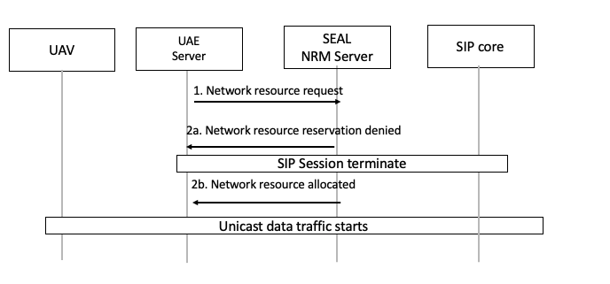
Figure 8.x.1-1: SIP session management based on network resource requirement
- The UAE server requests network bandwidth resources based on SDP’s description for a SIP session using the SEAL-S reference point as specified in Clause 14.2.2 of TS 23.434.
- (a) In the case where the SEAL NRM server may not be able to accommodate the requested bandwidth resource, the SEAL NRM server may choose to terminate the SIP session use the SIP-3 reference point. Otherwise, (b) bandwidth may be allocated and unicast traffic starts.
In other cases, additional network bandwidth resources may be requested. Figure 8.x.1-2 illustrates that a SEAL NRM server may be used to request additional bandwidth for a particular SIP session.
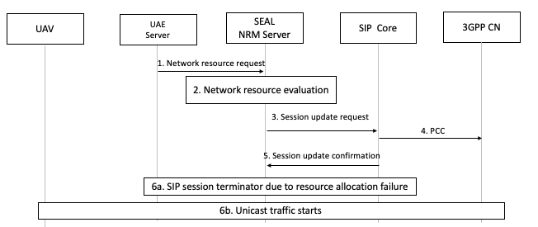
Figure 8.x.1-2: a SEAL-NRM server may be used to request additional bandwidth for a particular SIP session.
- The UAE server requests network bandwidth resources based on SDP’s description for a SIP session using the SEAL-S reference point as specified in Clause 14.2.2 of TS 23.434.
- The SEAL NRM server evaluates the request.
- The SEAL NRM server sends session bandwidth requests to SIP Core using the SIP-2 reference point as specified in Clause 6.5.3.3 of TS 23.434.
- PCC is initiated to 3GPP CN network for more resources as specified in 3GPP TS 23.503
- The SIP core sends recourse request status using SIP-2 reference points as specified in Clause 6.5.3.3 of TS 23.434.
- (a) If the requested resource is not able to be allocated, the UAE server may decide to determine the SIP session otherwise (b) unicast traffic starts.

8.x.2 Solution evaluation
Editor's Note: This subclause will evaluate the solution.

