3GPP TSG-SA WG6 Meeting #37-e S6-200708
E-meeting, 11st May – 21th May 2020

Source: ZTE Corporation
Title: Device group management
Spec: 3GPP TR 23.745 v0.7.0
Agenda item: 8.4
Document for: Approval
Contact: Shao Weixiang, shao.weixiang@zte.com.cn

1. Introduction
This contribution is Device group management.
2. Reason for Change
Key issue 6 - 5GLAN group management describes integration of 5G LAN type service for group management.
This contribution is support for group management part of key issue 6.
3. Proposal
It is proposed to agree the following changes to 3GPP TR 23.745 v0.7.0.

* * * First Change * * * *

7.X Solution #x: Device group management

7.x.1 Solution description
This solution function addresses the Key issue #6.
Pre-conditions:
1. The factory network uses 5G LAN-type of services.
The procedure for device group management is illustrated in figure 7.x.1-1.
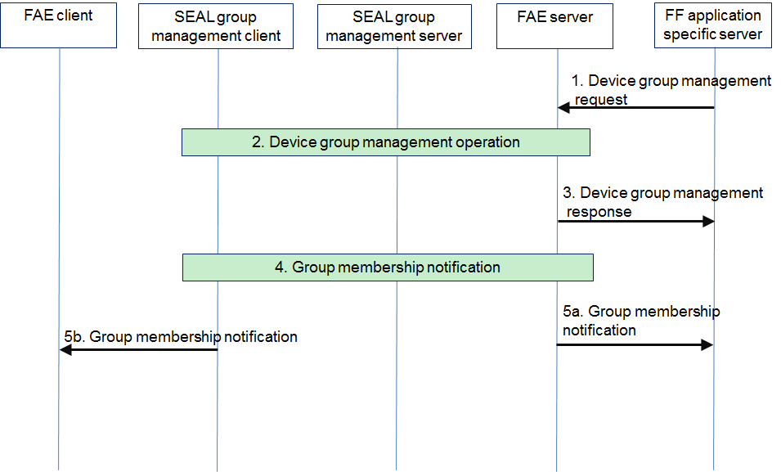
Figure 7.x.1-1: Device group management procedures
1. The FF application specific server sends device group management request (i.e create a group, modify a group, configure a group, deleting a group, add device, remove device) to the FAE server.
Table 7.x.1-1 describes the information flow for device group management request.
Table 7.x.1-1: Device group management request
Information element | Status | Description
VAL group ID | O | Identifies a group, i.e. ExternalGroupId
Operations | O | The management operation, which include:  create a group,  modify a group,  configure a group  deleting a group,  add device,  remove device
Identity list | O | FF UE IDs that are part of the group
VAL service ID list | O | FF application specific server IDs whose service communications are to be enabled on the group
VAL service specific information | O | The FF service specific information  (i.e. 5GLanParameters, TSN integration information, group name, )

2. The FAE server performs the device group management operation by interacting with the SEAL group management server & client as specified in the 3GPP TS 23.434 [8].
3. The FAE server sends a device group management response to the FF application specific server.
Table 7.x.1-2 describes the information flow for device group management response.
Table 7.x.1-2: Device group management response
Information element | Status | Description
VAL group ID | M | Identifies a group, i.e. ExternalGroupId
Operations | M | The management operation
Result | M | Indicates the success or failure for the operation

Step 4~5 are used for adding or removing device to/from the group.
4. The SEAL group management server notifies to the FAE server and the SEAL group management client about membership changing as specified in the 3GPP TS 23.434 [8].
5a. The FAE server notifies the FF application specific server regarding the group membership change with the information of the updated group members.
Table 7.x.1-3 describes the information flow for group membership notification for the FF application specific server.
Table 7.x.1-3: Group membership notification for the FF application specific server
Information element | Status | Description
VAL group ID | M | Identifies a group, i.e. ExternalGroupId
Identity | M | List of identities of the FF UEs affected by this operation
Operations | M | Add to or delete from the group

5b. The SEAL group management client updates the FAE client who have been added to or removed from the group.
Table 7.x.1-4 describes the information flow for group membership notification for the FAE client.
Table 7.x.1-4: Group membership notification for the FAE client
Information element | Status | Description
VAL group ID | M | Identifies a group, i.e. ExternalGroupId
Operations | M | Add to or delete from the group

7.x.2 Solution evaluation

* * * End Change * * * *

