3GPP TSG-SA WG6 Meeting #37-e S6-200707
E-meeting, 11st May – 21th May 2020

Source: ZTE Corporation
Title: QoS monitoring
Spec: 3GPP TR 23.745 v0.7.0
Agenda item: 8.4
Document for: Approval
Contact: Shao Weixiang, shao.weixiang@zte.com.cn

1. Introduction
This contribution is QoS monitoring.
2. Reason for Change
This contribution is for Key issue 5 - QoS monitoring

3. Proposal
It is proposed to agree the following changes to 3GPP TR 23.745 v0.7.0.

* * * First Change * * * *

7.X Solution #x: QoS monitoring

7.X.1 Solution description
This solution addresses Key issue 5 - QoS monitoring.
QoS monitoring is a critical requirement for many FF applications.
The issue to address here via the NEF, according to the procedures defined in 3GPP TS 23.502 [y] clause 4.15. NEF supports APIs of exposure of network events, analytics for QoS monitoring.
The detail procedures over NEF Northbound Interface are defined in 3GPP TS 23.522 [x] clause 4.4:
- Procedures for setting up an AF session with required QoS, which defines QoS monitoring event (QOS_MONITORING) within "QoSMonitoring_5G" feature
- Procedures for analytics information exposure, which defines analytics event (QOS_SUSTAINABILITY) within "QoS_Sustainability" feature

7.x.1.1 QoS monitoring procedure
Pre-conditions:
1. The FF UE has already registered, configured, provisioned.
2. The FF UE has an established connection to 5G network.

The procedure for QoS monitoring is illustrated in figure 7.x.1.1-1.
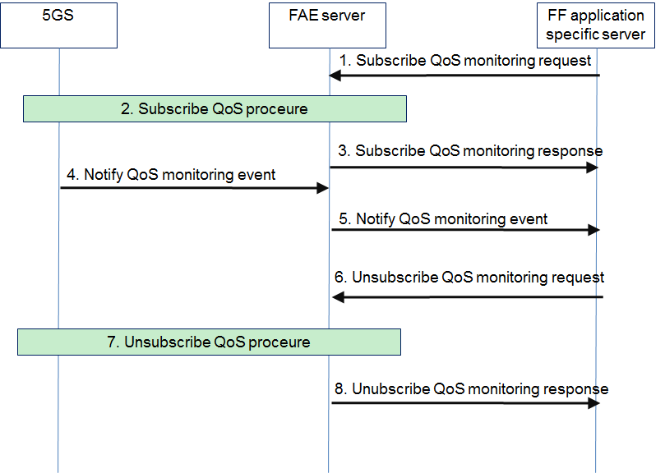
Figure 7.x.1.1-1: QoS monitoring procedures
1. The FF application specific server sends a QoS monitoring subscribe request to the FAE server.
2. The FAE server interacts with NEF to subscribe to QoS monitoring events, including:
- QOS_MONITORING, supported by AsSessionWithQoS API of 3GPP TS 23.522 [x]
- QOS_SUSTAINABILITY, supported by AnalyticsExposure API API of 3GPP TS 23.522 [x]
3. The FAE server sends a QoS monitoring subscribe response to the FF application specific server.
4. When QoS monitoring event is triggered, NEF sends a QoS monitoring notification to the FAE server.
5. The FAE server notifies the FF application specific server about the QoS monitoring event.
NOTE: Steps 4 and 5 are repeated when QoS monitoring events occur.
6. When the FF application specific server decides to unsubscribe for the QoS monitoring, the FF application specific server sends a QoS monitoring unsubscribe request to the FAE server.
7. The FAE server interacts with NEF to unsubscribe from QoS monitoring events.
8. The FAE server sends a QoS monitoring unsubscribe response to the FF application specific server.

* * * Second Change * * * *

2 References
[x] 3GPP TS 29.522: "5G System; Network Exposure Function Northbound APIs; Stage 3".
[y] 3GPP TS 23.502: "Procedures for the 5G System (5GS); Stage 2".

* * * End Change * * * *

