3GPP TSG-SA WG6 Meeting #37-e S6-200707
E-meeting, 11st May – 21th May 2020

Source: ZTE Corporation
Title: Device connectivity monitoring
Spec: 3GPP TR 23.745 v0.7.0
Agenda item: 8.4
Document for: Approval
Contact: Shao Weixiang, shao.weixiang@zte.com.cn

1. Introduction
This contribution is Device connectivity monitoring.
2. Reason for Change
This contribution is for Key issue 5 - QoS monitoring

3. Proposal
It is proposed to agree the following changes to 3GPP TR 23.745 v0.7.0.

* * * First Change * * * *

7.4 Solution #x: Device connectivity monitoring
This solution function addresses the Key issue #5.
Pre-conditions:
1. The device has already registered, configured, provisioned.
2. The device has an established connection to 5G network.

The procedure for device connectivity monitoring is illustrated in figure 7.x-1.
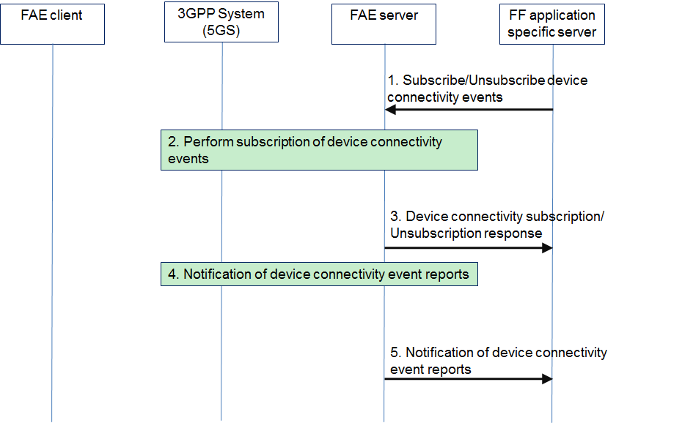
Figure 7.4.1.x-1: Device connectivity monitoring procedures
1. The FF application specific server subscribes/unsubscribes one or several device connectivity events (i.e. user plane events of the connection session, analytics events) to the FAE server.
2. The FAE server check current device subscription status and performs the subscription of device connectivity events through the 3GPP system (e.g. 5GS) by N33 reference point, the detail procedures are specified in clause 4.15 in 3GPP TS 23.502 [y] and clause 4.4.9 & 4.4.14 in 3GPP TS 29.522 [x].
3. The FAE server sends a device connectivity subscription/unsubscription response to the FF application specific server.
4. The FAE server gets notification of device connectivity event reports (i.e. user plane event reports, analytics event reports) from the 3GPP system (e.g. 5GS).
5. The FAE server sends notification to the FF application specific server about the device connectivity event reports.

Table 7.4.1.x-1 describes the information flow for Device connectivity monitoring subscription request.
Table 7.4.1.x-1: Device connectivity monitoring subscription request
Information element | Status | Description
FF UE ID | M | Identifier of the FF UE (i.e. GPSI or identity token)
Connection ID | M | The device connection identifier (PDU sessison ID of this FF UE)
Event Reporting Information | O | Event Reporting Information (defined in Table 4.15.1-1 of 3GPP TS 23.502 [y] )
UserPlaneEvent | O | The user plane event of the connection session, supported by NEF AsSessionWithQoS API specified in clause 5.3 in 3GPP TS 29.522 [x], which include:  QOS_GUARANTEED,  QOS_NOT_GUARANTEED,  QOS_MONITORING
AnalyticsEvent | O | The analytics event type supported by NEF AnalyticsExposure API specified in clause 5.6 in 3GPP TS 29.522 [x], which include:  QOS_SUSTAINABILITY

Table 7.4.1.x-2 describes the information flow for notification of device connectivity event reports.
Table 7.4.1.x-2: Notification of device connectivity event reports
Information element | Status | Description
Subscription | M | Link to the subscription resource to which this notification is related.
UserPlaneEventReport | O | The user plane event report.
AnalyEventNotifs | O | The analytics events to be reported

* * * Second Change * * * *

2 References
[x] 3GPP TS 29.522: "5G System; Network Exposure Function Northbound APIs; Stage 3".
[y] 3GPP TS 23.502: "Procedures for the 5G System (5GS); Stage 2".

* * * End Change * * * *

