3GPP TSG-SA WG6 Meeting #37-e S6-200704
E-meeting, 11st May – 21th May 2020

Source: ZTE Corporation
Title: UE connectivity management
Spec: 3GPP TR 23.745 v0.7.0
Agenda item: 8.4
Document for: Approval
Contact: Shao Weixiang, shao.weixiang@zte.com.cn

1. Introduction
This contribution is UE connectivity management.
2. Reason for Change
This contribution is to add UE connectivity management key issue and related solution.

3. Proposal
It is proposed to agree the following changes to 3GPP TR 23.745 v0.7.0.

* * * First Change * * * *

5.x Key Issue x - UE connectivity management
In 3GPP TS 22.263 [x], based on operator policy, the 5G system shall support a mechanism to provision on-demand connectivity (e.g. IP connectivity for remote provisioning). The 5G system shall support an on-demand mechanism for a user (human or software) to request on-the-spot network connectivity while providing operators with identification and security tools for the provided connectivity.
Open issue:
- Whether and how to perform UE connectivity management by FF Application on demand?

7.X Solution #x: UE connectivity management

7.X.1 Solution description
This solution addresses Key issue x - UE connectivity management.
Management of FF UE network connectivity is a critical requirement for many FF applications.
The issue to address here via the Service Enabler application layer (SEAL), as according to the concepts defined in 3GPP TS 23.434 [8]. SEAL Network Resource Management service enabler specifies APIs of unicast resource management and multicast resource management for EPS, see clause 14 in 3GPP TS 23.434 [8]. Possible ways to enhance the existing Network Resource Management service enabler:
- Establish/add an new IP connection of 5G network for FF UE
- Establish/add an new Ethernet connection of 5G network for FF UE
- Modify the current QoS parameters of an already established FF UE connection of 5G network.
- Terminate a connection and release the associated network address and the associated 5G network resources

7.x.1.1 UE connectivity management procedure
The procedure for UE connectivity management is illustrated in figure 7.x.1-1.
Pre-conditions:
1. The FF UE has already registered, configured, provisioned.
2. The FF UE has an established connection to 5G network and the FF application specific server was notified of connectivity status.

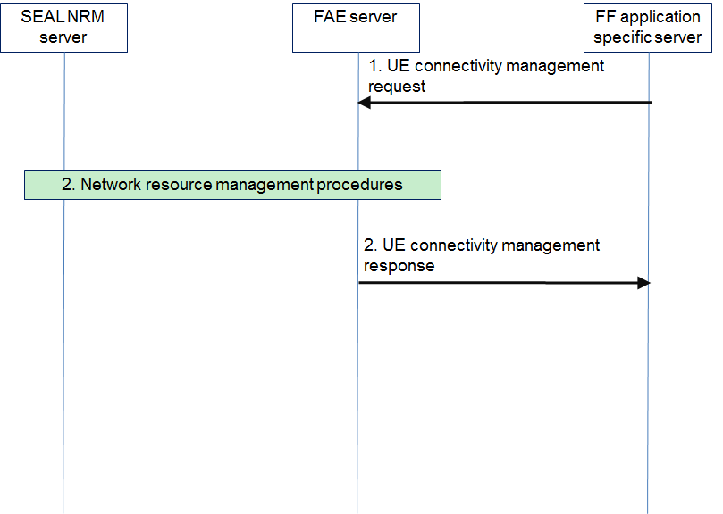
Figure 7.x.1.1-1: Device connectivity management procedures
1. The FF application specific server sends an UE connectivity management request to the FAE server.
2. The FAE server interacts with the SEAL NRM server to manage FF device network connectivity, the management operation including, but not limited:
- Establish/add an new IP connection of 5G network for FF device
- Establish/add an new Ethernet connection of 5G network for FF device
- Modify the current QoS parameters of an already established FF device connection of 5G network.
- Terminate a connection and release the associated network address and the associated 5G network resources
3. The FAE server sends an UE connectivity management response to the FF application specific server about the execution result.

7.X.2 Solution evaluation

* * * Second Change * * * *

2 References
[x] 3GPP TS 22.263: "Service requirements for video, imaging and audio for professional applications (VIAPA)".

* * * End Change * * * *

