3GPP TSG-SA WG6 Meeting #37-e S6-200704
E-meeting, 11st May – 21th May 2020

Source: ZTE Corporation
Title: Device connectivity management
Spec: 3GPP TR 23.745 v0.7.0
Agenda item: 8.4
Document for: Approval
Contact: Shao Weixiang, shao.weixiang@zte.com.cn

1. Introduction
This contribution is Device connectivity management.
2. Reason for Change
This contribution is for Key Issue 7 - Device Onboarding.
The overall process of onboarding devices can include the use of tools such as device management, credentials and subscription management, and network connectivity management.
For network connectivity management in Device Onboarding, which include terminate device connection, reconnection device.
For reconnection device by 5G network, the steps are definded in clause 4.3.2 of 3GPP TS 23.502, which include:
- UE initiated PDU Session Establishment procedure
- Network triggered PDU Session Establishment procedure, In this case the network sends the device trigger message to application(s) on the UE side by invoke Nnef_Trigger service.
For terminate device connection by 5G network, the steps are definded in clause 4.3.4 of 3GPP TS 23.502, which include:
- UE requested PDU Session Release
- Network requested PDU Session Release by PCF, AMF, SMF, RAN

3. Proposal
It is proposed to agree the following changes to 3GPP TR 23.745 v0.7.0.

* * * First Change * * * *

7.4 Solution #4: Device Onboarding support in FF

7.4.1.x Device connectivity management

The procedure for device connection termination is illustrated in figure 7.4.1.x-1.

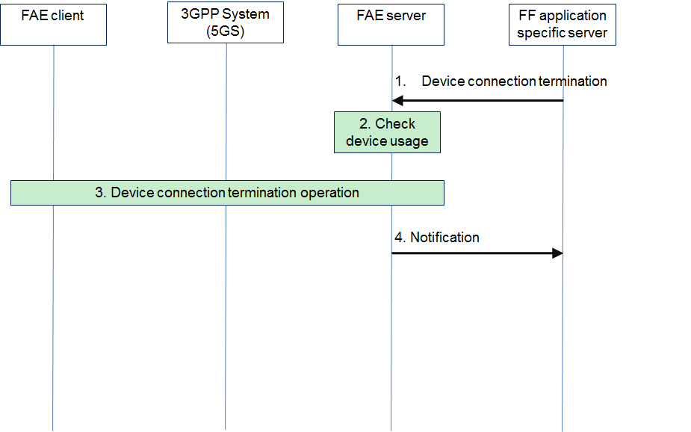
Figure 7.4.1.x-1: Device connectivity management (server side) procedures
1. The FF application specific server sends a device connection termination command with FF UE ID & PDU session ID to the FAE server.
2. The FAE server check whether the device is in usage or not. If the device is in usage by other application, then move to step 4.
3. The FAE server sends a device connection termination command to the FAE client.
4. After 5GS sends device status event to the FAE Server, the FAE server notifies to the FF application specific server about the device connection event: offboarding.

The procedure for reconnection device is illustrated in figure 7.4.1.x-2.

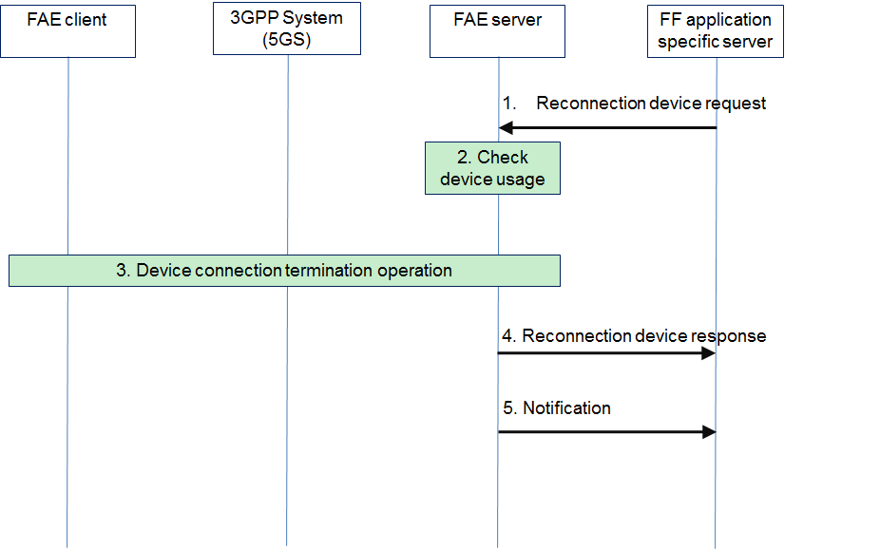
Figure 7.4.1.x-2: Reconnection device procedures
1. The FF application specific server sends a reconnection device request with FF UE ID to the FAE server.
2. The FAE server check whether the device is in usage or not. If the device is in usage by other application, then move to step 4 with unsuccessful reponse, then finish the procedure.
3. There are two ways for reconnection device between the FAE server, the FAE client, 5GS:
3a. The FAE server directly sends reconnection device command to the FAE client.
3b. The FAE server invokes device triggering API through N33 to 5GS, which follow network triggered PDU Session Establishment procedure of 4.3.2 and 4.13.2 in 3GPP TS 23.502[x].
4. The FAE server sends a reconnection device response to the FAE FF application specific server.
5. After 5GS sends device status event to the FAE Server, the FAE server notifies to the FF application specific server about the device connection event: onboarding.

* * * Second Change * * * *
[x] 3GPP TS 23.502: " Procedures for the 5G System (5GS); Stage 2".

* * * End Change * * * *

