3GPP TSG-SA WG6 Meeting #37-e S6-200703
E-meeting, 11st May – 21th May 2020

Source: ZTE Corporation
Title: Subscribe&notify about device provisioning
Spec: 3GPP TR 23.745 v0.7.0
Agenda item: 8.4
Document for: Approval
Contact: Shao Weixiang, shao.weixiang@zte.com.cn

1. Introduction
This contribution is Subscribe&notify about device provisioning.
2. Reason for Change
This contribution is for Key Issue 7 - Device Onboarding

The FF application specific servers can subscribe and get notification about FF device provisioning status
3. Proposal
It is proposed to agree the following changes to 3GPP TR 23.745 v0.7.0.

* * * First Change * * * *

7.4 Solution #4: Device Onboarding support in FF

7.4.1.x Subscribe&notify about device provisioning
The procedure for subscription and notification of device provisioning status is illustrated in figure 7.4.1.x-1.

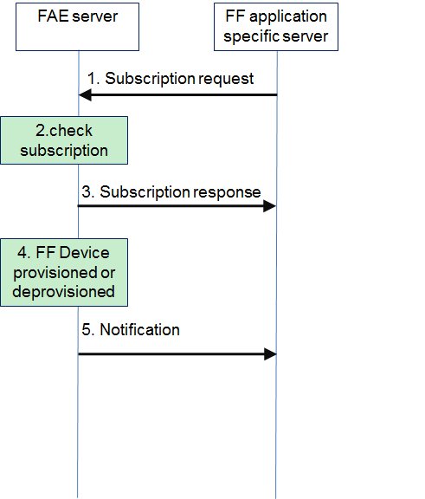
Figure 7.4.1.x-1: subscription and notification of device provisioning status
1. The FF application specific server sends subscription request to the FAE Server.
Table 7.4.1.x-1 describes the information flow for subscription request.
Table 7.4.1.x-1: subscription request
Information element | Status | Description
FF UE ID | M | Identifier of the FF UE
Event | M | Provisioning status (i.e. onboarding, offboarding)

2. The FAE server check whether the device has already subscribed for provision status. If yes, move to step 3. If not, the FAE server communicates with 5GS for subscription of device provision status.
3. The FF application specific server receives subscription response from the FAE Server.
Table 7.4.1.x-2 describes the information flow for subscription request.
Table 7.4.1.x-2: subscription response
Information element | Status | Description
Result | M | Result from the FAE server in response to subscription request indicating success or failure

4. The FF device is provisioned or deprovisioned, 5GS sends device status event to the FAE Server.
5. The FAE Server sends notification to the FF application specific server.
Table 7.4.1.x-3 describes the information flow for notification.
Table 7.4.1.x-3: Notification
Information element | Status | Description
FF UE ID | M | Identifier of the FF UE
Provisioning status | M | Provisioning status (i.e. onboarding, offboarding)

* * * End Change * * * *

