3GPP TSG-SA WG6 Meeting #37-e S6-200702
E-meeting, 11st May – 21th May 2020

Source: ZTE Corporation
Title: Device configuration
Spec: 3GPP TR 23.745 v0.7.0
Agenda item: 8.4
Document for: Approval
Contact: Shao Weixiang, shao.weixiang@zte.com.cn

1. Introduction
This contribution is Device configuration.
2. Reason for Change
This contribution is for Key Issue 7 - Device Onboarding
After FF UE Connection, Registration to 5GS, the FF UE should use configuration management service to get default configuration data of related FF device.
3. Proposal
It is proposed to agree the following changes to 3GPP TR 23.745 v0.7.0.

* * * First Change * * * *

7.4 Solution #4: Device Onboarding support in FF

7.4.1.x Device configuration

Pre-conditions:
1. FF UE Connection, Registration to 5GS.
2. The FAE client has supported interaction with the SEAL client.
The procedure for device configuration is illustrated in figure 7.4.1.x-1.

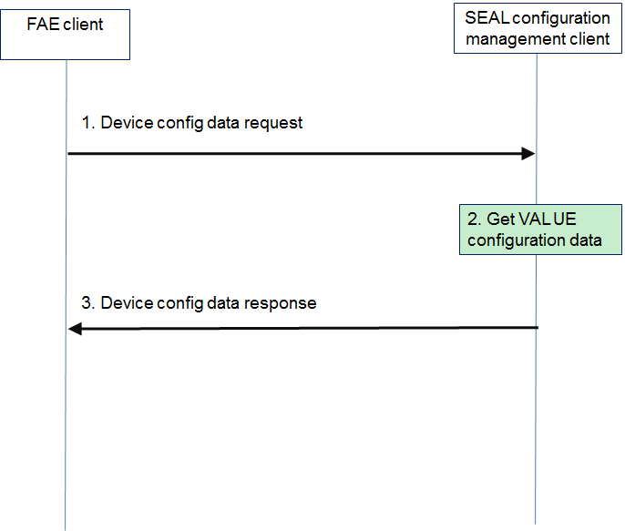

Figure 7.4.1.x-1: Device configuration
1. The FAE client sends device configuration data request to the SEAL configuration management client.
Table 7.4.1.x-1 describes the information flow for device configuration data request.
Table 7.4.1.x-1: Device configuration data request
Information element | Status | Description
FAE Client ID | M | Identifier of the FAE client

- The SEAL configuration management client get VAL UE configuration data from SEAL configuration management server as specified in subclause 11.3.3 of 3GPP TS 23.434 [8].
3. The FAE client receives device configuration data response from the SEAL configuration management client.
Table 7.4.1.x-2 describes the information flow for device configuration data response.
Table 7.4.1.x-2: Device configuration data response
Information element | Status | Description
FAE Client ID | M | Identifier of the FAE client
Result | M | Result in response to device configuration data request indicating success or failure
FAE server info | O | The FAE server information (i.e.the physical address of FAE server)
FF application default info | O | FF application default information (i.e. service area, message size, transfer interval)

* * * End Change * * * *

