3GPP TSG-SA WG6 Meeting #37-e S6-200701
E-meeting, 11st May – 21th May 2020

Source: ZTE Corporation
Title: FAE client registration
Spec: 3GPP TR 23.745 v0.7.0
Agenda item: 8.4
Document for: Approval
Contact: Shao Weixiang, shao.weixiang@zte.com.cn

1. Introduction
This contribution is FAE client registration.
2. Reason for Change
This contribution is for Key Issue 7 - Device Onboarding
The FF Application registration procedures of FF Device Onboarding automatic process (solution #4) include:
- The FAE client registers to the FAE server via FAE-1 reference point. (In this contribution)
- The FF application specific client registers to the FAE client via FAE-C reference point. (Specific application related, out of scope of the present document)
- The FF application specific server registers to the FAE server via FAE-S reference point. (Specific application related, out of scope of the present document)

3. Proposal
It is proposed to agree the following changes to 3GPP TR 23.745 v0.7.0.

* * * First Change * * * *

7.4 Solution #4: Device Onboarding support in FF

7.4.1.x FAE client registration
Pre-conditions:
- The FF UE has already connected & registered to 5G network.
- The FF UE is configured with FF application default information (i.e. the physical address of FAE server).
The procedure for FAE client registration is illustrated in figure 7.4.1.x-1.
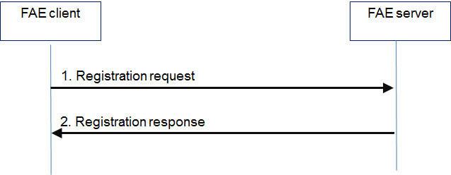
Figure 7.4.1.x-1: FAE client registration
- The FAE client sends a registration request to the FAE server with FF device information (i.e. software, hardware, capabilities, optional management objects if available).
2. The FAE server sends a registration response to the FAE client indicating success or failure result.

7.4.1.y FAE client deregistration
Pre-condition:
- The FAE client has already registered with the FAE server.
- The FAE client can proactive deregistration or on demand of the FAE sever.

The procedure for FAE client deregistration is illustrated in figure 7.4.1.y-1.
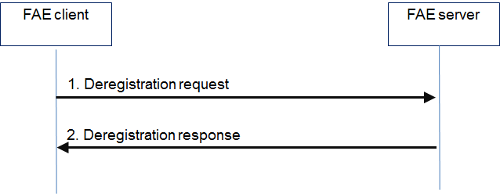
Figure 7.4.1.y-1: FAE client deregistration
1. The FAE client sends a deregistration request to the FAE server.
2. The FAE server sends a deregistration response to the FAE client.

* * * End Change * * * *

