3GPP TSG-SA WG6 Meeting #37-e S6-200701
E-meeting, 11st May – 21th May 2020

Source: ZTE Corporation
Title: FAE client registration
Spec: 3GPP TR 23.745 v0.7.0
Agenda item: 8.4
Document for: Approval
Contact: Shao Weixiang, shao.weixiang@zte.com.cn

1. Introduction
This contribution is FAE client registration.
2. Reason for Change
This contribution is for Key Issue 7 - Device Onboarding
The FF Application registration procedures of FF Device Onboarding automatic process (solution #4) include:
- The FAE client registers to the FAE server via FAE-1 reference point. (In this contribution)
- The FF application specific client registers to the FAE client via FAE-C reference point. (Specific application related, out of scope of the present document)
- The FF application specific server registers to the FAE server via FAE-S reference point. (Specific application related, out of scope of the present document)

3. Proposal
It is proposed to agree the following changes to 3GPP TR 23.745 v0.7.0.

* * * First Change * * * *

7.4 Solution #4: Device Onboarding support in FF

7.4.1.x FAE client registration
Pre-conditions:
1. The FF UE has already connected & registered to 5G network.
The procedure for FAE client registration is illustrated in figure 7.4.1.x-1.
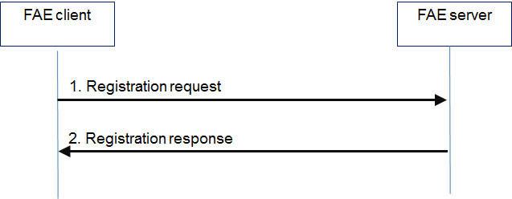
Figure 7.4.1.x-1: FAE client registration
- The FAE client sends a registration request to the FAE server.
Table 7.4.1.x-1 describes the information flow for registration request.
Table 7.4.1.x-1: Registration request
Information element | Status | Description
FF UE ID | M | Identifier of the FF UE (i.e. GPSI or identity token)
FAE Client ID | M | Identifier of the FAE client
Management Object List | O | The list of management data model of the device which including but not limited to below information (i.e. software, hardware, capabilities, log, device configurations)
Device Node Info | O | The information of device node (i.e. node information, local management client information)

2. The FAE server sends an acknowledgement to the FAE client.
Table 7.4.1.x-2 describes the information flow for registration response.
Table 7.4.1.x-2: Registration response
Information element | Status | Description
Result | M | Result from the FAE server in response to registration request indicating success or failure

7.4.1.y FAE client deregistration
Pre-condition:
1. The FAE client has already registered with the FAE server

The procedure for FAE client deregistration is illustrated in figure 7.4.1.y-1.
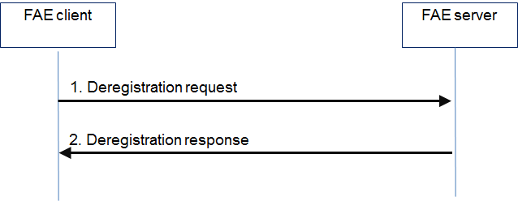
Figure 7.4.1.y-1: FAE client deregistration
1. The FAE client sends a deregistration request to the FAE server.
Table 7.4.1.y-1 describes the information flow for deregistration request.
Table 7.4.1.y-1: Deregistration request
Information element | Status | Description
FF UE ID | M | Identifier of the FF UE (i.e. GPSI or identity token)
FAE Client ID | M | Identifier of the FAE client

2. The FAE server sends a deregistration response to the FAE client.
Table 7.4.1.y-2 describes the information flow for deregistration request.
Table 7.4.1.y-2: Deregistration response
Information element | Status | Description
Result | M | Result from the FAE server in response to deregistration request

* * * End Change * * * *

