3GPP TSG-SA WG6 Meeting #37e S6-200820
E-meeting, 14th – 26th May 2020 (revision of S6-200xxx)

Source: Huawei, Hisilicon
Title: Retrieve Target Edge Enabler Server
Spec: 3GPP TS 23.558 v0.2.0
Agenda item: 7.5
Document for: Approval
Contact: Niranth (namogh@huawei.com)

1. Introduction
This contribution provides a proposal for Retrieve Target Edge Enabler Server.
2. Reason for Change
This contribution contains the second procedure proposal in S6-700780. Retrieve target EES as a common procedure is required in multiple procedure supported for service continuity.
3. Proposal
It is proposed to agree the following changes to 3GPP TS 23.558 v0.2.0.

* * * First Change * * * *

8.8 Capabilities to support service continuity

8.8.2 Procedures

8.8.2.bb Retrieve Target Edge Enabler Server procedure
Figure 8.8.2.bb-1 illustrates the procedure for the source Edge Enabler Server to retrieve the target Edge Enabler Server information from the Edge Configuration Server.
Pre-condition:
1. The source Edge Enabler Server has been pre-configured with the address of the Edge Configuration Server.
2. 1. The Application Client at the UE already has on-going application traffic with the source Edge Application Server.
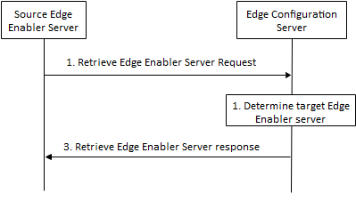
Figure 8.8.2.bb-1: Retrieve target Edge Enabler Server procedure
1. The source Edge Enabler Server sends the Retrieve Edge Enabler Server request (UE location information or UE identity, EAS ID of the source Edge Application Server) to the Edge Configuration Server in order identify the target Edge Enabler Server which has an Edge Application Server with the same EAS ID registered and available to serve the given Application Client in the UE.
2. The Edge Configuration Server identifies one or more target Edge Enabler Server(s) as per the parameters in the request. If the request contained the UE identity but the UE location is not known to the Edge Configuration Server, then the Edge Configuration Server interacts with 3GPP core network to retrieve the UE location.
3. The Edge Configuration Server sends the Retrieve Edge Enabler Server response (EAS ID of the source Edge Application Server, list of target Edge Enabler Server(s) information) to the source Edge Enabler Server. The list of target Edge Enabler Server(s) information includes the endpoint for each of the target Edge Enabler Server(s), e.g. IP address determined in step 2.

