3GPP TSG-SA WG6 Meeting #37-e S6-200768
e-meeting, 14th – 26th May 2020

Source: Nokia, Nokia Shanghai Bell
Title: Pseudo-CR on annex for relationship to ETSI ISG MEC
Spec: 3GPP TS 23.558 v0.2.0
Agenda item: 7.5
Document for: Approval
Contact: Omar Elloumi <omar.elloumi@nokia.com>

1. Introduction
ETSI ISG MEC and 3GPP SA6 have both worked on their own architectures for Multi-access Edge Computing within the bounds of their different scopes.
ETSI ISG MEC has specified a MEC system and its relationship with an ETSI NFV Management and Orchestration (MANO) system. They could not specify any details of a 3GPP UE or network’s direct interaction with their MEC system as those are not in their scope.
3GPP SA6 is specifying the 3GPP UE and network’s relationship with their EDGEAPP system. They could not specify all the details of their system’s interaction with a management system as that is not in their scope (it would be done by SA5 as per S5-201598.zip).

At the heart of both architectures lies the MEC Platform/Edge Enabler Server and the MEC Applications/Edge Application Servers instantiated upon it. There is a great degree of commonality apparent in the two architectures on those points, and in the information carried between those functions.
This contribution suggests the addition of an annex section to provide information on how both architectures could complement each other or co-exist in a given implementation. It is in the industry’s best interests to define how a standardised end-to-end architecture can be created from a combination of these two complimentary parts.
2. Reason for Change
Provide clarifications on how ETSI MEC and 3GPP SA6 EDGEAPP can coexist and complement each other.
3. Proposal
It is proposed to agree the following changes to 3GPP TS 23.558 v0.2.0

* * * First Change * * * *

2 References
The following documents contain provisions which, through reference in this text, constitute provisions of the present document.
- References are either specific (identified by date of publication, edition number, version number, etc.) or non-specific.
- For a specific reference, subsequent revisions do not apply.
- For a non-specific reference, the latest version applies. In the case of a reference to a 3GPP document (including a GSM document), a non-specific reference implicitly refers to the latest version of that document in the same Release as the present document.
[1] 3GPP TR 21.905: "Vocabulary for 3GPP Specifications".
[2] 3GPP TS 23.501: "System Architecture for the 5G System; Stage 2".
[3] 3GPP TS 23.502: "Procedure for the 5G System; Stage 2".
[4] 3GPP TS 29.522: "5G System; Network Exposure Function Northbound APIs; Stage 3".
[5] 3GPP TS 29.122: "T8 reference point for northbound Application Programming Interfaces (APIs)".
[6] 3GPP TS 23.222: "Functional architecture and information flows to support Common API Framework for 3GPP Northbound APIs; Stage 2".
[7] 3GPP TS 23.271: "Functional stage 2 description of Location Services (LCS)".
[8] 3GPP TS 36.305: "Evolved Universal Terrestrial Radio Access Network (E-UTRAN); Stage 2 functional specification of User Equipment (UE) positioning in E-UTRAN".
[9] 3GPP TS 23.273: "5G System (5GS) Location Services (LCS); Stage 2".
[10] 3GPP TS 38.305: "NG Radio Access Network (NG-RAN); Stage 2 functional specification of User Equipment (UE) positioning in NG-RAN".
[11] 3GPP TS 23.003: "Numbering, addressing and identification".
[i.1] ETSI ISG MEC ETSI GS MEC 011 V2.1.1 (2019-11), “Multi-access Edge Computing (MEC); Edge Platform Application Enablement”
* * * End First Change * * * *

* * * Second Change * * * *

Annex C (Informative):
Relationship with ETSI MEC architecture

C.1 Introduction
This clause shows an example for how the EDGEAPP architecture and ETSI ISG MEC architecture [i.1] can complement each other.
ETSI ISG MEC addresses aspects pertaining to MEC Application enablement through the MEC platform. Additionally, ETSI ISG MEC supports management and orchestration aspects for MEC components.

C.2 Enhanced ETSI MEC architecture with EDGEAPP
Figure provides the ETSI ISG MEC architecture enhanced with EDGEAPP architecture.

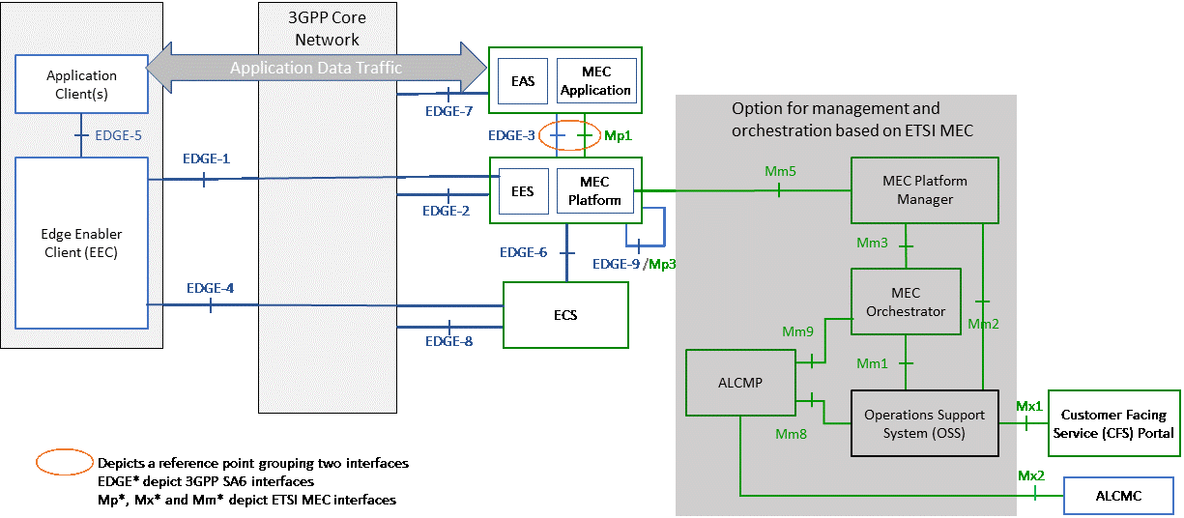
Figure C.2-1: An enhanced ETSI MEC architecture with EDGEAPP
Abbreviations used in Figure C.2-1 are:
ACLMP: Application Life Cycle Management Proxy
ALCMC: Application Lifecycle Management Client
Details about MEC entities (MEC Platform, MEC Application, MEC Platform Manager, MEC Orchestrator, OSS and CFS) can be found in [i.1]
In ETSI MEC, MEC Applications and MEC Platform can expose services which may include network services, subject to their availability at the core or access network level.

* * * End Second Change * * * *

