3GPP TSG-SA WG6 Meeting #36-e S6-200394
E-meeting, 24th – 28th Feb 2020 (revision of S6-20xxxx)

Source: Huawei, Hisilicon
Title: Pseudo-CR on key issue on UE-to-UE application layer relay
Spec: 3GPP TR 23.764 v0.4.0
Agenda item: 8.2
Document for: Approval
Contact: Cuili Ge – gecuili@huawei.com

1. Introduction
This pCR is proposed to introduce a new key issue on UE-to-UE application layer relay.
2. Reason for Change
UE-to-UE application layer relay may be used to enhance the V2V communication coverage. The UE-to-UE application layer relay applies to both LTE-V2X and NR-V2X.
In the context of UE-to-UE application layer relay scenario, a V2X message may be broadcast by each relay UE which may cause V2V message broadcast flood as shown in the figure below. For example, the relay UE 3 may receive the same V2X message from V2X UE1, UE2, UE4 at the same time or during a period of time. The UE 3 has to determine how to process the V2X message(s) received, broadcast only the first received messages over PC5, or broadcast each V2X messages over PC5. If all relay UE clients broadcast the identical V2X message from UE1 over PC5, then V2X message flood will occur over PC5, and the condition becomes worse if all the received V2X messages are broadcast.
Thus, how to reduce the V2X message broadcast flood using relay UE is for further study.
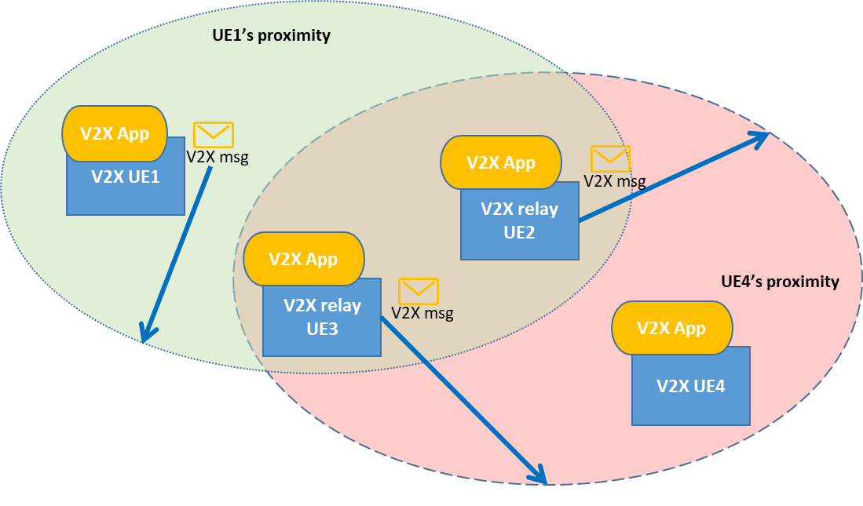

3. Proposal
It is proposed to agree the following changes to 3GPP TR 23.764 v0.4.0.

* * * First Change * * * *

5.X Key issue x – UE-to-UE application layer relay
UE-to-UE application layer relay may be used to enhance the V2V communication coverage. The V2X relay UEs applies to both LTE-V2X and NR-V2X. To enhance the V2V communication coverage one or more V2X relay UEs may be involved.
In the scenario where V2X relay UEs are used to re-transmit the V2X messages to a wider coverage area, it is possible that a V2X UE may receive multiple copies of the same message that are repeatedly re-transmitted by several V2X relay UEs causing a V2X message broadcast flood as shown in figure 5.x-1.
For example, V2X UE1 transmits a V2X message over PC5 which needs to be delivered to a coverage area which includes V2X UE4. The V2X message is received by V2X relay UE2 and V2X relay UE3 at the same time or with some time difference. Due to the relay nature, the V2X relay UE2 and V2X relay UE3 re-transmit the V2X messages over PC5 to the coverage area of V2X UE4. V2X UE4 receives multiple copies of the same V2X message transmitted by V2X UE1 and further V2X relay UE2 and V2X relay UE3 also receive the same V2X message again. It is possible that the V2X relay UEs re-transmit the newly received V2X messages from the other V2X relay UEs thus causing a V2X message broadcast flood.
Thus, how to reduce the V2X message broadcast flood when using V2X relay UEs for V2V communications is for further study.
Solutions for application layer support of UE-to-UE relay functionality will need to be studied.
Figure 5.x-1: V2X message flood scenario
NOTE: Reuse of 5GS UE-to-UE relay solutions defined by SA2 is FFS.

* * * End of Change * * * *

